|  |
| --- |
| **Emotie: Abstracted Emotive Robotic Data Collection for Socially Assistive Robotic Implementation** |
| Submitted in partial fulfilment of: BSC (Hons) Artificial Intelligence and Robotics Staffordshire University |
| Written By William John Lawson |

|  |
| --- |
| Supervised By Dr Benhur Bakhtiari BastakiMay 2023 |



# Acknowledgements:

To all who know me, I can only apologise, and thank you, for putting up with myself.

****Extended acknowledgments available at :

Or:

https://github.com/willlaws35/FYP-Emotie/blob/main/Acknowledgements.md

# Abstract:

The field of Socially assistive robotics, or S.A.Rs tends to occupy a level of hybrid utility between animatronic technologies and health care robotics, to a further extent the development of robotics to suit health care tend to occupy a form of physical aide assistance, with fewer breaches into mental health assistance.

This project aims to develop, deploy, test, and gather information, to emulate and create a compilation of information, for the purposes of displaying and conveying emotion to users on an abstracted emotive platform, reducing issues which plagues current humanoid robotics.

The Project will discuss the conventions of developing an artefact with a focus with regards embedded system, as well as the developmental production and design of a custom testbed emotional intelligence gathering artefact, affectionately dubbed Emotie.

Over the course of this document, discussions as to selected project methodologies, and prior case studies will be discussed, as well as the considered and eventually selected hardware, and software technologies utilised during the project’s conception through deployment, and eventual discussion and elaboration on the overall success and the significance of what the project has discovered.

Table of Contents

[Acknowledgements: 1](#_Toc135382408)

[Abstract: 1](#_Toc135382409)

[Chapter 1: Introduction 6](#_Toc135382410)

[1.1 Background 6](#_Toc135382411)

[1.2 Project Aim 8](#_Toc135382412)

[1.3 Disclaimer 9](#_Toc135382413)

[1.4 Project Scope 9](#_Toc135382414)

[1.4.1 Objectives & Deliverables 9](#_Toc135382415)

[1.5 Project Plan 11](#_Toc135382416)

[Chapter 2: Project Research 12](#_Toc135382417)

[2.1 Prior Research 12](#_Toc135382418)

[2.1.1 Methodology Approach 12](#_Toc135382419)

[2.1.2 Reflection of previous SARs 15](#_Toc135382420)

[2.1.3 Psychological Factors Related to Expression 20](#_Toc135382421)

[2.1.4 User characteristics, behaviour, and requirements 21](#_Toc135382422)

[2.1.5 Summary of prior research 22](#_Toc135382423)

[2.2 Developmental Research 23](#_Toc135382424)

[2.2.1 Hardware Research 23](#_Toc135382425)

[2.2.2 Software Research 41](#_Toc135382426)

[2.2.3 Concluded Technologies 43](#_Toc135382427)

[Chapter 3: Artefact Design 44](#_Toc135382428)

[Chapter 4: Artefact Development 46](#_Toc135382429)

[4.1 Initial Prototype construction 46](#_Toc135382430)

[4.1.1 Initial Sound System Construction: 46](#_Toc135382431)

[4.1.2 Drive Train Construction 47](#_Toc135382432)

[4.1.3 Neck Base Assembly 50](#_Toc135382433)

[4.1.4 Casing Development 51](#_Toc135382434)

[4.1.5 Eye Mounting System 53](#_Toc135382435)

[4.1.6 Basic Integration Test 54](#_Toc135382436)

[4.1.7 Eyebrow Integration 55](#_Toc135382437)

[4.1.8 Drive Train Upgrades 57](#_Toc135382438)

[4.1.9 Data Collection User Interface 58](#_Toc135382439)

[4.1.10 Further additions consideration 60](#_Toc135382440)

[4.1.11 Bluetooth Integration 60](#_Toc135382441)

[4.1.12 Oled Display Integration 61](#_Toc135382442)

[4.1.13 Completion Of Base Hardware 62](#_Toc135382443)

[4.2 Arduino Program Architecture: 64](#_Toc135382444)

[4.2.1 Configuration: 65](#_Toc135382445)

[4.2.2 Wait On Interaction 71](#_Toc135382446)

[4.2.3 Instruction Providing 73](#_Toc135382447)

[4.2.4 Wait On Response 74](#_Toc135382448)

[4.2.5 Record Information 75](#_Toc135382449)

[4.3 Graphical Python Companion Program 76](#_Toc135382450)

[4.3.1 Data Transference Format 76](#_Toc135382451)

[4.3.2 Data Extraction 77](#_Toc135382452)

[4.3.3 Data Display. 78](#_Toc135382453)

[Chapter 5: Deployment, Testing and Further Iterations 80](#_Toc135382454)

[5.1 Deployment 1: 80](#_Toc135382455)

[5.1.1 Deployment Findings 80](#_Toc135382456)

[5.1.2 Deployment Reflection 81](#_Toc135382457)

[5.2 Deployment 2: 82](#_Toc135382458)

[5.2.1 Deployment Findings 82](#_Toc135382459)

[5.2.2 Deployment Reflection 82](#_Toc135382460)

[Chapter 6: Conclusion and future works 84](#_Toc135382461)

[6.1 Resultant Analysis 84](#_Toc135382462)

[6.2 Project Retrospective 85](#_Toc135382463)

[6.3 Future Works 87](#_Toc135382464)

[Appendices 95](#_Toc135382465)

[Figure 1: Walt Disney in the Enchanted Tiki Room with primitive animatronic birds. (Image Source: //www.disdom.com/walt-disneys-enchanted-tiki-room)/ 8](file:///C:\Users\willi\Desktop\Fyp%20-%20Emotie%20Project%20Report.docx#_Toc135382322)

[Figure 2: Sophia the robot (Image Source: Wonderland Magazine) 8](file:///C:\Users\willi\Desktop\Fyp%20-%20Emotie%20Project%20Report.docx#_Toc135382323)

[Figure 3: MOSCOW Architecture Project Outline 11](#_Toc135382324)

[Figure 4: Waterfall methodology diagram (Image Source: Lucid Chart) 13](file:///C:\Users\willi\Desktop\Fyp%20-%20Emotie%20Project%20Report.docx#_Toc135382325)

[Figure 5: Agile Methodology diagram (Image Source: mobile-jon.com) 14](#_Toc135382326)

[Figure 6: Agile Methodology Stages 14](#_Toc135382327)

[Figure 7: Scrum Methodology (Image Source: programmingwithbasics.com) 15](file:///C:\Users\willi\Desktop\Fyp%20-%20Emotie%20Project%20Report.docx#_Toc135382328)

[Figure 8: Proposed Methodology Analysis 16](#_Toc135382329)

[Figure 9: Chiron, robotics platform (Image Source: https://chiron.website/) 17](file:///C:\Users\willi\Desktop\Fyp%20-%20Emotie%20Project%20Report.docx#_Toc135382330)

[Figure 10: Huggable Robot (Image Source: https://youtu.be/QwTCmbq9C4o (New York Times)) 18](file:///C:\Users\willi\Desktop\Fyp%20-%20Emotie%20Project%20Report.docx#_Toc135382331)

[Figure 11: MIT Tega (Image Source: https://youtu.be/sF0tRCqvyT0 (Personal Robotics Group)) 18](file:///C:\Users\willi\Desktop\Fyp%20-%20Emotie%20Project%20Report.docx#_Toc135382332)

[Figure 12: Pleo interactive robot (Image Source: https://robots.ieee.org/robots/pleo/) 19](file:///C:\Users\willi\Desktop\Fyp%20-%20Emotie%20Project%20Report.docx#_Toc135382333)

[Figure 13:Nao Robot Platform (Image Source: http://us.softbankrobotics.com/nao) 20](file:///C:\Users\willi\Desktop\Fyp%20-%20Emotie%20Project%20Report.docx#_Toc135382334)

[Figure 14: Paro, Robotics Seal (Image Source: http://www.parorobots.com/) 21](file:///C:\Users\willi\Desktop\Fyp%20-%20Emotie%20Project%20Report.docx#_Toc135382335)

[Figure 15: Raspberry Pi 4B I/O Diagram (Image Source: www.raspberrypi.com) 25](file:///C:\Users\willi\Desktop\Fyp%20-%20Emotie%20Project%20Report.docx#_Toc135382336)

[Figure 16: Teensy Performance Quantification (Image Source: www.pjrc.com) 26](file:///C:\Users\willi\Desktop\Fyp%20-%20Emotie%20Project%20Report.docx#_Toc135382337)

[Figure 17: Teensy 3.x Device (Image source: www.pjrc.com) 26](file:///C:\Users\willi\Desktop\Fyp%20-%20Emotie%20Project%20Report.docx#_Toc135382338)

[Figure 18: Teensy 4.x Device (Image Source: www.pjrc.com) 27](file:///C:\Users\willi\Desktop\Fyp%20-%20Emotie%20Project%20Report.docx#_Toc135382339)

[Figure 19: Arduino Uno Micro Controller (Image Source: www.arduino.cc) 28](file:///C:\Users\willi\Desktop\Fyp%20-%20Emotie%20Project%20Report.docx#_Toc135382340)

[Figure 20: AT Mega2560 Micro Controller Chip (Image Source: www.microchip.com) 28](file:///C:\Users\willi\Desktop\Fyp%20-%20Emotie%20Project%20Report.docx#_Toc135382341)

[Figure 21: Arduino Mega Micro Controller (Image Source: www.arduino.cc) 29](file:///C:\Users\willi\Desktop\Fyp%20-%20Emotie%20Project%20Report.docx#_Toc135382342)

[Figure 22: Key studio Mega Micro Controller (Image Sourced: wiki.keyestudio.com.) 29](file:///C:\Users\willi\Desktop\Fyp%20-%20Emotie%20Project%20Report.docx#_Toc135382343)

[Figure 23: SG 90 Micro Servo (Image Source: sg.cytron.io) 31](file:///C:\Users\willi\Desktop\Fyp%20-%20Emotie%20Project%20Report.docx#_Toc135382344)

[Figure 24: MG 90S Micro Servo (Image Source: components101.com) 31](file:///C:\Users\willi\Desktop\Fyp%20-%20Emotie%20Project%20Report.docx#_Toc135382345)

[Figure 25: 28BYJ-48 Stepper Motor (Image Source: www.makerfabs.com) 32](file:///C:\Users\willi\Desktop\Fyp%20-%20Emotie%20Project%20Report.docx#_Toc135382346)

[Figure 26: 42 BYGH Stepper Motor (Image Source: docs.makeblock.com) 33](file:///C:\Users\willi\Desktop\Fyp%20-%20Emotie%20Project%20Report.docx#_Toc135382347)

[Figure 27: L298N Stepper Motor Drive Board (Image Source: www.makerfabs.com) 34](file:///C:\Users\willi\Desktop\Fyp%20-%20Emotie%20Project%20Report.docx#_Toc135382348)

[Figure 28: Stepper Motor Drive Board (Image Source: alexnld.com) 34](file:///C:\Users\willi\Desktop\Fyp%20-%20Emotie%20Project%20Report.docx#_Toc135382349)

[Figure 29: Selection of Linear Actuators (Image Source: www.actuonix.com) 35](file:///C:\Users\willi\Desktop\Fyp%20-%20Emotie%20Project%20Report.docx#_Toc135382350)

[Figure 30: Linear Servo (Image Source: : alexnld.com) 35](file:///C:\Users\willi\Desktop\Fyp%20-%20Emotie%20Project%20Report.docx#_Toc135382351)

[Figure 31: Soft Body Robotics Grip Component (Image Source: thenewstack.io) 36](file:///C:\Users\willi\Desktop\Fyp%20-%20Emotie%20Project%20Report.docx#_Toc135382352)

[Figure 32: DFPlayer Mini (Image Source: www.dfrobot.com) 37](file:///C:\Users\willi\Desktop\Fyp%20-%20Emotie%20Project%20Report.docx#_Toc135382353)

[Figure 33: DFPlayer Pro (Image Source: www.dfrobot.com) 37](file:///C:\Users\willi\Desktop\Fyp%20-%20Emotie%20Project%20Report.docx#_Toc135382354)

[Figure 34: HC-SR04 Ultrasonic Sensor (Image Source: alexnld.com) 39](file:///C:\Users\willi\Desktop\Fyp%20-%20Emotie%20Project%20Report.docx#_Toc135382355)

[Figure 35: Ultrasonic Sensor Functionality (Image Source: howtomechatronics.com) 39](file:///C:\Users\willi\Desktop\Fyp%20-%20Emotie%20Project%20Report.docx#_Toc135382356)

[Figure 36: Arduino IDE Snapshot 43](file:///C:\Users\willi\Desktop\Fyp%20-%20Emotie%20Project%20Report.docx#_Toc135382357)

[Figure 37: rudimentary design sketch as to points of articulation. 45](file:///C:\Users\willi\Desktop\Fyp%20-%20Emotie%20Project%20Report.docx#_Toc135382358)

[Figure 38: Initial CAD model for the purposes of further research. 46](file:///C:\Users\willi\Desktop\Fyp%20-%20Emotie%20Project%20Report.docx#_Toc135382359)

[Figure 39: Secondary 3D render 46](file:///C:\Users\willi\Desktop\Fyp%20-%20Emotie%20Project%20Report.docx#_Toc135382360)

[Figure 40: DFPlayer Pro Test 47](file:///C:\Users\willi\Desktop\Fyp%20-%20Emotie%20Project%20Report.docx#_Toc135382361)

[Figure 41: DFPlayer Pro functionality table 48](#_Toc135382362)

[Figure 42: Test Stepper Motor Integration 48](file:///C:\Users\willi\Desktop\Fyp%20-%20Emotie%20Project%20Report.docx#_Toc135382363)

[Figure 43: Stepper Motor Mount 49](file:///C:\Users\willi\Desktop\Fyp%20-%20Emotie%20Project%20Report.docx#_Toc135382364)

[Figure 44: Stepper Motor Hub Adapter 49](file:///C:\Users\willi\Desktop\Fyp%20-%20Emotie%20Project%20Report.docx#_Toc135382365)

[Figure 45: Adapted Test Bed Platform 50](file:///C:\Users\willi\Desktop\Fyp%20-%20Emotie%20Project%20Report.docx#_Toc135382366)

[Figure 46: 12V Power Adapter 50](file:///C:\Users\willi\Desktop\Fyp%20-%20Emotie%20Project%20Report.docx#_Toc135382367)

[Figure 47: Main Neck Base Components 51](file:///C:\Users\willi\Desktop\Fyp%20-%20Emotie%20Project%20Report.docx#_Toc135382368)

[Figure 48: Initial Neck Prototype 51](file:///C:\Users\willi\Desktop\Fyp%20-%20Emotie%20Project%20Report.docx#_Toc135382369)

[Figure 49: Assembled Base Case 52](file:///C:\Users\willi\Desktop\Fyp%20-%20Emotie%20Project%20Report.docx#_Toc135382370)

[Figure 50: Acrylic Corner Mount 52](file:///C:\Users\willi\Desktop\Fyp%20-%20Emotie%20Project%20Report.docx#_Toc135382371)

[Figure 51: Base Laser Cut Template 53](file:///C:\Users\willi\Desktop\Fyp%20-%20Emotie%20Project%20Report.docx#_Toc135382372)

[Figure 52: Small Shock Absorber Bracket 53](file:///C:\Users\willi\Desktop\Fyp%20-%20Emotie%20Project%20Report.docx#_Toc135382373)

[Figure 53: Base Eye Configuration 54](file:///C:\Users\willi\Desktop\Fyp%20-%20Emotie%20Project%20Report.docx#_Toc135382374)

[Figure 54: Main Eye Mounts 54](file:///C:\Users\willi\Desktop\Fyp%20-%20Emotie%20Project%20Report.docx#_Toc135382375)

[Figure 55: Eye Base LED Test 55](file:///C:\Users\willi\Desktop\Fyp%20-%20Emotie%20Project%20Report.docx#_Toc135382376)

[Figure 56: Code Version 0.5 Flow Chart 56](file:///C:\Users\willi\Desktop\Fyp%20-%20Emotie%20Project%20Report.docx#_Toc135382377)

[Figure 57: Print In Place Hinged Eyebrow 57](file:///C:\Users\willi\Desktop\Fyp%20-%20Emotie%20Project%20Report.docx#_Toc135382378)

[Figure 58: Integrated Eyebrow Risers 58](file:///C:\Users\willi\Desktop\Fyp%20-%20Emotie%20Project%20Report.docx#_Toc135382379)

[Figure 59: Rear Eyebrow Segments. 58](file:///C:\Users\willi\Desktop\Fyp%20-%20Emotie%20Project%20Report.docx#_Toc135382380)

[Figure 60: Test Calibration Button 59](file:///C:\Users\willi\Desktop\Fyp%20-%20Emotie%20Project%20Report.docx#_Toc135382381)

[Figure 61: Belt Tensioner 59](file:///C:\Users\willi\Desktop\Fyp%20-%20Emotie%20Project%20Report.docx#_Toc135382382)

[Figure 62: Potentiometer Mount Display 60](file:///C:\Users\willi\Desktop\Fyp%20-%20Emotie%20Project%20Report.docx#_Toc135382383)

[Figure 63: SD Card Mount 60](file:///C:\Users\willi\Desktop\Fyp%20-%20Emotie%20Project%20Report.docx#_Toc135382384)

[Figure 64: Assembled Base Artefact 60](file:///C:\Users\willi\Desktop\Fyp%20-%20Emotie%20Project%20Report.docx#_Toc135382385)

[Figure 65: SH-HC-08 Bluetooth Transmitter 61](file:///C:\Users\willi\Desktop\Fyp%20-%20Emotie%20Project%20Report.docx#_Toc135382386)

[Figure 66: DSD Mobile Application (Image Source: DSD Tech) 62](file:///C:\Users\willi\Desktop\Fyp%20-%20Emotie%20Project%20Report.docx#_Toc135382387)

[Figure 67: Voltage Divider Circuit (Image Source: www.rfwireless-world.com) 62](file:///C:\Users\willi\Desktop\Fyp%20-%20Emotie%20Project%20Report.docx#_Toc135382388)

[Figure 68: OLED Integration. 63](file:///C:\Users\willi\Desktop\Fyp%20-%20Emotie%20Project%20Report.docx#_Toc135382389)

[Figure 69: Project Wiring Architecture. 64](file:///C:\Users\willi\Desktop\Fyp%20-%20Emotie%20Project%20Report.docx#_Toc135382390)

[Figure 70: Program Design Flow Chart 65](file:///C:\Users\willi\Desktop\Fyp%20-%20Emotie%20Project%20Report.docx#_Toc135382391)

[Figure 71:Library Table List 66](#_Toc135382392)

[Figure 72: Main Configuration Variables 68](#_Toc135382393)

[Figure 73: Configuration Program Flow-Chart 69](file:///C:\Users\willi\Desktop\Fyp%20-%20Emotie%20Project%20Report.docx#_Toc135382394)

[Figure 74: Wait On Interaction Program Flowchart 72](file:///C:\Users\willi\Desktop\Fyp%20-%20Emotie%20Project%20Report.docx#_Toc135382395)

[Figure 75: Instruction Providing Program Segment Flowchart 74](file:///C:\Users\willi\Desktop\Fyp%20-%20Emotie%20Project%20Report.docx#_Toc135382396)

[Figure 76: Wait On Response Program Flow Chart 75](file:///C:\Users\willi\Desktop\Fyp%20-%20Emotie%20Project%20Report.docx#_Toc135382397)

[Figure 77: Saving Functionality Program Flow Chart 76](file:///C:\Users\willi\Desktop\Fyp%20-%20Emotie%20Project%20Report.docx#_Toc135382398)

[Figure 78: Stored Data Paradigms 78](#_Toc135382399)

[Figure 79: Graphical Result Conversion 80](file:///C:\Users\willi\Desktop\Fyp%20-%20Emotie%20Project%20Report.docx#_Toc135382400)

[Figure 80: Deployment 1 Testing 82](#_Toc135382401)

[Figure 81: Substitute Speaker Conversion 82](file:///C:\Users\willi\Desktop\Fyp%20-%20Emotie%20Project%20Report.docx#_Toc135382402)

[Figure 82: Deployment 2 Testing 83](#_Toc135382403)

[Figure 83: Graphical Feedback Visualization 85](file:///C:\Users\willi\Desktop\Fyp%20-%20Emotie%20Project%20Report.docx#_Toc135382404)

[Figure 84: Reflective Moscow Table 87](#_Toc135382405)

[Figure 85: Arduino Giga Micro Controller (Image Source: www.arduino.cc) 89](file:///C:\Users\willi\Desktop\Fyp%20-%20Emotie%20Project%20Report.docx#_Toc135382406)

[Figure 86: Portenta X8 Micro Controller (Image Source: www.arduino.cc) 90](file:///C:\Users\willi\Desktop\Fyp%20-%20Emotie%20Project%20Report.docx#_Toc135382407)

# Chapter 1: Introduction

Mental health disorders are increasingly prevalent within modern day society.

According to Mental disorders(World Health Organisation, 2022) , as of 2019, 1 in 8 people (approximately 970 million), suffer from a degree of mental health disorders, more recent estimates place rates at 26% and 28% for anxiety and major depressive disorders, respectively.

However, even recognising the increasing issue of mental health disorders, access to suitable prevention and treatment options, simply do not exist without stigmatisation of the disorder, or barriers to entry ranging from discrimination to financial boundaries.

## 1.1 Background

As a result, alternative means of managing mental health is an advancing sector, a key area in question is Socially Assistive Robotics (SARs), considered to be a new and emerging field generates open-endedness with regards what a SAR is.

In accordance to Defining socially assistive robotics (D. Feil-Seifer and M. J. Mataric, 2005),upon considering what the field of SARs tends to cover, three main capacities were discussed which were, effective user task performance, autonomy of operation, and the entities presence whether that physical or virtual.

Elaborating particularly within effective user task performance, highlights the ability to complete a goal set by user or professional ranging from physical therapy or teaching, to the more applicable in this case mental health treatment and prevention.

The aim of this project is to develop a prototype of SAR that is capable of developing expressive emotion through user feedback.

This solution will attempt to improve the effective user task performance, using the information gained from this study and creating a platform for more engaging assistance with subjected to mental health conditions.

Emotive Robotics, whilst in comparison to prior works in similar fields such as Animatronics found its footing relatively early on.

During the 1950’s, heavily associated with Walt Disney (Gluck,K. 2013), Highlights that Initial inspiration developed from mimicry of life like actions found in windup toys during the time.

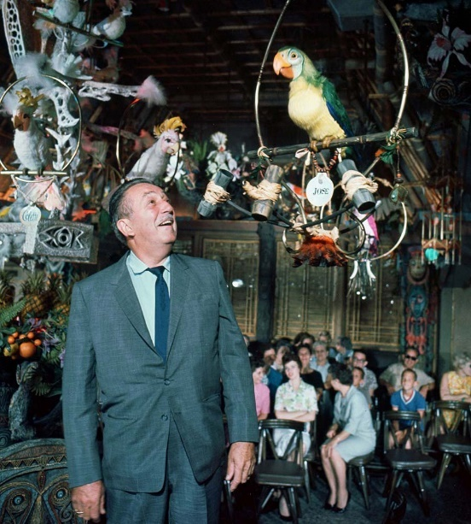Considering the fundamental basis of the toys, further development was made in the efforts of upscaling and developing full sized human based mechanical sculptures.

Figure 1: Walt Disney in the Enchanted Tiki Room with primitive animatronic birds. (Image Source: //www.disdom.com/walt-disneys-enchanted-tiki-room)/

Upon reaching the 1960’s, development of these animatronics had significantly developed into more and more lifelike representations, most notably a selection of animatronic birds which featured in the Walt Disney’s Enchanted Tiki Room, as seen in figure 1.

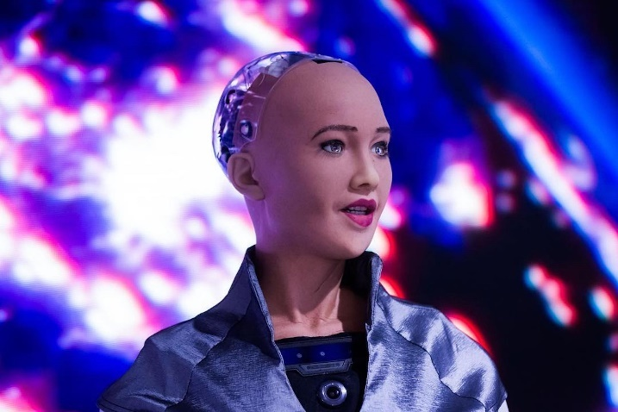However, Whilst Animatronics proved extremely versatile in providing a high plane of user experience/interaction, in the 1970’s the term “uncanny valley” would be coined to reflect some of the less successful components of animatronic systems.

Figure 2: Sophia the robot (Image Source: Wonderland Magazine)

The Term Uncanny valley originally came about in the 1970’s from Professor Masahiro Mori, who claimed the term to be an encapsulation of when there is a disparity between “between an object's appearance or motion and how people perceive the object”, according to Gee, F. C. et al (2005)’s paraphrasing.

Whilst the uncanny valley is apparent as something which is commonly referenced throughout animatronics, with regards robotics, and more specifically socially assistive robotics, the - incorporation of creating these platforms with a dynamic sense of interaction still proves difficult as can be evident with such systems as Sophia the robot, as seen in figure 2.

As incredible a feat in technology which the Sophia system has proven to be, in terms of human based expression, the uncanny valley’s effect can be particularly evident, in footage of interactions and operations.

Unfortunately, as a result two main conclusions can be made as a result of animatronics.

Firstly, High level emotive robotics is difficult to manage and process in an economical and feasible sense in order to suitably convey emotive, which would prove fundamentally lacklustre with regards the view of the project.

Secondly, success with regards the presentation of human interaction in some cases tends to improve successful experiences if the animatronic (or in this case Socially assistive robotics), is further removed from emotive preconceptions of established properties, but in fact attempts to generate a new perception as to a platform for emotive expression.

## 1.2 Project Aim

The Aim of this Project is to find and develop an intermediary Socially assistive robotics platform, one which strays away from issues which plague higher end emotive systems such as high costs of development and like the previously mentioned uncanny valley effect.

However, in contrary to other socially assistive robotics, the platform will not take a paediatric care-based route of a soft toy mimicking device which do not necessarily possess the level of emotive expression to suit abstracted emotional expression.

For the reasons explained above, the robot must maintain abstracted humanoid features as to be relatable but not to the point of an uncanny nature, furthermore the platform must look approachable for the purposes of user engagement, therefore the physical design must maintain a neutral and nonthreatening standpoint, but should also maintain a perspective of engagement which would not be dismissed by users who would fall outside the purview of paediatric care ,for the purposes of ensuring the platform be universally accessible to a degree without physical aesthetics being a hinderance.

Furthermore, withdrawing information from the premise of audio animatronics as described previously, the platform should maintain a method of “speech” as simple text-based means of communication and instruction would prove the project to not be suitably engaging enough to comprehend the potential success of an abstracted emotional socially assistive robotics platform.

The Project as a wholes further intention to fulfil an area of socially assistive robotics which is more accessible, should proceed to have a manageable and economic budget of development, in order to maintain reproducibility of potential future prototypes a conservative measure, and conscientious focus on resource and material requirement.

## 1.3 Disclaimer

Data Acquisition for this project is entirely anonymous and pertains to no personal information.

Considerations have been made at every stage during the project to eliminate any level of selection and personal data concerns as to improve the means and level of engagement.

For these reasons the project will not utilise computer vision over video and recording concerns, furthermore the entire process is simplified and streamlined to reduce all user input into a subjective numeric feedback value through a physical user interface designed for the express purpose being a simplified non data conscientious element.

## 1.4 Project Scope

With regards the project scope, the aim of the project is to produce an artefact capable of simulating a level of emotion and gaining information based on user input and subjective opinions of the robots attempts to express emotions on an abstracted level.

### 1.4.1 Objectives & Deliverables

In order to present a clarified project outline, the Moscow structure will be utilised to ensure and maintain project bounds.

The Moscow architecture consists of four main components, Must Have components, these areas are non-negotiable in terms of being completed, and in order for the project to succeed fundamentally, these must be accomplished.

The second layer to the Moscow architecture is the premise of should have components, these attributes are relatively important in the greater scheme of the project, however, should these outcomes not be delivered, the project can succeed to an extent.

The final level to included attributes under the Moscow architecture is components which would be considered a could have, these attributes are not required for the base functionality of the program, however including these attributes allows the project to excel in terms of functionality and develops towards the ambitions of future developmental works.

Besides what the Project will include the element of “won’t Have” is also included to provide designated boundaries towards the project, these attributes will be areas the project does not cover for one reason or another, they are not necessary or required for the purposes of the project.

|  |  |
| --- | --- |
| **MOSCOW Stage** | **Attributes** |
| Must have: | * A means of data entry. * Segmented programmable points of articulation. * Robust design for the purposes of user interaction. * A means of displaying or conveying information / instructions to many users, weather through a textual or audio basis * Approachable and human like recognisable design feature to create associative bond to attributes. |
| Should Have: | * Further point of articulation to potentially mimic eye contact with perspective users. * Audio based sound methodology for more engaging ports of interaction. * Data collection and storage means based on internal, non-personal data valuation to record and develop compiled information. * Programmable display methodologies to account for visual error handling and further emotive engagement * External processable means of integrating data from the device to ensure understanding and deductions to be concluded as a result. |
| Could Have: | * Bluetooth error checking and handling remotely as not to interfere with the data collection process by introducing influence. * Cooling systems and multiple voltage level handling for running multiple devices for the purposes of future modular compatibility. * Logic level shifting for further device integration. * Programmable and interfaceable audio for the purposes of future development of real time chatbot functionality. * Wi-fi integration as a posed to Bluetooth for longer distance bug catching and management of the deployed system during teasing. |
| Won’t Have: | * Mobile capabilities to maintain system integrity and manage security of the devices deployment without being a hazard to users. * Computer vision or advanced personal collection means in order to maintain universal consciousness over data storage and usage. |

Figure 3: MOSCOW Architecture Project Outline

In addition to the Moscow system functionality architecture, the following deliverables will also be required to be completed throughout the duration of the projects lifespan.

* Project proposal
* Project plan
* Gantt Chart Project Timeline
* Research into project methodologies
* Research into prior example cases of similar artefacts
* Research into indicative fields of emotional features
* Research suitable hardware
* Research into software
* Design and development of an artefact
* Deployment ad reflection of an artefact
* Conclusive analysis of findings and future improvements
* Meeting log
* Comprehensive Project Presentation

## 1.5 Project Plan

Considering the given project timeline, and external requirements of the project, the following timeline as seen in Appendix [C] was devised to provide a measure of progress and stages of the project’s development.

For further information with regards progress updates and reports, a meeting log can be found in Appendix [B].

# Chapter 2: Project Research

This section of the documentation will highlight the investigated areas, for which had been studied and evaluated for the purposes of this project, highlighting project methodologies, past and current socially assistive robotic technologies, indicative markers of human emotion, and respective hardware and software considerations to be utilised throughout the course of the project.

## 2.1 Prior Research

Considering the project in its whole, several key foundational areas of expertise need to be developed in order to intuitively reflect and develop the projects approach.

Discussion of the suitability and successes of prior examples of socially assistive robotics (SARs), hardware and system requirements, and design mentality in order to dictate the design and architecture of the artefact.

### 2.1.1 Methodology Approach

In order to effectively analyse and conclude on subject areas pertaining to the project, management methodologies are a key component into the maintenance and consistency of a project in all aspects.

#### A diagram of a waterfall diagram Description automatically generated with low confidence2.1.1.1 Waterfall

Figure 4: Waterfall methodology diagram (Image Source: Lucid Chart)

The waterfall methodology idealises a sequential development type emphasising on primary research beforehand into the respective time allocation to complete tasks in an orderly manner.

According to (Adenowo, Adetokunbo A. A. and Basirat A. Adenowo.2013), waterfall model uses linear approach and is only suitable for sequential or procedural design.

However, in the same resource, it is highlighted that in waterfall, errors can only be detected at the end of the entire process, and it may be difficult going back to repeat the entire process because the processes are sequential.

As a result of a linear process allowance for reconsideration and evaluation is not necessarily best suited for rapid prototyping design cycles and development offering an unnecessary level of complication and strictness to the structured development.

#### Applying the Agile Methodology to the Modern Workplace - Mobile Jon's Blog2.1.1.2 Agile

Figure 5: Agile Methodology diagram (Image Source: mobile-jon.com)

(Abrahamsson, P. et al. 2017) refers to the agile methodology as not having a clear definitive design system, however in reference to a source (miller. 2001) agile tends towards 9 key aspects as follows:

|  |  |
| --- | --- |
| 1. | Modularity on development process level |
| 2. | Iterative with short cycles enabling fast verifications and corrections |
| 3. | Time-bound with iteration cycles from one to six weeks |
| 4. | Parsimony in development process removes all unnecessary activities |
| 5. | Adaptive with possible emergent new risks |
| 6. | Incremental process approach that allows functioning application building in small steps |
| 7. | Convergent (and incremental) approach minimizes the risks |
| 8. | People-oriented, i.e., agile processes favour people over processes and technology |
| 9. | Collaborative and communicative working style |

Figure 6: Agile Methodology Stages

#### Scrum and Agile Software Development, Know the Difference2.1.1.3 Scrum

Figure 7: Scrum Methodology (Image Source: programmingwithbasics.com)

Scrum as a methodology is found to be somewhat derivative of the concepts found within systems, mostly associated within that of the agile approach.

However, features a variable rate of developmental loops and cycles with a non-essential linear structure allowing for allocation and reconsiderations within a development cycle should it be needed.

(Sachdeva, Sakshi. 2016) covers the essential basics of the system, highlighting the importance of Scrum’s attempts to build the work in short iterations where each iteration consists of short time boxes. Offering flexibility in research-based projects with a certain level of unpredictability and volatility creates for a more developer friendly system also functional within group mentalities should the method be required.

#### 2.1.1.4 Evaluated methodology.

In evaluating the appropriate methodology for the project, in comparison to typical software development timelines and integration, due to the system being entirely custom the design and development of hardware and software maintain a nearly simultaneous pace of progress,

somewhat dependent on the linear development of both components until the next developmental stage can be reached and progressed onto.

|  |  |  |
| --- | --- | --- |
| Methodology | Positive Attributes | Negative Attributes |
| Waterfall | Represents a segmented linear developmental process suited to the level of conditional design the project requires. | Due to the linear non iterative design concept, strict accordance to this methodology would result in the lack of revisiting areas of the project. |
| Agile | The iterative loop-based architecture allows for developmental insight as to where issues may have occurred in a previous cycle and develop upon that fact in the next portion. | By having a strict loop architecture, longer prototype development cycles where the test and developmental phases may take several subsections are not necessarily accounted for resulting in a problematic fit for some projects. |
| Scrum | The methodology allows for the consideration of iterative design sprints, and in some cases sprints within sprints which conceptually allow for each stage of the design iteration to be tested multiple times till the result suits a standard which is suitable or the next development stage. | As a result of the incorporation of sprints, the method requires inclusion of strict planning and scheduling, to which in a prototype phase design is not as easy to plan for in advance due to multiple potential points of failure. |

Figure 8: Proposed Methodology Analysis

Waterfall offers a Potentially a good project fit, however in order to make the methodology feasible, some deviation must be allowed to revisit components and stages based on their performance and viability.

Agile, demonstrates the iterative development stages with reflection, manages to compensate for the linear conceptualisation of the waterfall method, however, lacks the appropriateness for longer development stretches where required.

The scrum method has the potential in some circumstances to prove a suited method, however given the temperamental nature of physical artefact development in comparison to that of typical project or software development.

Considering these and further potential methodologies, in order for the most suitable and comprehensive development process, the use of a lucid based waterfall methodology would prove the most beneficial on the basis of being able to progress though a linear cycle, however the standard of constant onwards progression of the system may have to be resolved in some instances to account for “prototyping hiccups”.

### 2.1.2 Reflection of previous SARs

Socially assistive robotics, whilst something of an emerging and developing field in terms of direct human interaction in contrast to the level of interaction which is offered through different forms, such as that as the previously discussed animatronics, there are still some testing applications in development and being tested utilising differing approaches to the concept.

#### 2.1.2.1 Chiron

Chiron represents something of a niche within the field of SARs mainly due to its internet of things (IOT) integration allowing multiple systems to work together in order to provide a seemingly seamless experience for a user.

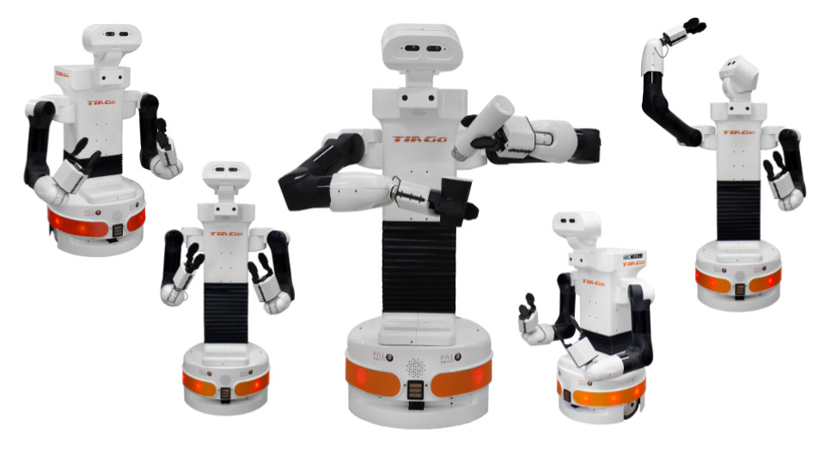The issue presented with this platform is that while it does prove the usefulness of a networked system, it has no singular presence, and the proposed systems while capable of being helpful in a traditional sense, do not extend to a psychological bond between user and system.

Figure 9: Chiron, robotics platform (Image Source: https://chiron.website/)

#### 2.1.2.2 Huggable

Huggable as mentioned by (Stiehl, Walter Dan et al. 2006) is a new type of robotic companion being designed specifically for such cases. It features a full body “sensitive skin” for relational affective touch, silent, muscle-like, voice coil actuators, an embedded PC with data collection and networking capabilities.

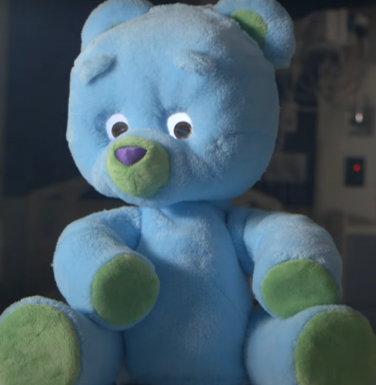The system started to develop a fully integrated system allowing for closer interactions with users, however while offering great receptive abilities, relay and reaction to environmental and user characteristics were limited offering some hindrance to the devices development.

Figure 10: Huggable Robot (Image Source: <https://youtu.be/QwTCmbq9C4o> (New York Times))

#### 2.1.2.3 Tega

Presented by MIT Tega, represents a field of socially assistive robotics for children, the system is focusing on using expressive interaction in order to portray a peer or mentor to a proposed user.

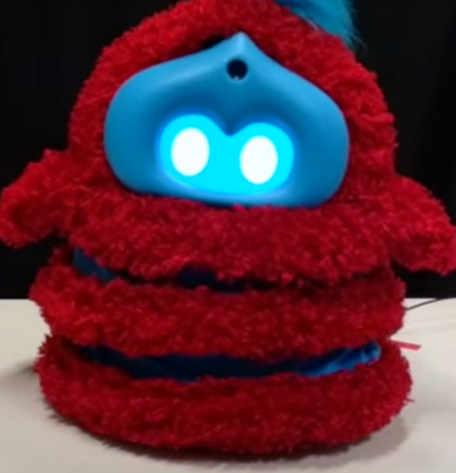The system mainly uses bodily emotive technologies as part of MIT’s “Squash and stretch style robots” which offers a new insight to the possibilities with emotive expression in relation to the effectiveness of engaging with robots in a social scenario.

Figure 11: MIT Tega (Image Source: <https://youtu.be/sF0tRCqvyT0> (Personal Robotics Group))

#### 2.1.2.4 Pleo

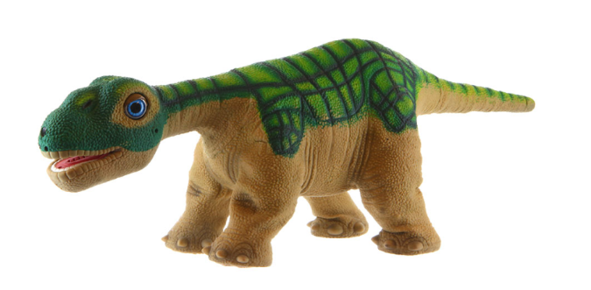Pleo focuses on a younger audience as a platform generating interaction though dance with its perspective user.

Figure 12: Pleo interactive robot (Image Source: https://robots.ieee.org/robots/pleo/)

(Curtis, Aaron et al. 2011), highlights the methods in which the robot conveys with users through physical motion and haptic feedback in a lower cost item, however considering the platforms abstract appearance nature, for more developmental psychological analysis of interaction, based on conceptual body image techniques.

This project while impressive in its engineering and capable functionality, also presents the degree of suitability and appropriateness in relation to the users’ requirements, while the dinosaur-based aesthetics create a suitable sense of interaction with an infantile audience, however, would not propose a suitable interaction with adults requiring more conservational therapy treatment.

#### 2.1.2.5 Nao

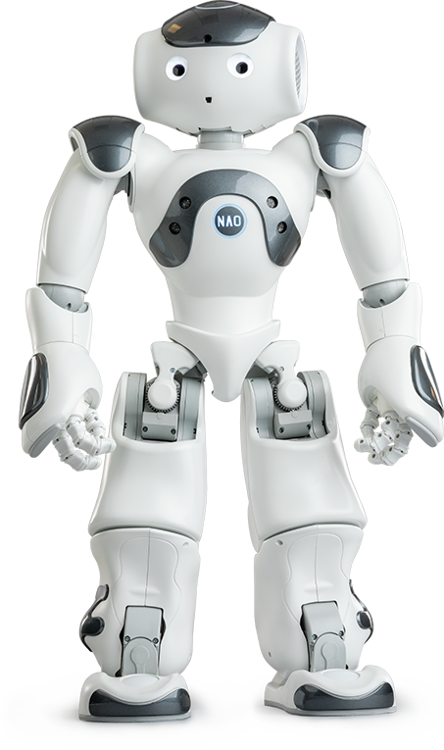The Nao robot presents a more direct humanoid structure to the user, however, does not offer the specification in software, as Nao is the base platform which offers the opportunity for developers to use however, they best see fit .

Figure 13:Nao Robot Platform (Image Source: http://us.softbankrobotics.com/nao)

In a study by (Vital, Jessica P. M. et al. 2018) attempted to demonstrate the domestic uses of the platform, in particular rehabilitation purposes and treatment of autism, which demonstrates the platforms opportunity for featuring as an SAR.

On the other hand, due to the platform not being quite specific it offers a complicated balance of having features which are not required, and also a lack of required features.

#### 2.1.2.6 Paro

As an interesting alternative to traditional therapy based social interaction, the Paro robot is focused on therapeutic treatment of those suffering with dementia.

A study done by (Hung, Lillian et al. 2019), compared feedback to exposure in ten scenarios of the Paro robot, with patients suffering from dementia. The study found that the majority of those interacting with the system found a degree of relief and “happiness” without necessarily interacting with the robot directly, but simply due to the presence of the system within the scenario, demonstrating an area that physical and practical deign represents a large area of the interactable ability of the robotics platform, and that the software operations offers a level of prolonged appeal to continue interacting with the platform, demonstrating the importance of 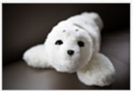continuing an interaction series for more effective user engagement.

Figure 14: Paro, Robotics Seal (Image Source: http://www.parorobots.com/)

### 2.1.3 Psychological Factors Related to Expression

When considering the psychological process behind emotional interaction, due to a lack of being able to comprehend internal neural signals, the recognition of emotions, tends to be left to common emotional markers, as reference to associated emotion, generationally, humans have grown to be able to comprehend such minute gestures, more often than not without thinking about it, however trying to comprehend and synthesise such an analysis to a repeatable process, is not quite as simple.

#### 2.1.3.1 Limiting Factors

Emotive expression is considered to be one of the largest physical indicators as a means of subtextual communication, however understanding and gaining a comprehension of emotive states is a complex task developed throughout lifetimes and often varies in presentation from person to person, therefore developing an aura of complexity surrounding the development and fundamental understanding in a psychological setting.

Not only is the issue surrounded with complexity to understand, however there is often mental health complications which can result in reduced cognitive function within the ability of emotive expression, as outlined by (Blair RJ, 2003) those who suffer from Autism, psychopathy, and acquired sociopathy.

Such conditions lead to break downs in social relationships and may lead to isolation-based experiences.

#### 2.1.3.2 Facial emotive markers and associated relevancy

During a fundamental study by (Bassili JN. 1979) an experiment conducted featured an array of markers placed on a subject’s face and then using the points to measure variation between expressive ranges.

The study developed key factors of relation marking the upper and lower section of facial movements. The paper while literature while considered an older piece of experimentation, is referred to by (Gonsiorowski A. 2016) stating that the validity of the study indicated the foundational knowledge gathered, while also highlighting the relevancy of a more adaptive study.

Creating a two-part divide in facial analysis allows focus for separate studies, based on these conceptual attributes, for the purpose of this study, focus will be placed upon the upper portion of expression to attempt analytical study of the effects of contact, or perhaps the lack of contact, and its resultant impact on prospective users.

(Rychlowska, Magdalena et al. 2012) discusses the concept of emotional impact and significance of eye contact within expressional reception, referring to three key studies consisting of exposure testing and reception of emotive states. The study also further elaborates on the further implications of using the interaction model for development of a machine-based interactions.

### 2.1.4 User characteristics, behaviour, and requirements

When considering a system with a fundamental function to be used and tested for the purposes of interactions, a number of considerations must be made for the system to be fit for use, even during a prototype research phase.

#### 2.1.4.1 User characteristics

User characteristics tend to refer to the natural habits and methods users typically interact with given systems , often studied within context of system design, creates for an understanding of generating a system which can cater closer to requirements and increase overall system efficiency.

A study developed by (Song, Tae Houn et al. 2007) focused on the relevancy of different hardware interfaces on a scale of convince, providing a useful scale of accessibility in catering for user characteristics in conjunction with multiple system designs.

#### 2.1.4.2 User requirements

Socially assistive robotics creates a new range of potential definitions of user requirements within the field of robotics. Due to the close proximity of operation and influence of users and the related feedback, requirements have to be extremely specific in order to operate as efficiently as intended.

(Schneider, Sebastian et al. 2017) highlights a hypothetical framework consisting by proposing a three-layered architecture for rapid prototyping of SAR systems as proposed by (C. Jayawardena, I. -H. Kuo, E. Broadbent, and B. A. MacDonald, 2016)

### 2.1.5 Summary of prior research

From the review of studies and projects, some key factors are noticeable, and would prove to be helpful point of development for this project.

With regards the contents of past/current similar projects, a general disparity was found in the lack of convention in the methods of which emotions are recognised and portrayed.

Whilst most projects operate on the basis of displays or simple movement, most tend to occupy a form which is not remotely recognisable as human elements, and some projects choosing a purely animalistic route, in the project’s interactive aesthetics.

Whilst utilising an entirely human removed approach in terms of a produced artefact, is a perfectly valid approach, within the context of mental health treatment, and diagnosis, however, it proves difficult to develop more practical and varied interactions without relatability and understanding of emotional capacities.

Whilst some of the discussed systems do utilise a humanoid based aesthetic, this is purely just in form factor, only using a face or head like design for the purposes of mounting sensory inputs, rather than a means to display emotive capabilities to engage with users, therefore for the contextual progression of the project, focus will be placed on creating a somewhat humanoid feature based robot, utilising the premise of displaying suitable ranges of emotions in order to provoke engagement.

## 2.2 Developmental Research

Based on prior contextual foundations of other works of socially assistive robotics, and the proposed project scope, a number of key elements are required for the purposes of development.

Mainly two areas can be derived, focusing on conceptual basis of hardware and software.

Unlike typical Programmatic based projects, this developmental process represents a co-dependency between the two elements to maximise program functionality.

### 2.2.1 Hardware Research

Whilst considering the projects development a few key factors determined the properties of how the system must operate.

Primary considerations were given to the embedded microcontroller the system will operate from, the controller had to have a suitable amount of I/O connectivity for the purposes of interfacing and programming individual artefact components.

#### 2.2.1.1 Micro Controllers

Micro controllers are typically considered to be lower end computational devices utilised most frequently in embedded systems, this tends towards self-contained subsystems in a greater system, for example, an ECU unit in a vehicle which is a form of controller designated to one system or another.

Within the project scope, an embedded solution would allow for the reduction of convoluted higher level developed program and allow for focus on pure device integration and data manipulation and storage, however, it is worth providing consideration to the concept of future development, and how the current system could be capable of interfacing of future higher-level controllers.

#### A close-up of a computer chip Description automatically generated with low confidenceRaspberry Pi

Figure 15: Raspberry Pi 4B I/O Diagram (Image Source: www.raspberrypi.com)

Raspberry pi’s are considered a single board computer housing most of the integral required components of a system architecture in a board of small form factor, of which technical specifications can be found in appendix [F]

The system can be programmed through python-based means, however due to advanced development of the architecture, the device is capable of running a reduced Linux OS called Raspbian.

Whilst the level of wireless interconnectivity of a raspberry pi cannot be understated the platform generates a couple main issues.

The physical I/O of the device is relatively limited considering the means and production to expand the platform, this issue could potentially be solved by the functionality of clustering the devices to create a system of greater physical I/O connectivity for the purposes of the project, however this then represents further issues.

The Raspberry pi system has become a highly desirable architecture for the purposes of clustered computing power, this fact combined with the supply and demand issues of chip shortages, has subsequently resulted in an astronomical price inflation which considering that one of the projects objectives is to maintain a financially viable prototyped solution, the resultant price rise reduces the suitability of the solution.

#### Teensy Controllers

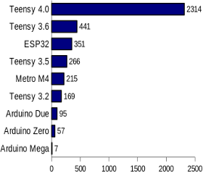The Teensy Microcontroller systems are considered to be high-end embedded system controllers, boasting significant performance increases over that of comparable Arduino devices.

Figure 16: Teensy Performance Quantification (Image Source: www.pjrc.com)

The devices whilst developed through a third party to Arduino, occupy and have the capability of utilising essentially the framework in terms of programming and interfacing.

interfacing with some devices However, most noticeably, the teensy controllers tend towards operating on 3.3 volts of logic, meaning that signals of high and low, indicative of waves or binary in essence, has a maximum output of 3.3V which indicates that may be more difficult to convert to typical 5v logic systems which most devices conform to.

#### A picture containing electronics, electronic component, circuit component, passive circuit component Description automatically generatedTeensy 3.0 & 3.1

Figure 17: Teensy 3.x Device (Image source: www.pjrc.com)

Teensy 3.0 and by association Teensy 3.1 controllers are the companies last generation device, in comparison to Arduino devices at a comparable price point, the available processing capabilities are vastly superior, however subsequent I/O connectivity is not available or as scalable as the project would necessarily require.

Furthermore, since the start of this project, PJRC the creator and main distributor of the platform, have deemed the platform to not be recommended for future or continued development on systems, designating the platform to a legacy system.

#### A picture containing electronics, circuit, electronic component, circuit component Description automatically generatedTeensy 4.0 & 4.1

Figure 18: Teensy 4.x Device (Image Source: www.pjrc.com)

Teensy 4.0 and onward devices have vastly improved onboard processing, I/O capabilities, and direct onboard SPI bus integration for the purposes of onboard SD card memory storage, elaborated further in appendix [G]

However subsequently as a result of being a Teensy device, the board operates on the basis of 3.3v logic thus making its compatibility with most typical integrated devices more difficult wither requiring a 3.3-to-5-volt logic conversion system or specific devices which operate on the basis of 3.3v which are harder to source and maintain a reasonable financial expenditure for the course of the project.

#### Arduino Controllers

Arduino Microcontrollers are a line of systems designed for smaller sub industrial scale projects, however as a controller represent a highly versatile platform, for the purposes of rapid prototype development and deployment.

The Arduino platform refers to a number of devices all unified by a software package of the same name, the software prides itself of rapid development and accessibility, as well as being able to manage devices for scalable project bases.

For example, the Arduino nano and micro are smaller form factor microcontroller designed for relatively lightweight project design, where minimal amounts of I/O are required for the task at hand.

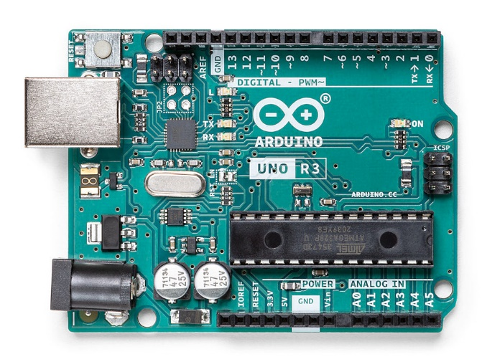Should a projects scope increase beyond lightweight prototyping and require additional I/O capability, the Arduino uno platform offers a greater amount of I.O capabilities and multiple serial channels which allows for a further means of communication and SPI bus functionality for the purposes of volumetric data transmission, for which technical specifications can be found in appendix [H]

Figure 19: Arduino Uno Micro Controller (Image Source: www.arduino.cc)

Finally, among some of the larger scale platforms, the Mega line offers arguably the most versatility in rapid embedded system development.

#### A close-up of a microchip Description automatically generatedArduino Mega Family

Figure 20: AT Mega2560 Micro Controller Chip (Image Source: www.microchip.com)

The Arduino Mega associated family maintain one universal component, that being the main processor, The AT Mega 2560, the processor is relatively low power in comparison to similar embedded platform, however for the project scope, the capabilities suit the desired quota.

#### A000067 iso bothBase Arduino Mega

Figure 21: Arduino Mega Micro Controller (Image Source: www.arduino.cc)

The Arduino Mega Controller is an integrated platform with Significant I/O capabilities, with both analogue, digital, PWM , SPI, Serial, and II2C methods of connectivity, all of which would prove extremely functional and beneficial towards the projects aims.

Furthermore, by having not only the onboard 7-12V power supply input and direct ethernet interfacing for IDE interaction and access to a debug monitor for developmental purposes, further elaborated in appendix [I]

#### A picture containing electronic engineering, electronics, circuit, electronic component Description automatically generatedKey Studio Arduino Mega

Figure 22: Key studio Mega Micro Controller (Image Sourced: wiki.keyestudio.com.)

The Key Studio Mega Micro Controller is heavily inspired from the base Arduino Mega with a few quality-of-life improvements to aid in the overall utility and flexibility of the device.

Initially the direct ethernet interface has been substituted for a more suitable USB-C port, which makes the device more accessible and increasingly easily powered for the sole reason the connectors footprint is minimal compared to that of ethernet, therefore, improving cable routing means.

Furthermore, the Key Studio rendition of the Mega has accounted for redirection of a managed power supply mainframe and I/O connectivity to the centre of the board which allows for direct interfacing of servo motors and similar connected systems and devices, without more over thinking of the power harness requirements, only requiring offloading in the event of voltage specific devices, or devices which exceed the 5v power consumption levels as required.

Considering the improved accessibility of the board, and the need for potential future expansion the Key Studio system offers a desired level of processing functionality, sufficient physical I/O connectivity, and the means of an affordable platform to maintain a reasonable financial expenditure.

#### 2.2.1.2 Actuation Methods

Upon review, in order to effectively articulate and generate expression, a means of physical actuation will be required for the purposes of moving and programming the position of components, furthermore, considering the projects scale and finances, the technology has to be reliable and maintain a relative affordability, and ideally a reproducible operation and modularity which would allow for substitution of parts and actuators should a failure occur.

#### Servo Motors

Servo motors are a relatively common means of simple controlled and programmable movements within systems, furthermore the devices are available in a scalable and modular formats, allowing for easy substitution of devices based on performance and operational wear.

#### SG90 Micro ServoSG 90 Micro Servos

Figure 23: SG 90 Micro Servo (Image Source: sg.cytron.io)

SG 90 Servos are a light-weight servo designed commonly utilised within radio-controlled flight systems due to their versatility and programmability.

Servo Motor functionality consists of two main electronic segments, the first of which being a small-scale motor for the initial drive, and an internal potentiometer, through a combination of measuring the potentiometers rotation in comparison to the motors drive on the potentiometer, the position of the gearing can be approximated and used to generate positional references for the purposes of reproducible results.

Unfortunately, the SG 90 servo is prone to a significant flaw of the gearing assemblies being nearly entirely plastic or nylon based, and as a result the tortional capabilities of the system is greatly reduced by the fact the gears will shred under significant load, requiring a gearbox rebuild which is time consuming and uneconomical.

#### MG 90S Micro Servos

Figure 24: MG 90S Micro Servo (Image Source: components101.com)

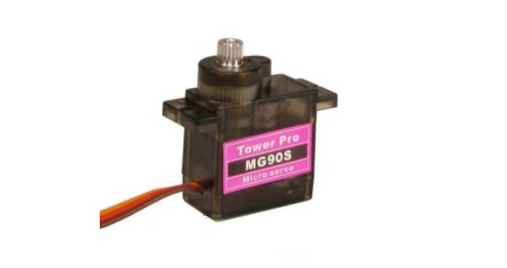MG 90S Servos maintain the same overall footprint and form factor as to that of the SG90 Servo, however one main difference is the substitution of the plastic/nylon gearbox for a full metal assembly which is significantly more capable in terms of tortional output, in comparison to the SG90 solution.

However, it is important to consider that as a result instead of the gear assembly shearing, the amperes of the system will continue to increase in an attempt to meet the programs command which could potentially result in further electrical motor damage.

#### Stepper Motors

Stepper motors are High Torque, Low Speed motors designed for reliable and repetitive programmable functionality on the basis of programmable electromagnets.

The Motors typically have 4 – 6 electromagnetic coils which once activated in a sequence creates a pulse with capabilities of lower speeds than that of a servo motor, however much high tortional output, which in practise is suitable for reliable movement of larger components, with reduced strain on gearing assemblies, and the strain placed on the motor.

#### 28BYJ-48 Stepper Motor-5V | Makerfabs28BYJ-48 Stepper Motor

Figure 25: 28BYJ-48 Stepper Motor (Image Source: www.makerfabs.com)

The 28BYJ-48 stepper is a standard relatively lightweight stepper motor construction, the system is capable of a decently high level of torque output which either in combination with other motors of the same type, or on smaller project applications, proves to be useful consideration, however considering the scale and potential for the projects scope to expand and develop further the concept of the platform, using a lower powered motor would limit the additional functionality which could be added.

#### 微信截图_2016012815292442BYGH Stepper Motor

Figure 26: 42 BYGH Stepper Motor (Image Source: docs.makeblock.com)

The 42BYGH stepper motor is a higher-powered substitute to the previous motor, consisting of 6 coils with programmability to switch between higher torque functionality or higher speeds, the system does however unlike the previous motor operate on higher voltage levels, in this circumstance, 12 volts upwards, which then requires additional consideration to the overall power supply design and system architecture, in order for the motor to be able to operate in its intended manor.

#### ULN2003 Four-phase Five-wire Driver Board Electroincs Stepper Motor ...Stepper Motor Driver Boards

Figure 27: L298N Stepper Motor Drive Board (Image Source: www.makerfabs.com)

Figure 28: Stepper Motor Drive Board (Image Source: alexnld.com)

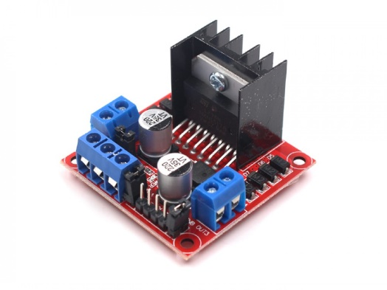Stepper Motors largely cannot directly interface to most microcontrollers, as a result the motors tend to make use of an intermediary controller called a driver board, in essence the board is responsible for taking in binary programmable sequences and allocate the input accordingly to control the motors drive.

Figure 28, is representative of a lower end stepper motor board, managing 5 volts and minimal logical conversions, however, Figure 27 highlights a L298N driver board, this board is rated to a higher voltage level, and is capable of running either to DC motors in parallel, or a 4-bit encoded stepper motor.

#### Linear Actuators

Linear actuators operate on the basis of transferring motor drive to a linear basis for the extension or in extension of components in an assembly.

Operating on a similar electronic basis to the micro servo utilising a motor with a method of potentiometer to measure positional references.

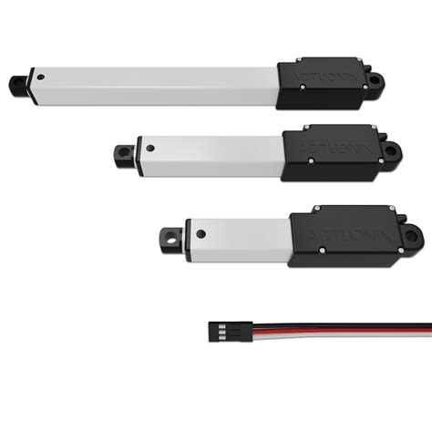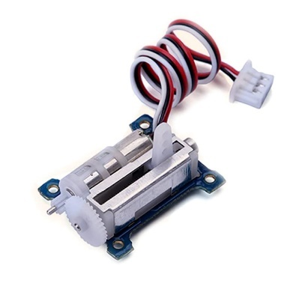In comparison to more standard servo design, the linear servo design could be argued to be a more streamlined method of generating movement, without exceptional design modifications, due to the fact the linear servos motion is more predictable due to the embedded extensive design.

Figure 29: Selection of Linear Actuators (Image Source: www.actuonix.com)

Figure 30: Linear Servo (Image Source: : alexnld.com)

Consequently, of the unique and lesser used format of electronic actuators, they take two main forms of production quality, either taking an approach of a lower quality exposed unit as seen in figure 29, which utilises nylon components which are prone to breakage under significant strain.

Alternatively, figure 30 highlights self-contained linear actuator units, however as a result the controllers are significantly higher retail costings, which unfortunately fall outside the financial purview of the project.

#### Scientists Developing Self-Healing Soft Robot That Can 'Feel' Pain ...Hydraulic Soft Body Robotics

Figure 31: Soft Body Robotics Grip Component (Image Source: thenewstack.io)

Soft Body robotics is a relatively newly emerging sector in which the utilisation of material science allows for either a method of robotic actuation through a compliant mechanism fundamental process of relying on material flexibility in order to fold or bend in such a way to execute a mechanical motion, alternatively through the use of either Hydraulic or pneumatic valves which once pressurised actuate a mechanical motion.

Unfortunately, in order to construct a soft body robotic mechanical system, there is a high specialised level of engineering required which is beyond the physical resource access and budgetary availability of the project, as well as representing a high failure rate due to the strain that pressurised systems withhold.

#### 2.2.1.3 Integrated Sound System

Deployment of embedded sound systems can prove difficult due to provide in a system whilst maintaining a degree of quality and system performance.

The issue presented with sound systems on a typical basis, is that in order to schedule and maintain a repeatable and synchronised performance, the processing capabilities of the main controller needs to be capable of multi-threading for the purposes of maintaining continuity, unfortunately while this is becoming a more featured attribute of micro controllers, within the projects budgetary scope, it would not prove a feasible solution to the issue at hand.   
Alternatively, in order to offload the processing requirements, the best presentable option in reference to cost and functionality would be a secondary processing board, which is communicated to as a daughter board, allowing for the simultaneous playing of audio on one device, whilst the main mother board is capable of the remaining system functionality.

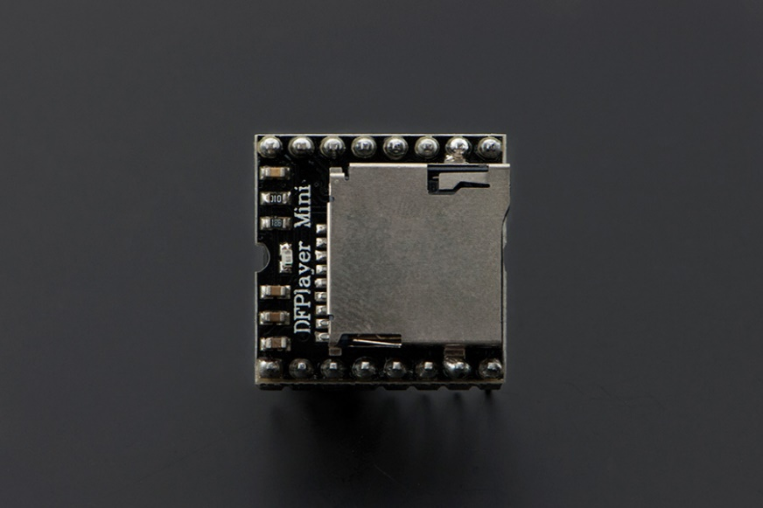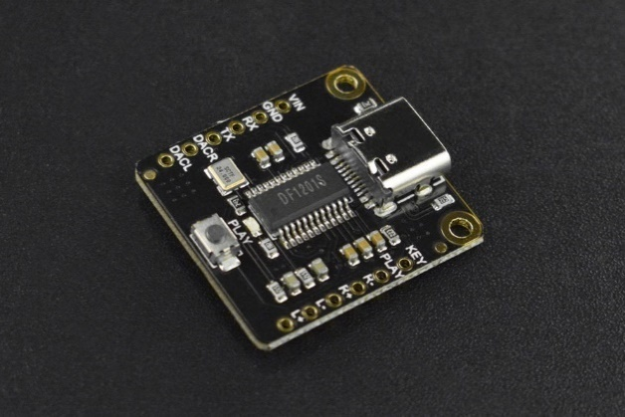Considering the secondary approach as the most viable method of sound integration for the project, two main hardware solutions are available to accomplish this task.

Figure 32: DFPlayer Mini (Image Source: [www.dfrobot.com](http://www.dfrobot.com))

Figure 33: DFPlayer Pro (Image Source: www.dfrobot.com)

The DfPlayer Mp3 module line offers an impressive amount of versatility in terms of audio control and manipulation all within a realtively compact and reformed form factor.

Figure 32 highlights what could be argued as the Base Model DFPlayer system, it posesses a range of versatility, which could prove integral to the project on a fundamental basis.

The controller is capable of utilising serial transmission to and from a mother board to the player, in which parameters such as volume, designated file to play, and amplitudes can be configured.

However Upon Comparing Figure 37, To that of the Figure 33, the DFPlayer Pro, three main advances can be noted, initially the inclusion of an onboard micro switch allows for independent device testing without external motherboard programming dependancies being required.

Secondly, the Inclusion of a USB-C integration allows for the DFPlayer Pro to be utilised further as its configuration once connected to a device, can be substituted as a usb enabled sound card for a computer. As a result of of this additional functionality, this would allow for the potential integration of externally synthesised dynamic speech for improved situational awareness and interaction, alternatively, under the contextual usage of the medical sector, in events of patients who may be immuno suppressed, and as such may have limited social interactions leading to an isolatory experience, the card would allow for call/chat integration, utilising the emotive display functionality inorder to reduce isolatory conditions in such a circumstance.

Finally, the DFPlayer Pro maintains, 128 megabytes of onbaord integrate strorage, incomparison to the DFPlayer which resuires a formatted sd card, whilst the sd card integration would allow for the expansion of recorded phrasing, which would improve capabilities for future development and expanision, however in comparison to having USB soundcard integration, full offloaded synthesis would prove the more benificial choice in the duration of the project.

#### 2.2.1.4 Sensory I/O Devices

In order for the system to be able to acknowledge it environment and react in an appropriate manor, the requirement of the system sensory input methods would be required.

Considerations were initially made for a computer vision-based tracking and recognition system; however this approach introduces a number of hurdles, in particular with regards ethical recording concern, and presents issues of integration within an embedded system, due to the low level of available computing capabilities, the level of onboard computing required to operate a low end vision system is not accessible within the current project scope, however should this approach be considered in the future, computing at the edge styles of architecture would be a recommended.

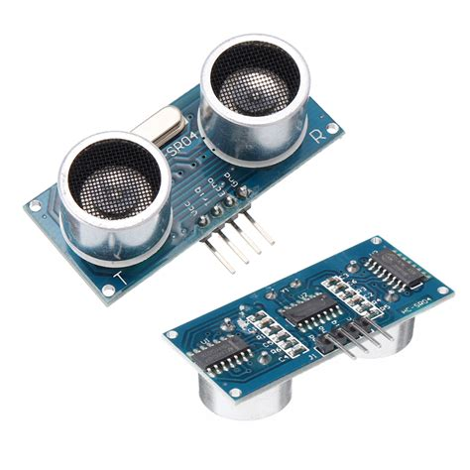As a result of the elimination of computer vision based sensory information, the option of an ultrasonic system, seems to prove the lowest resource intensive solution.

Figure 34: HC-SR04 Ultrasonic Sensor (Image Source: alexnld.com)

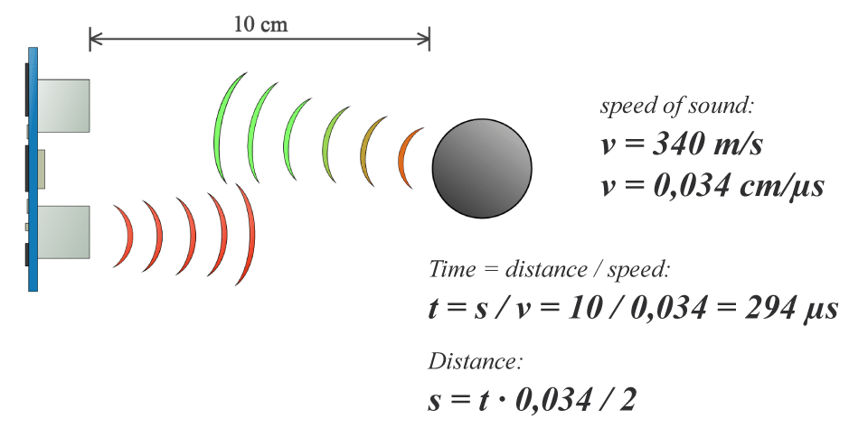HC-SR04 Ultrasonic sensors have a relatively wide usage within embedded systems, due to the operational premise being simple, a low power consumption device, making the long-term deployment on systems, furthermore the sensors are relatively affordable, and maintain a high level of accuracy to around the 10-meter range, with minimal deflection beyond that range.

Figure 35, highlights the methodology of which ultrasonic sensors use a similar method to that of bats using the process of echolocation, utilising the combination of high frequency tones to project onto objects / obstacles, then waiting for a reflected response, using the duration of the time it takes for the projected wave to be received to calculate the approximate distance to an object.

Figure 35: Ultrasonic Sensor Functionality (Image Source: howtomechatronics.com)

Whilst the method is extremely useful and has proven useful in the authors past projects (Lawson, W. 2019), utilising these sensors for the purposes of environment acknowledgement and recognition.

However as discussed in the project, two main issues are present within the ultrasonic sensing method, first of all, extremely porous or permeable surfaces may not be recognised or reflected as intended, causing an error in obstacle recognition. Furthermore a secondary issue which is prevalent in within ultrasonic sensor system, is as a result of multiple sensors within a system, the potential for the ultrasonic waves to collide and result in either false or no readings, therefore any concept utilising multiple of these sensors, should design as to avoid these conditions.

#### 2.2.1.5 Production Methods and Construction

Considering the projects relatively unique architecture and design requirements, the physical artefact will need custom developed components, as a result, 3d printing will be heavily employed through the development of the project.

3D printing is considered as one method of "additive manufacturing" which contrary to most mediums such as milling and CNC machines, rather than material being removed to generate a structure, the component is actually formed through adhesion and the addition of material to the work area.

This technology has become relatively well commercialised and widely available, it has also taken a variety of differing formats and capabilities as such, however the two main mediums the project will be concerned with are SLA and FDM.

FDM represent the typical form of molten plastic-based substances being manipulated and formed via specialised scripting called g-code, generated in an external program called a slicer, this method of 3D printing, whilst being a perceived majority of current available 3D printing, was not the first method of which the premise of a 3D printer was made.

The first 3D printer was made in 1981 by Dr Hideo Kodama and took the method of making an SLA 3D printer, a printer with the basis of using a "vat" of material typically resin, placed on a display, which similar to a slicer displays the individual layers of a model and hardens the resin to generate the layers on an upside-down print surface, the axis then moves upwards then hardens another layer.

SLA and FDM while fundamentally a similar concept, as a result offer hugely different benefits and consequences as a result of their differences.

Typical issues found with SLA is that due to the resin used in the printers being UV sensitive, they require containment to prevent undesired defect in the printed component, furthermore the vat capacity tends to be relatively minimal requiring a level of intervention ,and unlike FDM, it is not necessarily apparent when there is a lacking source material, Further tribulations of the SLA process it the clean-up process required after the production of the part, due to residual resin remaining on the surface of the part, the component requires a Isopropyl alcohol cleaning (or similar substitute), followed by further cleaning, and a curing process, as a result even though the print time of resin 3d printers on a quality basis tends to be a faster process than FDM, the finishing of an item takes much longer.

However, as a result of the use of curable resin, the resolution of the print tends to provide much higher accuracy and resolution to the designed component, in comparison to FDM, meaning that for extremely high detail structures which require either high precision, or a high measure of surface detail, this method tends to pose the most suitable option.

On the other hand, FDM as a 3d printing method offers a arguably more appropriate rapid prototyping medium, due to the reduction In post print maintenance, and the greater range of usable materials, FDM does arguably prove to be the more suitable method, also related to my personal 5 years of experience with regards FDM 3D printing, optimising and streamlining the FDM production process, proves easier and more reliable for the duration of this projects rapid prototyping method.

Typically, FDM utilises a material known as PLA (poly lactic acid) a very versatile starch-based plastic, however due to the significant heating of the plastic during the printing process, it has been found to release potentially harmful particulates, which raises moderate concern over the safety of being in close proximity to the printer while in operation, therefore a contained environment is recommended, (unless you live life on the edge, like the author).

Alternatively FDM can use materials such as ABS, an oil-based plastic with high strength, but proves to have a high contraction therefore difficult to print, TPU, a flexible material allowing for more creative ways and further use cases of 3D printed parts, however due to elasticity proves difficult due to getting "chewed up" within the feeding gears of the 3D printer, and even materials to the extent of carbon fibre can be printed with due to using a base plastic infused with carbon fibre, however due to the abrasiveness of the infusion can result in damage to the nozzle, should the nozzle not be of suitable tempering to endure the material.

Overall, both methods offer great versatility in terms of what can be produced within a rapid time frame, for the development cycle, for the project, however the capabilities and familiarity with not only using, but designing to FDM 3D printer parameters and requirements will most likely prove to be the most prevalently used element within this project.

### 2.2.2 Software Research

Given the project scope, the developmental process, a number of software packages and platforms will be required in order to achieve the desired project objectives.

Furthermore, considering that this project is not purely a software artefact, software in terms of producing, designing and conceptualising artefact components, this will most likely be a form of CAD package.

Further consideration should be given to that of programming microcontrollers typically require specific software, which will require selection based on microcontroller selected, and preferred programming environment.

#### 2.2.2.1 Design Software

Auto Desk 123D, is not exactly a typical program which would be discussed in development, mainly due to the fact that the software was discontinued by Autodesk in 2017, due to an over complicated portfolio (Auto desk, 2017).

However, there's a level of discussion to be had as their current portfolio consists of a similar number of offerings.

It could be further argued that they had a desire to eliminate their past software due to the programs being free and extremely accessible, for the compromise of creating a universal subscription model, however, since corporate business model transitioning is not the aim of this document, we'll avoid the subject.

123D as a platform provides an extremely accessible and intuitive design approach most commonly for 3D assets, however, is capable of 2D designs should it be required. The main issues presented by the program is due to the age, unless a user has an old installation, or use less than legitimate means of sourcing the original files, it’s not easy to gain access, further problems are the program is capable of texturing components, however not for rendering, which for lower end devices attempting CAD to a relatively complex degree is still capable of managing the workload.

However, as a result, loading in complex mesh's will result in significant performance limitations, therefore for object creation.

The software is incredibly useful, this may potentially be due to having 8 years of experience with the program, and many fantastic results, including the majority of components produced for this project.

However, for more complex file editing and mesh manipulation alternative programs should ideally be used.

#### 2.2.2.2 Programming Software

For the purposes of this system, a combination of python will be used for offloaded graphical depiction generation of the collated data gathering method, and Arduino IDE, a purpose-built program with the capabilities of integrating with Arduino microcontrollers, and additional compatible controllers.

The software, freely available allows for the inclusion of hardware compatible libraries, and the creation of new features.

Arduino IDE is primarily based on fundamentals found within C++ and as a result makes the program relatively accessible, even with the consideration of hardware specific coding practices being required.

Since the outset of the project, Arduino also released the Arduino IDE 2, however, out of concern for functionality support and potential “teething issues” with the IDE, the original version was chosen as the primary programming environment.

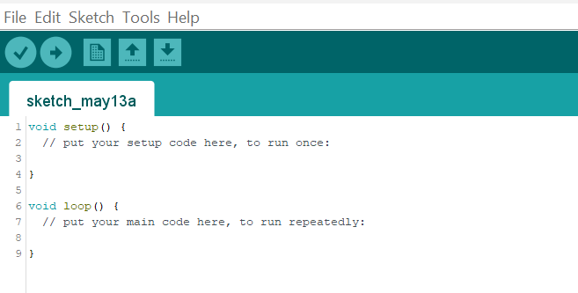

Figure 36: Arduino IDE Snapshot

### 2.2.3 Concluded Technologies

Considering the discussed technologies, in the course of the research conducted, a number of confirmations with regard the intended utilised hardware and software.

Due to the project scope and considering reasonable scalability of the projects intended platform, the Key studio rendition of the Arduino mega microcontroller allows for the desired level of capabilities and functionality at a financially viable price point and allows for improved I/O functionality to manage the current planned list of devices, with the potential of future expandability for further project development.

With regards actuation methods, a combination of both stepper motors and servo motors should be utilised for the suitability off the project, allowing the degree of accuracy and programmability of certain components utilising servo motors, in this circumstance MG 902 motors, due to their improved load bearing functionality, and the use of a 5 volt stepper motor, however it is highly suspected that the motor will not be capable of functioning to its full extent underload, which will be researched further within design and development.

With regards software, the out of the authors past experience and use of the Autodesk 123D program, furthermore the option to program utilising the Arduino IDE, shares much of the same reasoning, allowing that the project can be completed with the fewest programmatic and design limitations possible with regards available software.

# Chapter 3: Artefact Design

Considering the relative objectives and deliverables previously discussed and the desire to avoid a level of uncanniness in design, the option was chosen to base the design on robotics featured in popular media which focus on expression utilising eyes and abstracted forms of eye based features (eyelid, eye lashes, and eyebrows), for this reason two main sources were drawn upon for the purpose of rudimentary design, these were Wall-E from the Pixar movie of the same name in 2008, and a secondary source, being that of the character Johnny 5 from the movie short circuit in 1986.

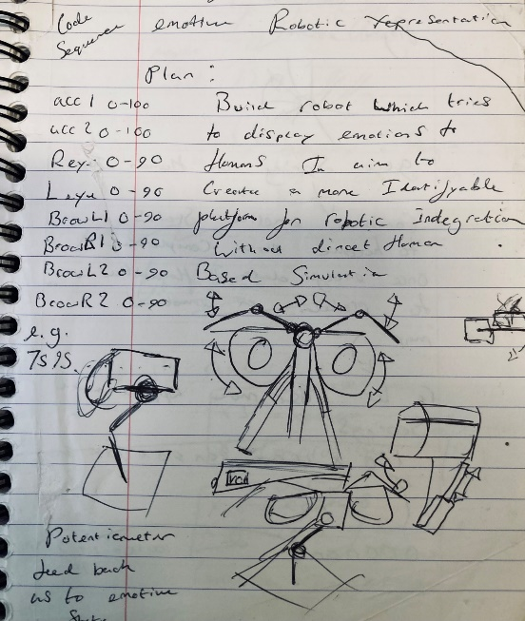Both of these hypothetical platforms maintain a level of character interaction by mainly focusing on the level of abstracted emotion they can portray by utilising their simulated eye like components, therefore proving a foundational means to develop the concept further whilst avoiding the uncanny valley.

Figure 37: rudimentary design sketch as to points of articulation.

Based on this project direction a few concepts were developed for the purposes of testing the hardware feasibility for the project. Upon a basic understanding of what the structure would look like on a conceptual basis, primary CAD (Computer Aided Design) prototype models were developed for the purposes of developing understanding to the project scope.

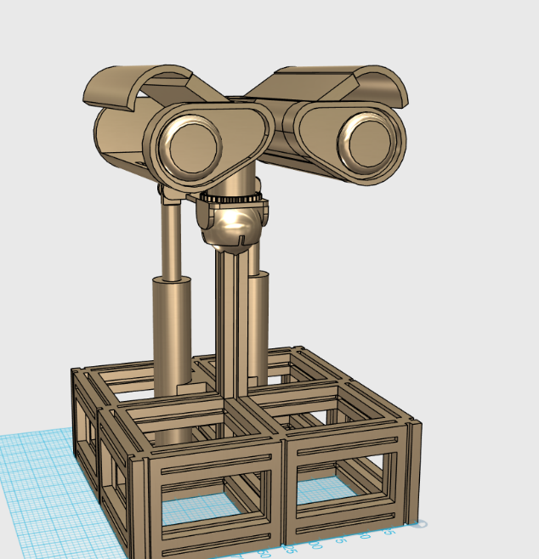The conceptual design featured the potential of using electronic actuators for the purposes of implementing a tilting action to the head component, however, as will be discussed further within the paper, the solution proved unsuitable in the end.

Figure 38: Initial CAD model for the purposes of further research.

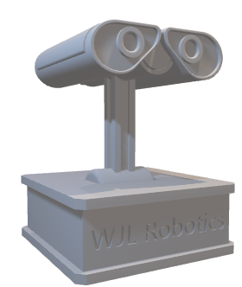Upon the consideration of further hardware, and the acquisition of partial components list, allowing for some design parameters being taken into consideration, the secondary design prototype was conceived as seen in figure 39, the design , whilst still not yet final comprehended the premise of the projects form factor and intended design concept, Based on some of the decided hardware components, of which measurements and parameters could be sourced.

Figure 39: Secondary 3D render

# Chapter 4: Artefact Development

Considering the rudimentary designs in chapter 3, a premise as to the projects form was partially decided, and subsequently development could begin through the process of linear development of hardware elements, till the level of desired functionality could be secured.

## 4.1 Initial Prototype construction

Due to the nature of the project, most of the complexity is not the functionality of singular components, but the integration between a system of components.

Figure 40: DFPlayer Pro Test

The DFPlayer Pro was chosen to be the main integrated audio system within the platform, however, without experience in embedded sound systems a primary test was constructed utilising low-end speakers and the DFPlayer Pro board directly accessed through the USB-C port for the purposes of power supply.

|  |  |
| --- | --- |
| Command Name | Command Description |
| Start | Start Files from Current Play Position |
| Pause | Stop and Wait at Current Play Position |
| Next | Skip To Next Available Audio File |
| Last | Return To Last Available Audio File |
| Fast Forward | Skips a Predetermined Amount of Time into the Audio File |
| Get Current File Number | Get the Numeric Order of the File Currently Playing |
| Get Total File | Get the Total Number of Available Audio Files Available |
| Get Current Time | Get the Current Time of the File Playing |
| Get Total Time | Get the Total Duration of the File Playing |
| Get File Name | Get the Number of The File Currently Playing In Order |
| Play File Number | Play File With the Programmed Numeric Designation |
| Delete Current File | Delete the File Which Is Currently Playing |

Figure 41: DFPlayer Pro functionality table

The test program was sourced from DF robot for the purposes of prototype functionality.

The Test Of the Platform Proved Successful, allowing for onboard recorded sound to be played back, as well as use as a USB Sound Card allowing for external dynamic phrase generation and replay, should future expansions suit such an improvement.

Figure 42: Test Stepper Motor Integration

### A picture containing tool, table, indoor, equipment Description automatically generated4.1.2 Drive Train Construction

Upon the proof of concept, of the audio system, a simple aluminium test bed was constructed for the purpose of load testing stepper motor capabilities. A simple belt drive using a series of tensioners provided inverse drive train properties to modified stepper motor mounts, due to the motors already having a suitable meshing surface, and bearings for reduced friction.

After the construction of the extruded aluminium test bed, Two Custom components were required in order to mount a 28BYJ-48 stepper Motor (Figure 43) and adapt the modified stepper motor hub for the purposes of device expansion further in the project, (Figure 44).

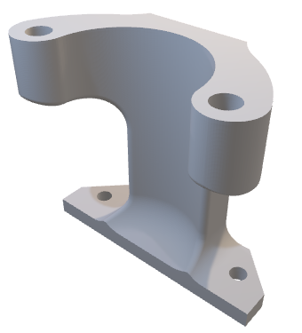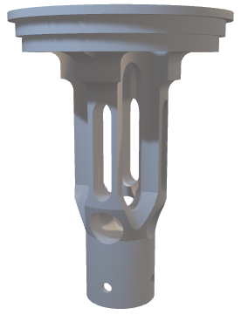

Figure 43: Stepper Motor Mount

Figure 44: Stepper Motor Hub Adapter

During testing with the lightweight five-volt stepper motor, the system while running, proved to be somewhat deficient in its testing, only capable of driving the system under low loads, which would limit the expandable functionality of the system.

As a result of the Stepper motor proving insufficient, the choice was made for the motor to be substituted for the 42BYGH stepper motor, as a result of its higher tortional output.

However a few further considerations need to be made, as a result of the stepper motor substitution.

Firstly, the larger stepper motor requires the use of a L298N stepper motor drive board, subsequently both the motor driver board and the Stepper Motor, require the use of a 12V capable input, in addition to providing a twelve-volt power supply, the L298N board, Is capable of suffering from excessive heating, for this reason cooling systems had to be considered, these were in the form of both a 30mm 5V fan, positioned facing the stepper motor, and a subsequent 12V 80mm Fan, placed on the exterior of the aluminium frame, for the purpose of general air flow and cooling once a more substantial casing solution is implemented.

Secondly, during the testing of the primary aluminium test bed was proven temperamental, unless secured to a flat plane with no twisted axis, to ensure full meshing of the belt drive.

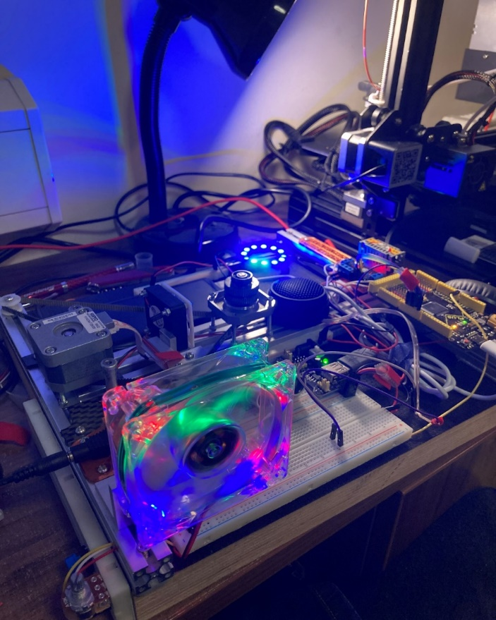

Figure 45: Adapted Test Bed Platform

The discussed issues, and changes to the platform, have been implemented, as can be seen in Figure 45.

In addition to the mentioned improvements, the speaker system was mildly upgraded to an ex-Ford Capri tweeter speaker, however the improvements were marginal in testing performance.

In addition, two developmental breadboard components were added for the purpose of ordering and maintaining, external components to the Arduino in a secure and reliable method, with the option for reconfiguration with relative ease.

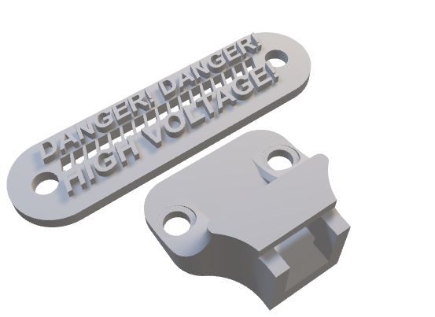To accommodate the addition of the twelve-volt system the contents of figure 46 was utilised.

Figure 46: 12V Power Adapter

### 4.1.3 Neck Base Assembly

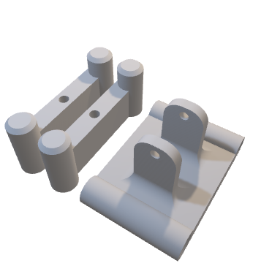Upon the addition of the discussed components, utilising two segments of extruded aluminium, and a selection of custom designed hardware as seen in Figure 47.

Figure 47: Main Neck Base Components

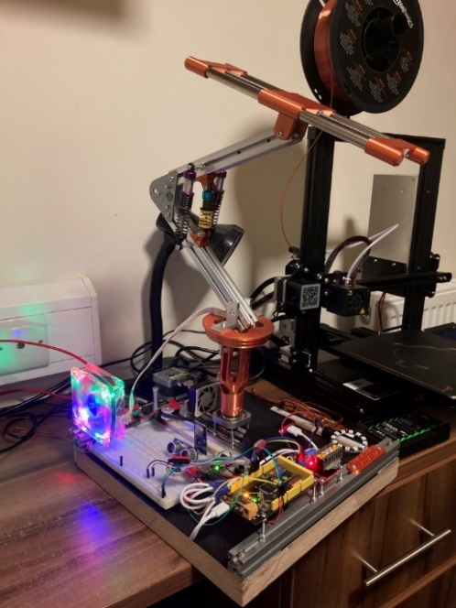In addition to the custom components, two aluminium rails, sourced from a 3d printer were utilised to maintain pivot points for the purpose of future additions, and providing a low frictional coefficient shaft for reduced loads on actuator components.

Figure 48: Initial Neck Prototype

The Test proved to be relatively successful in assembly proving a sturdy base system for further additions of the project, however, subsequent to the initial neck mounting test, in order to build a more versatile and secure system, the addition of two micro shock absorbing suspension pieces were added, as seen in Figure 48.

The components offered two main advantages, not only did the inclusion result in additional supporting strength to the head assembly, but also took into consideration a rebound affect for the purposes of if a potential user attempts to damage or manipulate the segment in an unfavourable way, instead of utilising a full rigid body structure, the solution would allow for build in tolerances to move with the user rather than suffer a significant project breakage.

Upon the addition of the neck section however, It became apparent that the project required a means of additional support, and as a protective method to contain all base mounted electronic hardware.

### A picture containing indoor, toy, floor Description automatically generated4.1.4 Casing Development

Figure 49: Assembled Base Case

Considering the sizable limits of 3d printing, it was decided that laser cutting acrylic sheets would provide the most suitable method of the custom required casing, the designs were illustrated with the consideration with a number of parameters to be included.

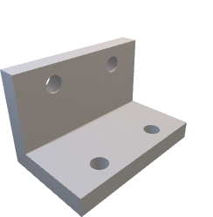Firstly the inclusion of suitable mounting points for custom mounting fixtures as seen in figure 50, allowing for a stronger internal structure, and reliable mounting system.

Figure 50: Acrylic Corner Mount

In addition to the design’s consideration for the mounting systems compatibility, design considerations were made for the inclusion of three ultrasonic sensors, these were designed to be placed prominently on the front of the casing, with space as to reduce the potential of ultrasonic wave collision.

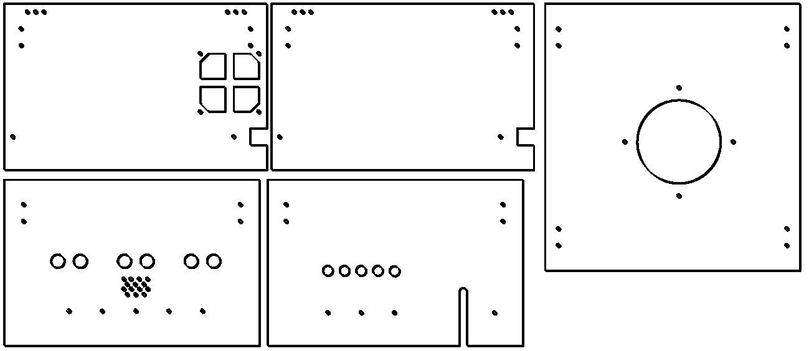The Resultant design template can be seen in figure 51.

Figure 51: Base Laser Cut Template

In order to Support the main neck assembly, a bearing was chosen due to a mixture of availability, and suitability, however the specific chosen bearing, has something of unique origins, as the bearing lived a previous life as Fernando Alonso’s rear differential bearing, within a formula one car, therefore considering the prior application, the author believes it is more than suitable for this project.

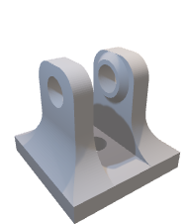Furthermore, considering the success of which the installation of a shock absorbing system within the lower neck frame, a smaller shock absorption assembly was installed to further reinforce the neck assembly, utilising the component as seen in figure 52.

Figure 52: Small Shock Absorber Bracket

### 4.1.5 Eye Mounting System

Since the base of the project now had a secure and reliable base, the development of the emotive components, first of which being the eyes operating off two MG 90S servo motors and holding one 24 led programmable ring lights on each eye, as can be seen in Figure 53.

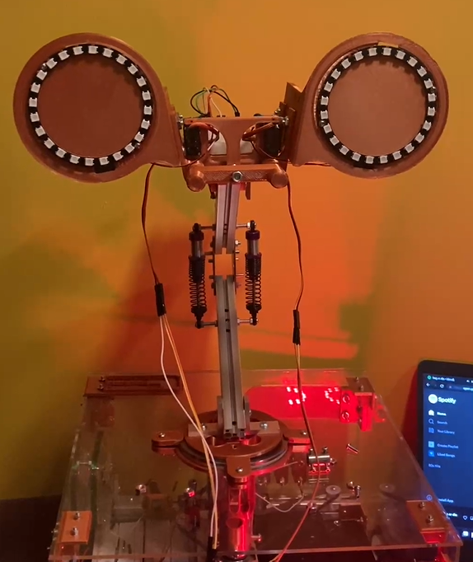

Figure 53: Base Eye Configuration

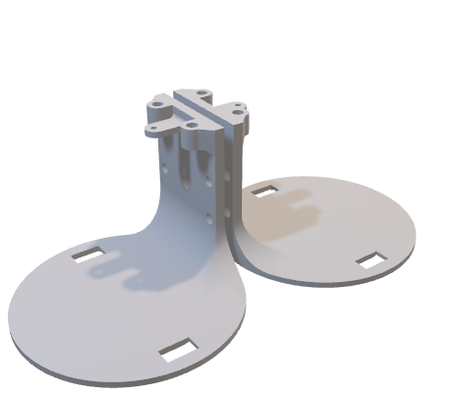The Mounting system ended up requiring some relatively unique and complex components in order to function the main of which being features in figure 54.

Figure 54: Main Eye Mounts

The components were designed to have perforated slots for the mounting of the previously tested speaker system, in addition to this design choice, the mount was manipulated through an adjustable linking armatures, for the purposes of increased modularity, and a reduction in required custom designed parts, furthermore the adjustability of the linkages allows for respective loosening or tightening to change how the motion interacts and the affect in 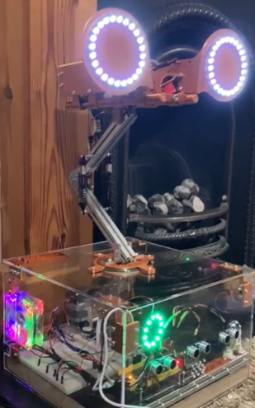association.

### 4.1.6 Basic Integration Test

Figure 55: Eye Base LED Test

Upon the construction of the eye assemblies, a simple test program was written for the purpose of testing the led units with integration to the ultrasonic sensors, as can be seen in the base of the unit in figure 55.

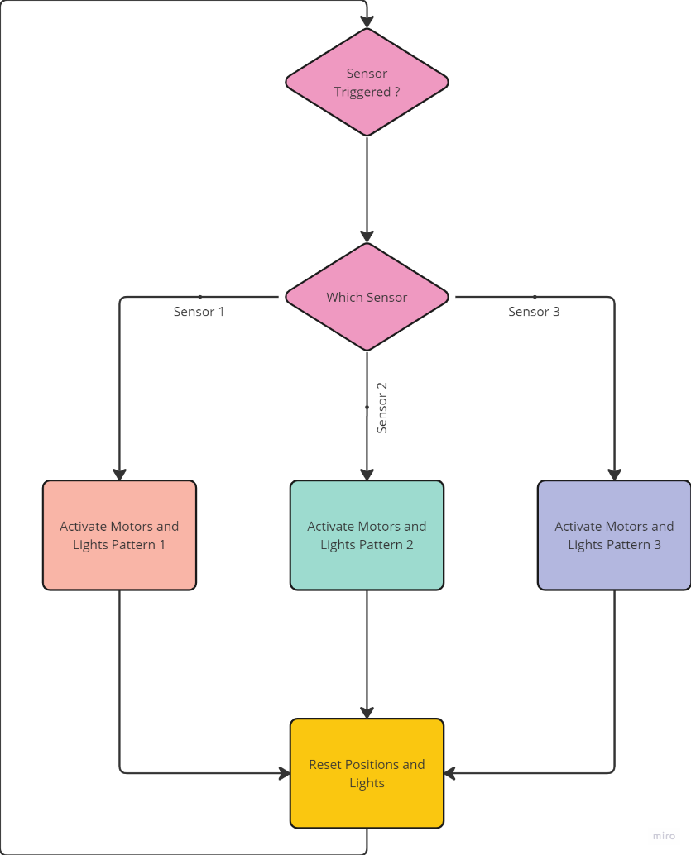The Script consists of relatively simple functionality but proved enough conceptual to prove the functionality of the platform’s current components, the operation functioned as can be seen in figure 56.

Figure 56: Code Version 0.5 Flow Chart

Upon Successful integration and testing of the base systems and operation, additional expansions for the eye segments were added to the platform.

### 4.1.7 Eyebrow Integration

As an attempt to improve the expressiveness of the platform, the next significant addition would take the form of a dual articulated eyebrow segment. The assembly will consist of a further two MG 90S servo motors, and a series of adjustable linkages, and print in place hinges, a unique type of embedded hinge concept only fundamentally possible through 3d printing.

The type of hinge incorporated in this design most commonly is referred to as a print in place hinge, this hinge, which by other production means is not possible, utilises the incremental z axis build of the 3D printer to create nested free-standing structures, similar to the cross-sectional view of Russian nesting dolls.

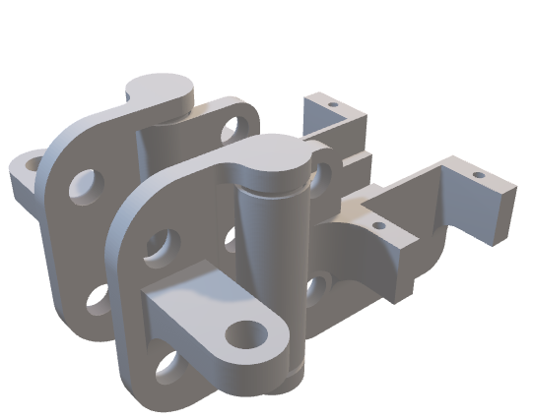By utilising the concepts system of creating interlocked parts (in this case a pivot point, and pivot plates) a singular designed part can incorporate multiple components in a singular production process meaning that assembly time and external hardware is drastically reduced, creating a compound structure which is easy to replace and substitute when required to maintain the hinged components accelerated wear in comparison to more static elements of the artefact, the example concept can be seen in figure 57.

Figure 57: Print In Place Hinged Eyebrow

With a combination of the components in figure 57, some linkage segments, and some riser sections for the purpose of improving the accentuation of the movements to simulate eyebrows ore similarly. the basis armature for the eyebrow expansion was complete as can be seen in figure 60 and figure 61.

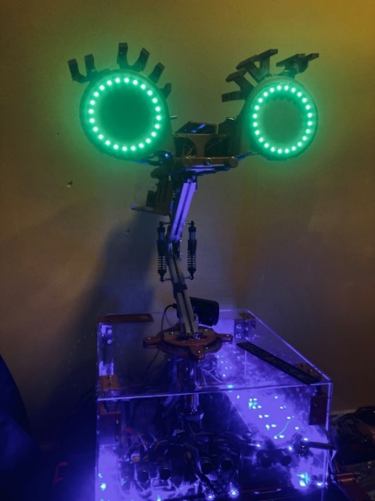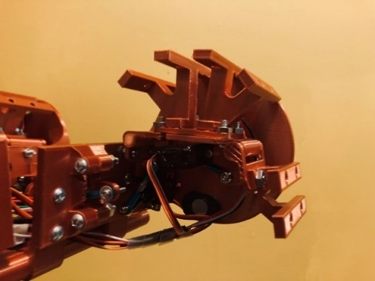

Figure 58: Integrated Eyebrow Risers

Figure 59: Rear Eyebrow Segments.

### 4.1.8 Drive Train Upgrades

At this stage in development, a further attempt was made to program and test the additional functionality of the system, whilst the newly added armatures proved to add a level of eccentricity to its emotive display, it was proven that the additional components placed excessive strain on the stepper motor the entire assembly was mounted to, as a result whilst the stepper motor was capable of manipulating the entire head assembly, the rotational values proved inconsistent, and difficult to counteract for, this subsequently presented two solutions, an upgraded stepper motor, which would be reaching near industry used sizes, and as a consequence price, alternatively, the removal of the newly added eyebrow components may reduce weight of the head significantly enough to allow for returned functionality.

Whilst both of these options would harm the projects functionality, a simple test mechanism was devised for the purposes of calibrating the rotational movement.

The mechanism consisted of a bolt placed into the main neck mounting system, and a 7th MG 90S servo with a micro switch button placed on a small piece of aluminium right-angle metal, the mechanisms intent to press the button through mechanical means against the protruding bolt, as a means of internal calibration, the additional assembly can be seen in figure 60.

In order to further improve the potential for success, the drive belt was substituted for a more reliable new belt drive system, and the integration of a tensioning components typically found on 3d printers to allow for adjustable alterations to the drive, therefore a proven component, and can be seen in figure 61.

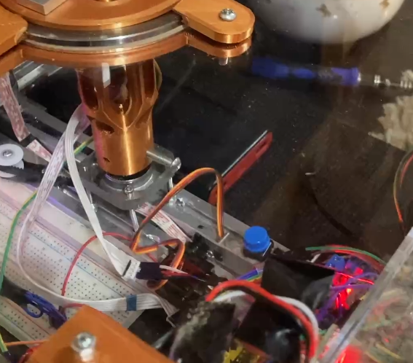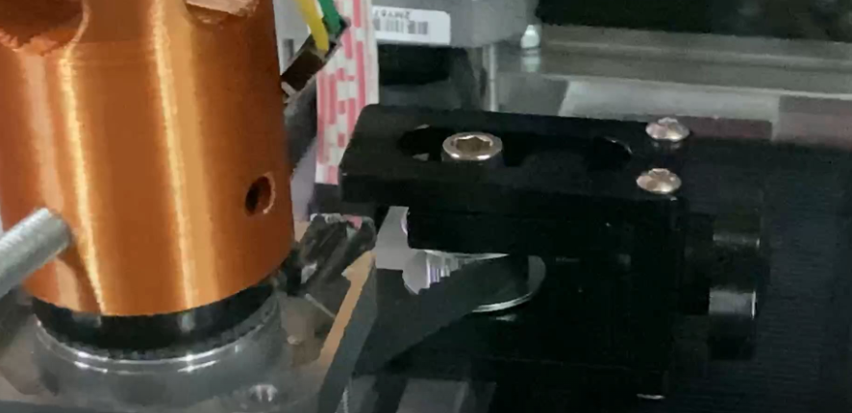

Figure 60: Test Calibration Button

Figure 61: Belt Tensioner

Unfortunately in testing of the rotational mechanism, while performance improved, the mechanism still remained unreliable, as a result of budgetary limitations with regards the project scope, the option was chosen to disable the stepper motor functionality.

Whilst the disabling of the functionality is highly regrettable, in order to continue and maintain the desired time frame as can be seen in appendix [C], the removal of the functionality programmatically would prove the most suitable option, however due to the components being integral to the project’s foundations, the hardware components will remain, till such a time, capabilities of tracking and accurately rotating the assembly can either be engineered or programmed.

Considering this setback, the next required component of the system was an interactive means of data collection.

### 4.1.9 Data Collection User Interface

The method had to be designed to maintain simple and accessible components as to minimise complexity in the user interaction process, overall the system ended up being comprised of a singular button, a potentiometer, and an SPI bus interfaced SD card read/write adapter.

In order to quantify the numeric potentiometer input of the system to meaningful values, the option was chosen to use an abstracted emotion wheel, a method of categorising and recognising the route emotions, experienced by humans, as a result by using the method of the emotion wheel on an inverse basis, a link between emotive feedback and numeric data management can be breached, creating quantifiable and useful information.

The assembly utilised custom components as seen in figure 62 and 63.

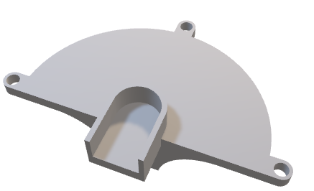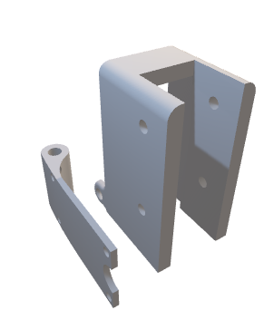

Figure 62: Potentiometer Mount Display

Figure 63: SD Card Mount

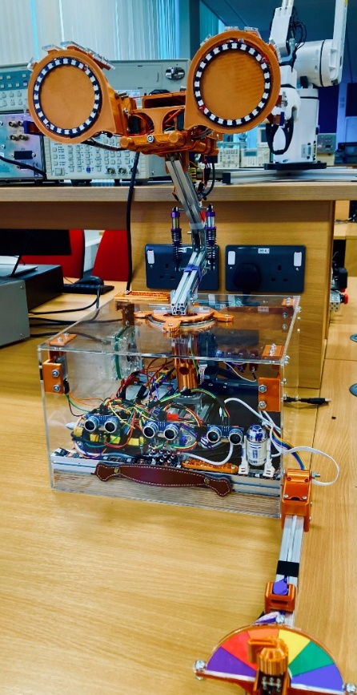The assembly utilised the final piece of extruded aluminium that the author had salvaged from an old 3d printer, and also forming a durable basis of user interaction reducing the chances of catastrophic user failure whilst in deployment.

Figure 64: Assembled Base Artefact

The Assembled structure mounted externally to the case as seen in figure 64 maintains a low enough profile as to not interfere with the ultrasonic sensor s ranges, but also provides a simple and accessible user interface tool, for the purposes of the required data collection.

### 4.1.10 Further additions consideration

During the course of construction and subsequent integration testing two issues became apparent, firstly in order to deploy remotely, the ability to wirelessly debug and monitor the status of the system, would significantly improve deployment success. Secondly, the integration of a physical display may allow for either accessible onboard debugging, or textual based prompts for a user.

### 4.1.11 Bluetooth Integration

To deal with the first concern of remote debug access, the option was chosen to utilise a sh-hc-08 Bluetooth transmitter, (as seen in figure 65) for the purposes of remote serial data transmission.

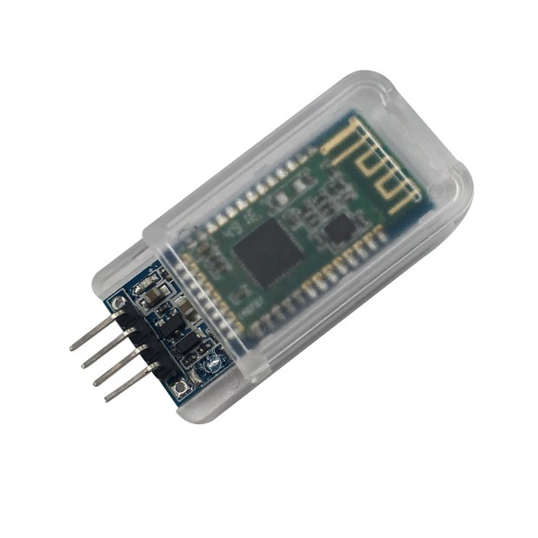However, in comparison to most devices integrated into the system, the Bluetooth transmitter requires 3.3volt logic, as opposed to that of the 5volt logic the Arduino currently operates on To rectify this a small circuit referred to as a voltage divider is required, this operates on the basis of utilising resistors to shift the 5-volt logic level to a compatible 3.3-volt level, a more comprehensive view can be seen in figure 66.

Figure 65: SH-HC-08 Bluetooth Transmitter

Image Source: www.deshide.com

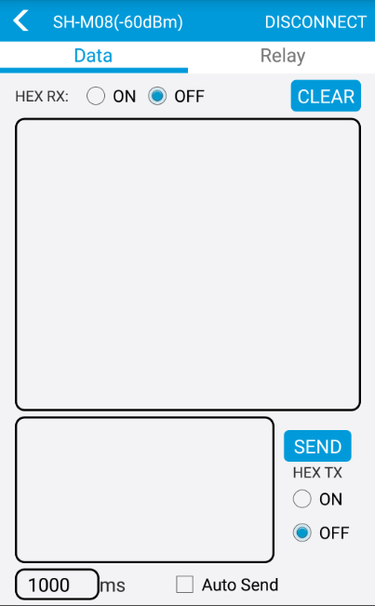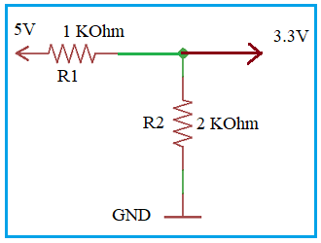The Bluetooth transmitter is prebuilt with functionality compatible with the DSD application, as can be seen in figure 67, the application whilst primitive, proves sufficient enough for the purposes of remote debugging, and still maintains expandability to custom applications, should real time feedback to a remote service provide a more suitable method of artefact utilisation.

Figure 66: DSD Mobile Application (Image Source: DSD Tech)

Figure 67: Voltage Divider Circuit (Image Source: www.rfwireless-world.com)

### 4.1.12 Oled Display Integration

In reference to the other potentially useful addition of a display for text-based outputs, the option was chosen for an OLED Display to be included on the device.

The display operates on a communication basis called II2C, utilising the basis of address enabled devices allowing for communication between multiple devices (up to 128), utilising one channel of communication.

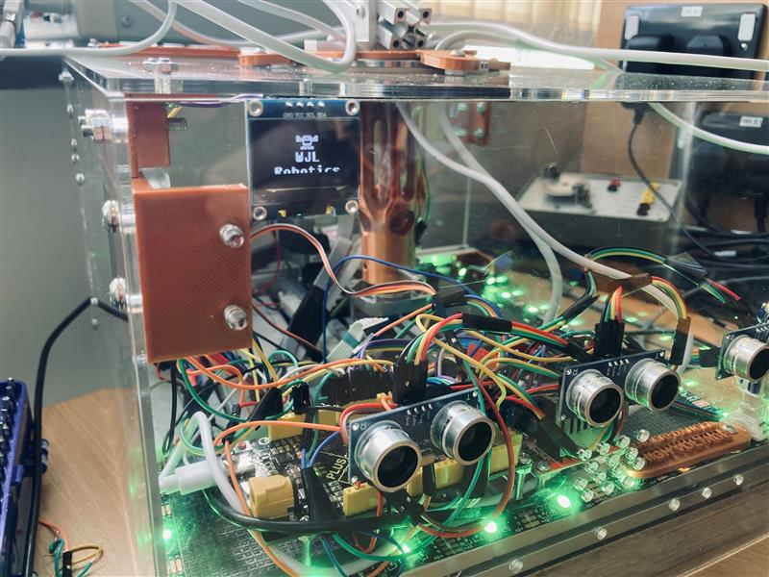The display however, whilst highly flexible in terms of its presentable capabilities, for full image display, the image encoding maintains quite the large form factor programmatically, as a result of this in combination with microcontrollers operating with relatively low amounts of physical memory, the number of dynamic custom outputs tend to be limited as such, however, still provides enough space for the purposes of a couple full display images, one of which can be seen in figure 68.

Figure 68: OLED Integration.

### 4.1.13 Completion Of Base Hardware

At this stage in development, the artefact reached a level of completion which allows for programming and deployment to take place, utilising a base test script for which has been designed for the premise of the simple interaction process.

The resultant system electronic architecture ended up resembling the diagram as seen in figure 69.

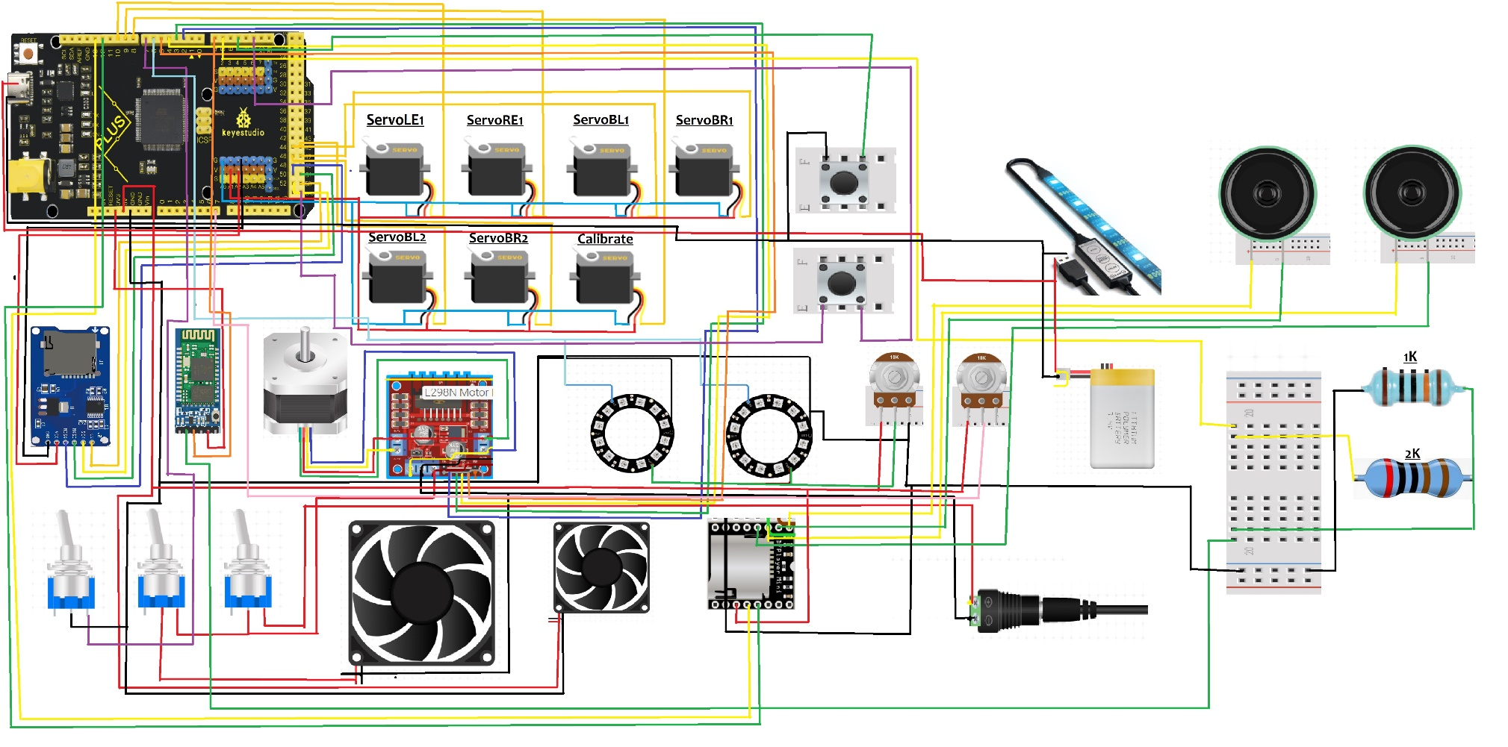

Figure 69: Project Wiring Architecture.

## 4.2 Arduino Program Architecture:

The program as an overview can be broken down into five main subsections, Configuration, Wait On Interaction, Instruction Providing, Wait On Response, Record Information.

The premise of each of these segments allow the program to operate in a way which methodically loops back and accounts for user error of input, or if a user leaves the interaction entirely therefore engineering a more fool proof interaction model.

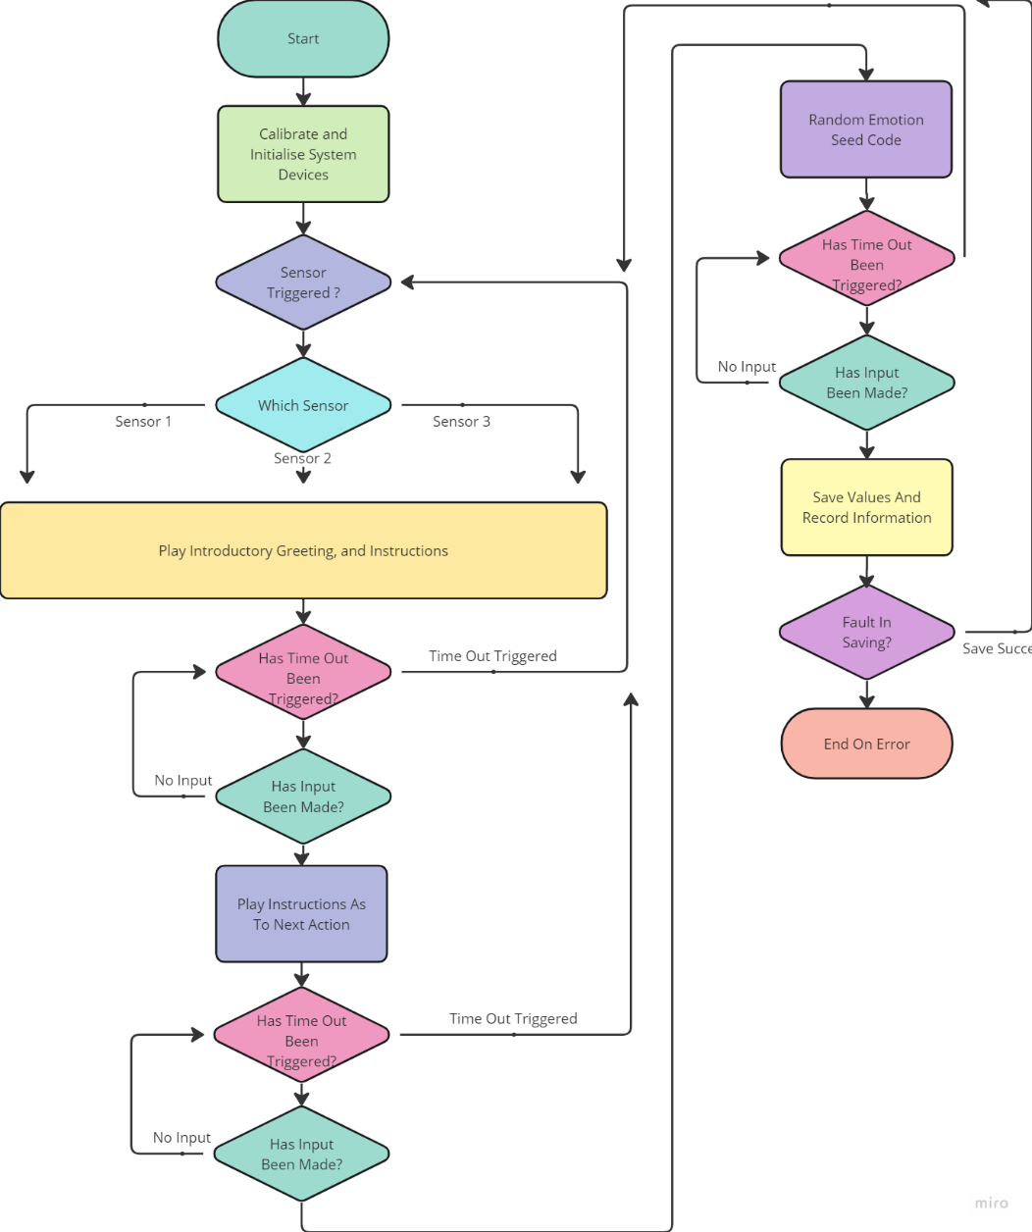A further Break down can be seen in figure 70.

Figure 70: Program Design Flow Chart

### 4.2.1 Configuration:

The Configuration of the project tends to take a large precedence within the program for the purposes of testing and creating means of communication to allocated devices.

Alongside configuration, this segment will also initialise a number of libraries, for the purposes of device specific communication, a complete list can be seen in figure 71.

|  |  |
| --- | --- |
| Library Name | Function |
| SD.h | Configure SPI BUS for the purposes of sending and receiving UTF-8 encoded messaging. |
| SPI.h | Configure SPI BUS for specific microcontroller board. |
| Wire.h | Enable use of the II2C communication lines. |
| Servo.h | PWM Functionality for establishing servo objects and specifying positional references with accuracy. |
| Stepper.h | Stepper motor integration and configuration (now redundant). |
| ezButton.h | Integration of push button functionality, utilising an integrated debounce function to responsively generate feedback from an analogue source. |
| Adafruit\_GFX.h | Adafruit OLED display compatibility library |
| SoftwareSerial.h | Generate secondary TX/RX transmission lines for communication. |
| DFRobot\_DF1201S.h | DFPlayer integration library. |
| Adafruit\_SSD1306.h | Further OLED display compatibility library. |
| Adafruit\_NeoPixel.h | Programmable LED integration. |

Figure 71:Library Table List

Beyond the inclusion of libraries, the setup protocol for the project utilises a number of set up parameters as can be seen in figure 72.

|  |  |  |
| --- | --- | --- |
| Parameter Name | Parameter Type | Function |
| Pin | Integer | Defines pin contact for LED eye drivers. |
| NUMPIXELS | Integer | Defines number of available addresses within connected LED units. |
| SCREEN\_WIDTH  SCREEN\_HEIGHT | Integer | Defines the size parameters for the II2C OLED display, and available programmable size. |
| OLED\_RESET | Integer | Provides a check case as to the refresh rate of the OLED display, typically set to -1. |
| SCREEN\_ADDRESS | Hexadecimal | Generates fixed II2C Hex address for which communications will be provided to. |
| LOGO\_WIDTH  LOGO\_HEIGHT | Integer | Sets Array dimensions for image properties to be displayed on the OLED device. |
| EchoPinR  EchoPin  EchoPinL  TrigPinR  TrigPin  TrigPinL | Integer | Defines for ultrasonic sensors both the transmission and reception pin contacts to the microcontroller with respect to each sensor. |
| Val | Integer | Analogue placeholder value for potentiometer input. |
| Pos | Integer | Generic origin parameter for servo motors to be calibrated from. |
| PotPin | Integer | Defined Analogue input for input potentiometer value. |
| DelayVal | Integer | Designated Debounce button delay to account for button presses. |
| Calibrated | Integer | Placeholder condition for if button press has been activated internally for the purposes of calibrating the heads position. |
| Chipselect | Constant Integer | Provides the start pin selection for the microcontrollers SPI bus. |
| StepsPerRevolution | Constant Integer | Defines the number of incremental positions of the stepper movement positions. |
| MOT1  MOT2  MOT3  MOT4  MOT5  MOT6 | Long Integer | Outlines the object instances, of each stepper motor, and which pin the respective motors operate via PWM signals. |
| Time  TempRec | Unsigned Long Integer | Place Holder terms for recording millisecond increments for the purpose of embedded timeout functionality. |
| Boswin\_Test  Emotie\_Test\_Screen | Constant Unsigned Character Array of Hexadecimal | 128x64 depth array of hexadecimal values for the purposes of hard coding II2C images into memory for the OLED display. |
| Lowest | Float | Place Holder Parameter for the purposes negotiating the lowest value to establish hierarchal importance of sensor input. |
| Duration\_usR  Duration\_us  Duration\_usL  Duration\_cmR  Duration\_cm  Duration\_cmL | Float | Ultrasonic Parameters for both the ultrasonic sensor raw feedback and converted centimetre feedback, for each of the three ultrasonic sensors. |

Figure 72: Main Configuration Variables

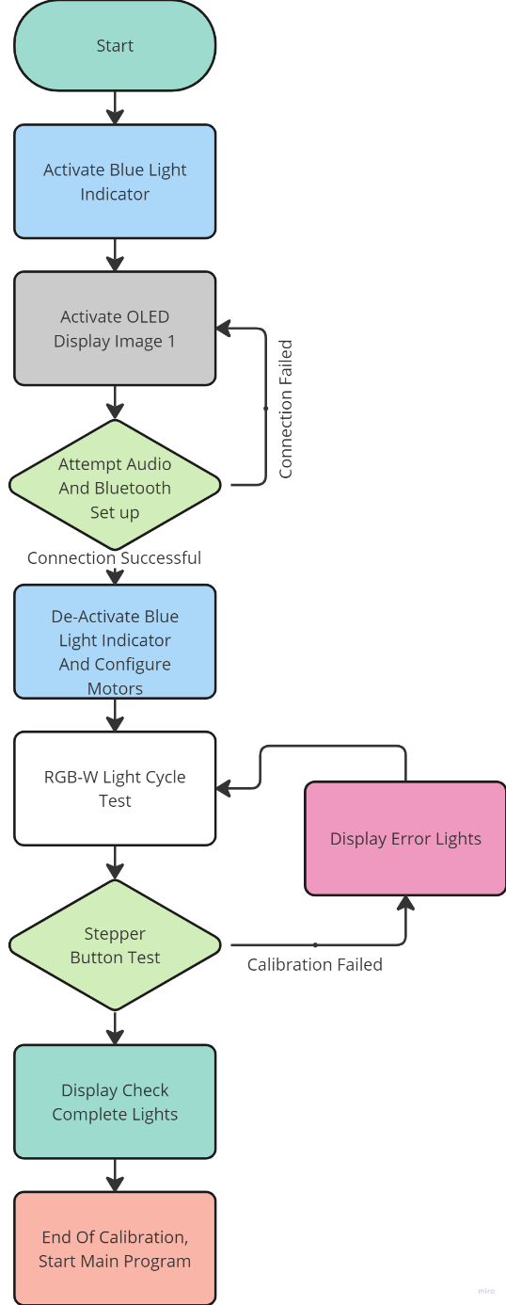 Enable LED functionality begins initially, as a means of indicating, firstly that the power is enabled, and the device has begun steps to configure the functionality of the program, and secondly to indicate that blue tooth communications, are beginning to be enabled and should a user be attempting to access information, any point after this set up o led functionality, the device will be available and providing the desired information.

Figure 73: Configuration Program Flow-Chart

the functionality of the LED lights, simply enact like an array, utilising each index as a referential node to an individual LED unit, then assigning the LED the desired colour based RGB value, as can be seen in the following code, which utilises differing iteration conventions for the purpose of changing how the LED units update and display their newly assigned value.

Following the LED literal light show, the OLED display is initialised and begins to display an initial startup image to verify that II2C communication channels have been established, this loads a 128x64 Hexadecimal array, stored within program memory, for the purposes of reliability, the image code will not be included, however is available under appendix [d].



Upon the display of the image, connections to both the onboard audio player, and Bluetooth module, both of these operate on the basis of serial communication, therefore utilising this setup method, not only verifies the serial communication capabilities, and the condition of the inbuilt logic level converter for the Bluetooth module.

This verification of connection can be checked quite simply by the following command of While(!Serial), this perpetuates any error in setup and restricts the program until connection is assured.

Upon validation of the communication methods, the blue led display fades, and the Oled display presents a secondary image, confirming that communication is valid, without the need to read direct serial information from the device.

Once the relative software configurations were complete, the physical head calibration then takes place, through the engagement of a servo motor, with an analogue button input to test the centring of the neck component, whilst this was intended for the utilisation in conjunction with the stepper motor drive train system, maintaining the functionality of the calibration system, ensure neutral and reliable positioning during setup as to maintain consistency in deployment testing.



Upon the event of successful calibration, the main program can begin to function.

### A picture containing screenshot, colorfulness, design Description automatically generated4.2.2 Wait On Interaction

Figure 74: Wait On Interaction Program Flowchart

Now calibration and respective devices have been set up and configured, the process of waiting on an interaction can begin, focusing on the utilisation of the front mounted ultrasonic sensors, a hierarchy is developed based on which one a user is allocated closest to, however as to reduce potential over activation, a designated “safe range” has been established, which the robot can recognise when an expected distance is closer, but until the user is in immediate range, the device remains inert.



Based on the concept of projecting a high frequency pulse width and receiving the refraction of the wave, the approximate distance converted to centimetres, with 2 d.p. of accuracy can be returned and used as a component of data collection.

Should the ultrasonic boundary be passed, the engagement of voice line prompts will be engaged, through the seral communication to the embedded sound system, through the known allocation of contained file numbers.



Based on this response a Millis() based time out function is engaged, this functions on the basis of taking the current internal device time, and comparing current time, to the initial time check plus approximately 20 seconds, as a result a level of inactivity can be determined, in order to prevent the event of a stale interaction process, restarting the interaction cycle.

During this time out period, a constant check is made for if an analogue button is pressed based on a debounce time period in the continuous waveform, utilising this as a confirmation of engagement on the basis of the initial instructions prompted by the included voice line.



Upon the completion of an interaction, the program can progress to the next level of the data collection of the process.

### A screenshot of a computer Description automatically generated with low confidence4.2.3 Instruction Providing

Figure 75: Instruction Providing Program Segment Flowchart

Now that a confirmed participant has been recognised and validated, a further line of dialogue is conveyed to the user, establishing further instructional advice for the user to press the button upon the completion of the voice line, which forms a second confirmation of the interaction process, whilst it could be possible to eliminate some of the interaction process, as a result of maintaining a sequence of events, the resultant collected data, maintains a level of quality to the sourced information.

A second timeout command is engaged waiting for a secondary button input, once triggered, then a randomised serial code of values from 0-18 for each motor is generated on the basis that 0-180 would offer ten times the quantity, of information, but the data collated would not be variety, to engage a significant range of values.

Based on this, the values are assigned to their respective motor, generating an expression, upon the display of this serialised expression, then the wait for user feedback is started.



### A screenshot of a computer Description automatically generated with medium confidence4.2.4 Wait On Response

Figure 76: Wait On Response Program Flow Chart

Now an emotion is expressed to a user, the third and final time out functionality is engaged, waiting for an analogue potentiometer to rotated to a respective term, and the button to be pressed a third time to confirm the interaction process, based on this input, the experienced emotion from the user can now be quantified, providing a means of tracking, and relating the motor based serial codes to an emotion, and vice versa.

 Upon the instance of which an input is verified, and inputted, the value is then appended to the serial number value, documenting the complete interaction process in this instance, then prepares to save the instance.

### A screenshot of a diagram Description automatically generated with low confidence4.2.5 Record Information

Figure 77: Saving Functionality Program Flow Chart

Based on the newly acquired interaction instance, the program then has to functionally assign the new case to the systems inbuild SD card storage system, via the SPI bus, in order to preserve the information and collate something of a dataset.



Upon the successful compilation of the of the new instance to the designated text file, a final voice line is activated, thanking the user for the information, and resetting the positional values of the system, returning to the initial default state, after the device configuration state.

## 4.3 Graphical Python Companion Program

Considering the nature of the artefact, the information gathered is relatively abstract, and whilst as a developer of the program, some inferences can be made, in order to truly identify trends within the data, the use of graphical representations can prove useful.

### 4.3.1 Data Transference Format

Data expelled from the artefacts system, maintains a standardised format across data entries, each consisting of ten attributes.

|  |  |  |
| --- | --- | --- |
| Attribute Name | Data Type | Data Purpose |
| Distance Left,  Distance Right,  Distance Mid | Float | Recording of ultrasonic positioning from the start of the interaction process, respective to the left right and centre sensors for rudimentary tracking of user positioning. |
| MOT1,MOT2,MOT3,  MOT4,MOT5,MOT6 | Integer | Recording of each respective servo motor position, on a scale of 0-18, respectively associated to that of 0-180, for purposes of reducing the volume of potential data collection points to a more rationalised level. |
| SCORING | Integer | The Resultant Value from the user, mapped from 0-1023 to 0-180, for relational reasons of maintaining a standardised range for most of the utilised data. |

Figure 78: Stored Data Paradigms

The information once formatted maintains the following format:

Distance Left: XXX.XX Distance Mid: XXX.XX Distance Right: XXX.XX MOT1: XX MOT2: XX MOT3: XX MOT4: XX MOT5: XX MOT6: XX SCORING: XXX

### 4.3.2 Data Extraction

The Data extraction method, utilises a simple read from fil functionality, utilising the white space as separation markers, for which can be used to verify positions and data values, without being dependent on fixed length data, meaning that should future developments, include further data points, as long as the initial base data string methods, maintain a consistent design, the program would remain functional.

Utilising try and except, also accounts for should the program or data be missing elements, and rather than suffer a level of catastrophic error, exceptions are caught and dealt with in an effective way.

try:  
 with open('D:\DISTANCE.TXT','r') as f:  
 for line in f:  
 print("running")  
 TempRead=str.split(line.strip())  
 DistanceLeft.append(TempRead[2])  
 DistanceMid.append(TempRead[5])  
 DistanceRight.append(TempRead[8])  
 MOT1.append(TempRead[10])  
 MOT2.append(TempRead[12])  
 MOT3.append(TempRead[14])  
 MOT4.append(TempRead[16])  
 MOT5.append(TempRead[18])  
 MOT6.append(TempRead[20])  
 SCORING.append(TempRead[22])  
 DataPoints = len(DistanceMid)  
 print(DataPoints)

### 4.3.3 Data Display.

For the purposes of display, matplotlib is utilised, on the basis of utilising effective and versatile presentation methods, for the purposes of this, multiple datapoints are assigned to a singular graph, which allows for trends to be easily tracked, and for the graph itself to be manipulate within the program, through matplotlib functionality, however, can also be saved locally for the purposes of having a static view of the system.

plt.figure()  
 plt.title("EMOTIE: Operational Data Collection Info")  
 plt.xlabel("READINGS")  
 plt.ylabel("VALUES")  
 for i in range (0,DataPoints-1):  
 TempFormat[0] = float(DistanceLeft[i+1])//10  
 TempFormat[1] = float(DistanceMid[i+1])//10  
 TempFormat[2] = float(DistanceRight[i+1])//10  
 TempFormat[3] = float(MOT1[i+1])\*10  
 TempFormat[4] = float(MOT2[i+1])\*10  
 TempFormat[5] = float(MOT3[i+1])\*10  
 TempFormat[6] = float(MOT4[i+1])\*10  
 TempFormat[7] = float(MOT5[i+1])\*10  
 TempFormat[8] = float(MOT6[i+1])\*10  
 TempFormat[9] = float(SCORING[i+1])  
 print(TempFormat)  
 plt.plot(TempFormat, color = np.random.rand(3,), marker = "s", label = LABELS)  
 plt.xticks(x, LABELS, rotation='vertical')  
 plt.subplots\_adjust(bottom=0.4)  
 plt.savefig(desktop+Fname)  
 print("Graph Generated And Saved To Desktop...")  
 plt.show()  
except:  
 print("error 404 file not found, D: Drive not Found")

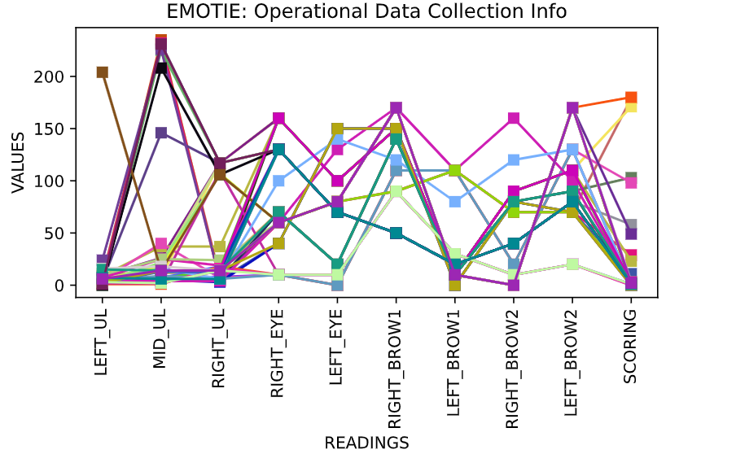once the program has run, ideally successfully, however even if not successful the error will be accounted for, the following graph is generated and saved to the desktop of the device in a dynamic file path generation sequence.

Figure 79: Graphical Result Conversion

# Chapter 5: Deployment, Testing and Further Iterations

Device deployment took two main initial deployment settings of the artefact, first of which was an open public space in which the device was remotely surveyed, and the second location was a private setting with a control group of users.

The deployment consisted of reviewing of the volume of collected data, and number of successful interactions, as well as any subsequent faults or required fixes.

## 5.1 Deployment 1:

Deployment 1 took place in an open public university building, expected to have high-capacity foot traffic and a more diverse range of subject specialists, and variety, as a result of the building not being tethered to any respective subject area.

### 5.1.1 Deployment Findings

During the deployment at the test location, the following user habits and system deviations were observed.

|  |  |  |
| --- | --- | --- |
| Interaction Number | Apparent Issue | Issue Solution |
| 1 | Users noted a noticeable lack of audibility from the device as a result of higher ambient sound, making the interaction process less accessible, resulting in more failed interactions. | Substitution of the current on-board speakers for the speaker system as seen in figure 81, allowed for a noticeable audio quality improvement, allowing for the robot to be understood clearly. |
| 2 | Device hard coded time out functionality exceeded most users’ response time leading to a number of failed interaction processes as a result. | The programmatically encoded time delay of ten seconds before assuming a timed-out state became substituted for a twenty second time frame, allowing for a longer response time. |
| 3 | Devices internal power drain, led to a shorter deployment life span than anticipated. | Considerations of the device life span had been accounted for during development, for this reason the device is capable of being converted to an external power source, should sufficient outlets be available to manage the number of devices. |
| 4 | Portability of the device gave way to issues surrounding the structural stability of some armature components. | The substitution of common place nuts and bolts, for nyloc threaded nuts, the inclusion of a nylon gasket allows for an improved grip and reduces greatly the likelihood that a nut should become lose due to natural vibration or subtle rotational forces. |
| 5 | Data Not Saving, thus boot-looping the device. | Simple error of a loose cable to the external SD card system, simply reconnecting and utilising a cable tie to prevent further disconnection errors. |
| 6 | Power Source Depletion and ceasing proper functionality. | This was found to be an issue with the external power supply unit, it became evident during the test that the “flagship building” (Staffordshire university, 2020), had sub-standard electronic output compatibility for what the system required, which in retrospect only consisted of two USB 5V ports, and an external mains power supply.  Potentially the proposed “40 million Pound” Building proved sub-par to requirements for this deployment instance. |

Figure 80: Deployment 1 Testing

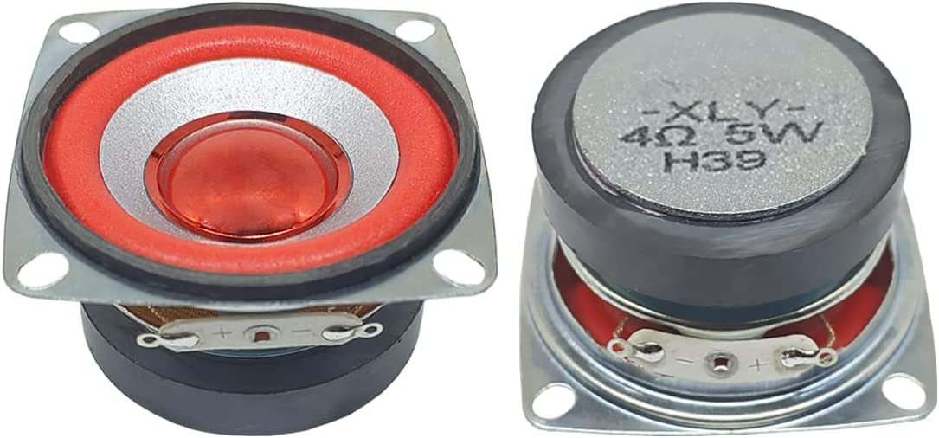

Figure 81: Substitute Speaker Conversion

### 5.1.2 Deployment Reflection

The overall deployment was active for a period of around 8 hours, and was showcased and tested through a number of participants, yielding only 26 successful interactions and data recording instances, a number of the participants neglected to follow the audio instructions, and engaged with the robot in other methods, whether it be simply taking a photograph with the system, or in some cases, users tried to make continued conversation with the device, despite the additional informative plaque which stated that the device was not to carry out that function, however it proved intriguing to remotely witness users who despite never having witnessed the device, or an artefact on a similar basis, were able to engage, and empathise with the system, inherently on a rudimentary basis, demonstrating the projects aim.

## 5.2 Deployment 2:

Deployment 2 took place in a private setting of the authors family home, where family members would interact on a more monitored and controlled environment, however still independent to interact with as they wished.

### 5.2.1 Deployment Findings

|  |  |  |
| --- | --- | --- |
| Interaction Number | Apparent Issue | Issue Solution |
| 1 | Misunderstanding of the input instructions and commands. | As a result of being on hand, relaying and explaining the interaction model allowed for an easier overall system interaction, however once the concept had been explained, continued system interaction maintained consistent results. |
| 2 | Hesitance to utilise or interact with the system. | In showcasing to other family members, it became apparent that a diverse split in results, with regards the user’s perception of the system, a young spectator became upset at the sight of the system, however this may be a result of the author being present at the time, which the spectator historically “not a fan of”.  Due to indecisive confirmation of the test as to the true cause of the issue, along with the ethical repercussions of testing the exposure of the device on the spectator repeatedly, this issue at present is unresolvable, other than the providing of a chocolate-based item to console the spectator. |

Figure 82: Deployment 2 Testing

### 5.2.2 Deployment Reflection

The secondary deployment benefited greatly off the back of the changes and additions made during the course of the first deployment session, utilising the improved sound system and increased interaction time to generate more consistent and reliable input responses.

Furthermore, within iteration number 2, the not necessarily planned or anticipated reaction, similarly to the first deployment that users were capable of interacting and reflecting on the artefact with a high degree of emotional feedback, which whilst the two events were not documented within the internally gathered information, comprehending the more profound level of interaction capable, proved a significant degree of validation as to the capabilities of abstracted socially assistive emotive robotics.

In addition, in a simple intermittent deployment over the course of several days amounting to no more activated on time than 3 hours, 24 readings were collated, proving a significantly higher rate of data acquisition than that of the initial deployment, potentially suggesting that either the improvements to the platform since deployment , made significant advances, or the connotation that interactions are more likely to take place in a more private and controlled space, which proves not to be a significant leap in logic to deduce, that users are more likely to be less emotionally available than in a public space.

# Chapter 6: Conclusion and future works

Considering the project deployment to date, the compiled results generated 50 overall successful interaction cases, each of which consisting of 10 unique data points which can allow for the reverse engineering of a range of emotions, so to speak.

## 6.1 Resultant Analysis

The Graph featured in figure , highlights the resultant data, upon external processing via the developed graphical python application.83

Figure 83: Graphical Feedback Visualization

The Results generated natural trends to the majority of the collated emotions reaching a level of “sad”, or “mad” feedback values, with notable outstanding interactions highlighting most of the remaining emotions, “scared, Joyful, and peaceful”.

However upon the studying of the resultant data, emotions related to the connotations of “powerful” appeared to be lacking from the range of emotions, however number of reasons may be responsible for this factor.

Initial considerations as to the lacking in powerful related emotions, may be as a result of a lacking data acquisitional time frame, approximate calculations put the number of potential emotions based on degree incrementation of the servo motors, the system based on these facts is capable of 6 variational factors of 180 increments each.

$$P\left(n,r\right)=P(180,6)$$

$$\frac{180!}{\left(180-6\right)!}$$

= 3.126579825E + 13 or = 32,165,798,256,000

The current version of the program has been designed to factor the potential into groups of ten, resulting in a tenth of the full range of the systems data collection to be tested, however the improvement of including a full sample range, would result in negligible developments and result in frequently higher values of similar scoring elements, reduction the significance of any developing trends.

However, based on an assumed interaction time of 30 seconds, approximately calculated it would take around 30 thousand and 600 years to collate a complete dataset utilising full resolution, and due to the authors inability to remain immortal till the heat death of the known universe, a lower resolution data collection field would prove significant enough for the purposes of the project.

## 6.2 Project Retrospective

Overall, considering the status of the project at current in comparison to the initial planned aims and respects of the project, as featured in figure 3, the following aspects were obtained within the project scope.

|  |  |  |
| --- | --- | --- |
| Task Moscow Designation | Task Parameters | Achieved/Not Achieved |
| MUST | A means of data entry. | Achieved |
| Segmented programmable points of articulation. | Achieved |
| Robust design for the purposes of user interaction. | Achieved |
| A means of displaying or conveying information / instructions to many users, weather through a textual or audio basis | Achieved |
| Approachable and human like recognisable design feature to create associative bond to attributes. | Achieved |
| SHOULD | Further point of articulation to potentially mimic eye contact with perspective users. | Not Achieved |
| Audio based sound methodology for more engaging ports of interaction. | Achieved |
| Data collection and storage means based on internal, non-personal data valuation to record and develop compiled information. | Achieved |
| Programmable display methodologies to account for visual error handling and further emotive engagement | Achieved |
| External processable means of integrating data from the device to ensure understanding and deductions to be concluded as a result. | Achieved |
| COULD | Bluetooth error checking and handling remotely as not to interfere with the data collection process by introducing influence. | Achieved |
| Cooling systems and multiple voltage level handling for running multiple devices for the purposes of future modular compatibility. | Achieved |
| Logic level shifting for further device integration. | Achieved |
| Programmable and interfaceable audio for the purposes of future development of real time chatbot functionality. | Achieved |
| Wi-fi integration as a posed to Bluetooth for longer distance bug catching and management of the deployed system during teasing. | Not Achieved |
| WON’T | Mobile capabilities to maintain system integrity and manage security of the devices deployment without being a hazard to users. | Not Achieved |
| Computer vision or advanced personal collection means in order to maintain universal consciousness over data storage and usage. | Not Achieved |

Figure 84: Reflective Moscow Table

In retrospect of the project, a great number of the intended outcomes had in fact been accomplished, resulting in an end system capable of the required level of interaction, independence, and data collection required for the information gather to be suitably viable for the improved interactivity within the context of mental health diagnosis and treatment.

Unfortunately however, two main tasks were not achieved within the scope of the project, the inclusion of a wi-fi based connectivity system, whilst still a “could” in the grand scheme of the criteria, the addition of such a feature would allow for the additional cap[ability of truly remote feedback and monitoring on a more reliable methodology, than that of Bluetooth, which for the purposes of the initial testing and deployment proved to be sufficient.

Alternatively to the Bluetooth to Wi-Fi conundrum, the issues which were presented with regards the stepper motor, were deeply unfortunate, resulting in a potential loss of some information of which could have been obtained, utilising concepts of direct, indirect, and avoiding eye contact, could have effectively tripled, resulting in approximately 96 trillion potential data collection points, which as previously mentioned would prove a little excessive for the purposes of the current data collection process.

With regards a retrospective overview of the project’s success in comparison to the designated deliverables, with respect to the chosen waterfall project architecture, a few key elements developed significant impacts.

Whilst the deliverables and overall project were developed and completed in a timely and significant manor, the complications of including a constant referral to a waterfall or for further fact any project methodology, often proved to be more of a hinderance than help throughout the duration.

The constant considerations of conformity to the provided methodologies created a sense of a system which while close to a suitable methodology, seemed to miss the mark somewhat as to what would deem an issue of excessive planning, utilising proportionally more time and resources planning for eventualities, than the true commitment to onward development of the project as an entirety.

Whilst an appreciation as to what methodologies attempt to manage and monitor systems of larger and more complex schemes than an individual basis, for the purposes of this project, whilst the fundamentals of a waterfall method was attempted, following a linear developmental pattern, breaks in conformity to the scheme had to be planned for the adverse revisiting of components, as the perpetuality of a mixed software and hardware project results in a level of persistent developmental feedback and testing, which whilst present in most project, it could be argued is more present throughout the merging of the two components.

## 6.3 Future Works

In Hindsight of the project, a number of choices would be altered in respect to newly developed technologies, and further additional improvement to which the platform could be developed significantly for the purposes of becoming a fully interactive dynamic system within the study area.

Whilst the project in its current stat has proven to be a great demonstration of the capabilities of such a system, the design in the authors opinion, is not repeatable, many of the components are either unique components, which are either difficult or simply non-existent to source, in some circumstances. Furthermore, the scale of the system could be vastly reduced considering a somewhat more compact and reliable form factor, however in terms of justifying the current systems architecture, some limitations were produced with respect to the sources of new and existing hardware, based on the financial limitations of the projects scope, therefore utilising larger pre-existing resources, proved more economically viable than that of sourcing external fitted components.

Considerations as to future integrations, maintained the form of additional functionality through the inclusion of replacement of the main micro controller system, in order to allow access for improved interconnectivity, or adaptation of real time dynamic interactions, and responsive generation.

Considering advancements in interconnectivity, since the outset of the project, Arduino, has released a new micro controller system, similar to that of the Arduino mega, however with some significant connectivity improvements.

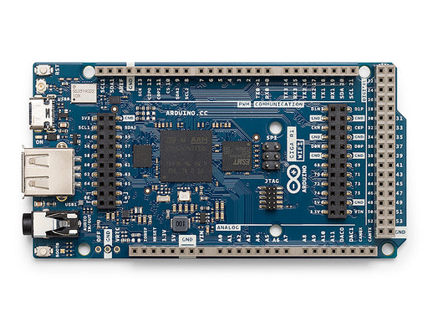The Arduino giga is a similar board composition of that to the mega, however has the advantage of integrated Bluetooth and Wi-Fi integration, with compatibility to the newly introduced, Arduino cloud platform, offering dynamic UI elements and real time data acquisition and hosting, allowing for the remainder segments of the initial outset of the project to be completed, and interface with an external administrative dashboard, for the purposes of prolonged data collection and device monitoring.

Figure 85: Arduino Giga Micro Controller (Image Source: www.arduino.cc)

Alternatively, should considerations be made to improve the level of computing power, the option falls to main contenders, the raspberry pi platform, or the Arduino industry level Portenta X8, a new Arduino microcontroller, with extremely impressive levels of computational abilities, even utilising a low-level Linux OS as a secure hosting environment for extended programs.

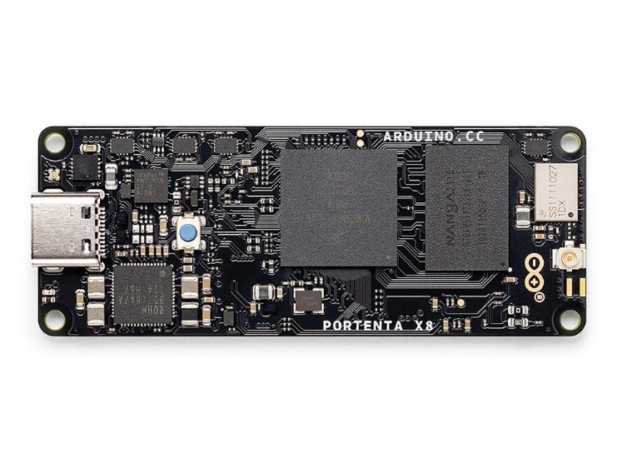However, at the current stage in development, both of the discussed units are scarcely available, or have a significant financial overhead, which given the circumstances, proves not to be viable, but should the project continue, utilising such a platform would greatly increase the artefacts functionality.

Figure 86: Portenta X8 Micro Controller (Image Source: www.arduino.cc)

For A closing statement please see appendix [J].

References and Citations

1. Abrahamsson, P., Salo, O., Ronkainen, J., & Warsta, J. (2017). Agile software development methods: Review and analysis. arXiv preprint arXiv:1709.08439.

2. Adenowo, A. A. A., & Adenowo, B. A. (2013). Software engineering methodologies: A review of the waterfall model and object-oriented approach. International Journal of Emerging Trends & Technology in Computer Science, 2(3), 233-238.

3. Al Moubayed, S., Beskow, J., Skantze, G., & Granstrom, B. (2012). Furhat: A back-projected human-like robot head for multiparty human-machine interaction. In Proceedings of the 2012 ACM/IEEE International Conference on Human-Robot Interaction (HRI) (pp. 307-308).

4. Aly, A., & Tapus, A. (2013). A model for synthesizing a combined verbal and nonverbal behavior based on personality traits in human-robot interaction. In Proceedings of the 8th ACM/IEEE International Conference on Human-Robot Interaction (HRI) (pp. 47-54).

5. Autodesk. (2017). Autodesk is no longer offering 123D. Retrieved from https://www.autodesk.com/solutions/123d-apps

6. Baccianella, S., Esuli, A., & Sebastiani, F. (2010). SentiWordNet 3.0: An enhanced lexical resource for sentiment analysis and opinion mining. In Proceedings of the Seventh Conference on International Language Resources and Evaluation (LREC'10) (pp. 2200-2204).

7. Ball, G., & Breese, J. (2000). Emotion and personality in a conversational character. In Proceedings of the 5th International Conference on Autonomous Agents (pp. 194-201).

8. Bartneck, C., Kulic, D., Croft, E., & Zoghbi, S. (2009). Measurement instruments for the anthropomorphism, animacy, likeability, perceived intelligence, and perceived safety of robots. International Journal of Social Robotics, 1(1), 71-81.

9. Bassili, J. N. (1979). Emotion recognition: The role of facial movement and the relative importance of upper and lower areas of the face. Journal of Personality and Social Psychology, 37(11), 2049-2058.

10. Bernice, A. P., Andrew, H-M., & Liying, L. (2021). Trends in public stigma of mental illness in the US, 1996-2018. JAMA Network Open, 4(2), e2036731.

11. Bevacqua, E., Mancini, M., & Pelachaud, C. (2004). Speaking with emotions. In Proceedings of the Fourth IEEE International Conference on Multimodal Interfaces (ICMI'02) (pp. 309-314).

12. Blair, R. J. R. (2003). Facial expressions, their communicatory functions, and neuro-cognitive substrates. Philosophical Transactions of the Royal Society of London. Series B: Biological Sciences, 358(1431), 561-572.

13. Breazeal, C. (2003). Emotive qualities in lip-synchronized robot speech. International Journal of Humanoid Robotics, 1(01), 39-59.

14. Carpinella, C. M., Wyman, A. B., Perez, M. A., & Stroessner, S. J. (2017). The robotic social attributes scale (ROSAS): Development and validation. International Journal of Social Robotics, 9(3), 363-377.

15. Chiron. (n.d.). Retrieved from https://chiron.website/

16. Csapo, A., Gilmartin, E., Grizou, J., Han, J., Meena, R., Anastasiou, D., Jokinen, K., & Wilcock, G. (2012). Multimodal conversational interaction with a humanoid robot. In Proceedings of the 13th Annual Meeting of the Special Interest Group on Discourse and Dialogue (pp. 25-33).

17. Curtis, A., et al. (2011). Dance dance Pleo: Developing a low-cost learning robotic dance therapy aid. In Proceedings of the 6th International Conference on Human-Robot Interaction (pp. 309-316).

18. Feil-Seifer, D., & Mataric, M. J. (2005). Defining socially assistive robotics. In Proceedings of the International Conference on Rehabilitation Robotics (pp. 465-468).

19. Gee, F. C., et al. (2005). Uncanny valley revisited. ROMAN 2005. IEEE International Workshop on Robot and Human Interactive Communication (pp. 368-373).

20. Gluck, K. (2013). The early days of audio-animatronics. Retrieved from https://www.waltdisney.org

21. Gonsiorowski, A. (2016). Adults’ and children’s identification of faces and emotions isolated from motion cues. Journal of Nonverbal Behavior, 40(1), 35-54.

22. Gosling, S. D., Rentfrow, P. J., & Swann, W. B. (2003). A very brief measure of the Big-Five personality domains. Journal of Research in Personality, 37(6), 504-528.

23. Grollman, D. H. (2016). Infinite personality space for non-fungible robots. In Proceedings of the 11th ACM/IEEE International Conference on Human-Robot Interaction (pp. 329-336).

24. Hung, L., et al. (2019). Exploring the perceptions of people with dementia about the social robot PARO in a hospital setting. International Journal of Social Robotics, 11(2), 317-336.

25. Jayawardena, C., Kuo, I. H., Broadbent, E., & MacDonald, B. A. (2016). Socially assistive robot health bot: Design, implementation, and field trials. Journal of Medical Internet Research, 18(5), e109.

26. Joosse, M., Lohse, M., Perez, J. G., & Evers, V. (2013). What you do is who you are: The role of task context in perceived social robot personality. In Proceedings of the 8th ACM/IEEE International Conference on Human-Robot Interaction (pp. 201-208).

27. Kabacińska, K., & Prescott, T. J. (2020). Socially assistive robots as mental health interventions for children: A scoping review. International Journal of Social Robotics, 12(2), 469-492.

28. Kennedy, J., et al. (2017). Learning and reusing dialog for repeated interactions with a situated social agent. In Proceedings of the 2017 ACM/IEEE International Conference on Human-Robot Interaction (pp. 173-181).

29. Kriegel, M. (2015). Towards a crowdsourced solution for the authoring bottleneck in interactive narratives. In Proceedings of the 10th International Conference on the Foundations of Digital Games (pp. 1-8).

30. Lasecki, W. S., Kamar, E., & Bohus, D. (2013). Conversations in the crowd: Collecting data for task-oriented dialog learning. In Proceedings of the 2013 Conference on Computer Supported Cooperative Work (pp. 939-948).

31. Lasecki, W., Wesley, R., Nichols, J., Kulkarni, A., Allen, J., & Bigham, J. (2013). Chorus: A crowd-powered conversational assistant. In Proceedings of the 2013 ACM Conference on Computer Supported Cooperative Work (pp. 1489-1498).

32. Lawson, W. (2019). Boswin 3.0 – Investigation into the receptiveness of ultrasonic sensitivity with regards to spatial awareness. Retrieved from https://github.com/willlaws35

33. Le, Q., & Mikolov, T. (2014). Distributed representations of sentences and documents. In Proceedings of the 31st International Conference on Machine Learning (Vol. 32, pp. 1188-1196).

34. Leite, I., Pereira, A., Funkhouser, A., Li, B., & Lehman, J. F. (2016). Semisituated learning of verbal and nonverbal content for repeated human-robot interaction. ACM Transactions on Interactive Intelligent Systems, 6(3), 1-25.

35. Mairesse, F., & Walker, M. A. (2011). Controlling user perceptions of linguistic style: Trainable generation of personality traits. In Proceedings of the 49th Annual Meeting of the Association for Computational Linguistics: Human Language Technologies (Vol. 1, pp. 694-704).

36. McCormick, M. (2012). Waterfall vs. Agile methodology. Retrieved from https://www.upguard.com/articles/waterfall-vs-agile-methodology

37. Meerbeek, B., et al. (2008). The influence of robot personality on perceived and preferred level of user control. In Proceedings of the 17th IEEE International Symposium on Robot and Human Interactive Communication (pp. 200-205).

38. Miller, G. G. (2016). The characteristics of agile software processes. In Proceedings of the 39th International Conference of Object-Oriented Languages and Systems (pp. 1-6).

39. Miwa, H., Umetsu, Y., Takanishi, A., & Takanobu, H.

40. Nao - http://us.softbankrobotics.com/nao

41. Oliveira, E., & Sarmento, L. (2002). Emotional valence-based mechanisms and agent personality. In Proceedings of the 3rd International Workshop on Agent Theories, Architectures, and Languages (pp. 105-114).

42. Oudeyer, P. Y. (2003). The production and recognition of emotions in speech: Features and algorithms. In Proceedings of the IEEE International Conference on Acoustics, Speech, and Signal Processing (Vol. 1, pp. I-421-I-424).

43. Pace, M. (2019). A correlation study on project management methodology and project success. Retrieved from [source URL]

44. Paro - http://www.parorobots.com/

45. pleo - https://robots.ieee.org/robots/pleo/

46. Ryan, R. M. (1982). Control and information in the intrapersonal sphere: An extension of cognitive evaluation theory. Journal of Personality and Social Psychology, 43(3), 450-461.

47. Rychlowska, M., et al. (2012). From the eye to the heart: Eye contact triggers emotion simulation. Emotion, 12(3), 618-626.

48. Salem, M., Kopp, S., Wachsmuth, I., Rohlfing, K., & Joublin, F. (2012). Generation and evaluation of communicative robot gesture. International Journal of Social Robotics, 4(2), 201-217.

49. Schneider, S., et al. (2017). A framework for designing socially assistive robot interactions. International Journal of Social Robotics, 9(1), 81-97.

50. Song, T. H., et al. (2007). A study on usability of human-robot interaction using a mobile computer and a human interface device. In Proceedings of the 2007 IEEE International Conference on Robotics and Automation (pp. 265-270).

51. Staffordshire University. (2020). £40m flagship building, The Catalyst, showcased. Retrieved from [www.staffs.ac.uk]

52. Stiehl, W. D., et al. (2006). The huggable: A therapeutic robotic companion for relational, affective touch. In Proceedings of the 1st ACM SIGCHI/SIGART Conference on Human-Robot Interaction (pp. 95-102).

53. Tan, C. T., & Cheng, H. L. (2007). Personality-based adaptation for teamwork in game agents. In Proceedings of the IEEE/WIC/ACM International Conference on Intelligent Agent Technology (pp. 545-548).

54. Tapus, A., Apu, C. T., & Mataric, M. J. (2008). User-robot personality matching and robot behavior adaptation for post-stroke rehabilitation therapy. In Proceedings of the 7th ACM/IEEE International Conference on Human-Robot Interaction (pp. 281-288).

55. tega - https://robots.media.mit.edu/portfolio/tega/

56. Vital, J. P. M., et al. (2018). Nao robot as a domestic robot. In Robotics Transforming the Future (pp. 303-320).

57. Warriner, A. B., Kuperman, V., & Brysbaert, M. (2013). Norms of valence, arousal, and dominance for 13,915 English lemmas. Behavior Research Methods, 45(4), 1191-1207

58. Wu, C. H., & Liu, H. C. (2007). Affective interaction between humans and virtual pet robots. In Proceedings of the 2007 IEEE International Workshop on Robot and Human Interactive Communication (pp. 234-239).

59. Yaghoubzadeh, R., et al. (2017). A dataset for developing and benchmarking active vision. In Proceedings of the 2017 ACM/IEEE International Conference on Human-Robot Interaction (pp. 309-317).

60. Yamaoka, F., & Yamaoka, T. (2012). Interaction between multiple robots and a user in a search task using communication language. In Proceedings of the 2012 IEEE International Symposium on Robot and Human Interactive Communication (pp. 400-405).

61. Yoshikawa, Y., & Kitamura, Y. (2015). Role assignment and human-robot interaction in multi-robot systems for service. In Proceedings of the 2015 10th Asian Control Conference (pp. 1-5).

62. Zecca, M., et al. (2009). Design and control of the humanoid robot WALK-MAN. In Proceedings of the 2009 IEEE International Conference on Robotics and Automation (pp. 780-785).

63. Złotowski, J., Proudfoot, D., Yogeeswaran, K., & Bartneck, C. (2015). Anthropomorphism: Opportunities and challenges in human-robot interaction. International Journal of Social Robotics, 7(3), 347-360.

64. IEEE Transactions on Robotics - https://ieeexplore.ieee.org/xpl/RecentIssue.jsp?punumber=8860

65. Human-Robot Interaction (HRI) - https://humanrobotinteraction.org/

66. ACM Transactions on Human-Robot Interaction (THRI) - https://thri.acm.org/

67. International Journal of Social Robotics - https://www.springer.com/journal/12369

68. Robotics and Autonomous Systems - https://www.journals.elsevier.com/robotics-and-autonomous-systems

69. Robotica - https://www.cambridge.org/core/journals/robotica

70. ACM Transactions on Interactive Intelligent Systems (TiiS) - https://tiis.acm.org/

71. "Emotion and Personality in a Conversational Character" by Greg Ball and John Breese. In Proceedings of the 5th International Conference on Autonomous Agents (Agents '01), 2001, pp. 60-67.

72. "Measurement instruments for the anthropomorphism, animacy, likeability, perceived intelligence, and perceived safety of robots" by Christoph Bartneck, David Kulic, Elizabeth Croft, and Somaya Zoghbi. International Journal of Social Robotics, vol. 1, no. 1, 2009, pp. 71-81.

73. "Emotion recognition: the role of facial movement and the relative importance of upper and lower areas of the face" by James N. Bassili. Journal of Personality and Social Psychology, vol. 37, no. 11, 1979, pp. 2049-2058.

74. "Trends in public stigma of mental illness in the US, 1996-2018" by Anthony P. Bernice, H-M Andrew, and Liying Li. Social Psychiatry and Psychiatric Epidemiology, vol. 56, no. 7, 2021, pp. 1147-1154.

75. "Speaking with emotions" by Elisa Bevacqua, Maja Mancini, and Catherine Pelachaud. In Proceedings of the 5th International Conference on Autonomous Agents and Multi-Agent Systems (AAMAS '06), 2006, pp. 1519-1526.

76. "Facial expressions, their communicatory functions, and neuro-cognitive substrates" by Ralph J. Blair. Psychological Bulletin, vol. 129, no. 5, 2003, pp. 835-859.

77. "Emotive qualities in lip-synchronized robot speech" by Cynthia Breazeal. In Proceedings of the 18th International Joint Conference on Artificial Intelligence (IJCAI '03), 2003, pp. 889-890.

78. "The robotic social attributes scale (rosas): Development and validation" by Caterina Carpinella, Audrey B. Stroessner, Miriam A. Perez, and Angela Wyman. International Journal of Social Robotics, vol. 9, no. 2, 2017, pp. 275-290.

79. "Adults’ and children’s identification of faces and emotions isolated from motion cues" by Anna Gonsiorowski. Perception, vol. 45, no. 2, 2016, pp. 243-261.

80. "A very brief measure of the big-five personality domains" by Samuel D. Gosling, Peter J. Rentfrow, and William B. Swann Jr. Journal of Research in Personality, vol. 37, no. 6, 2003, pp. 504-528.

81. "Infinite personality space for non-fungible robots" by David H. Grollman. In Proceedings of the 2016 International Conference on Autonomous Agents & Multiagent Systems (AAMAS '16), 2016, pp. 1008-1016.

82. "Exploring the perceptions of people with dementia about the social robot PARO in a hospital setting" by Lok Hang Hung, et al. Gerontechnology, vol. 18, no. 3, 2019, pp. 144-153.

83. "Socially Assistive Robot Health Bot: Design, Implementation, and Field Trials" by Chathuri Jayawardena, I-Hui Kuo, Elizabeth Broadbent, and Bruce A. MacDonald. International Journal of Human-Computer Studies, vol. 87, 2016, pp. 38-53.

84. "What you do is who you are: The role of task context in perceived social robot personality" by M. Joosse, M. Lohse, J. G. Perez, and V. Evers. International Journal of Social Robotics, vol. 5, no. 4, 2013, pp. 465-478.

85. "Socially assistive robots as mental health interventions for children: a scoping review" by Karolina Kabacińska and Tony J. Prescott. International Journal of Social Robotics, vol. 12, no. 4, 2020, pp. 1037-1055.

86. "Learning and Reusing Dialog for Repeated Interactions with a Situated Social Agent" by Jesse Kennedy, et al. In Proceedings of the 2017 ACM/IEEE International Conference on Human-Robot Interaction (HRI '17), 2017, pp. 121-130.

87. "Towards a crowdsourced solution for the authoring bottleneck in interactive narratives" by Markéta Křepelková, et al. In Proceedings of the 2015 ACM SIGGRAPH Conference on Motion in Games (MIG '15), 2015, pp. 147-154.

88. "Conversations in the crowd: Collecting data for task-oriented dialog learning" by Walter S. Lasecki, et al. In Proceedings of the 2013 ACM SIGCHI Conference on Human Factors in Computing Systems (CHI '13), 2013, pp. 2077-2086.

89. "Chorus: A crowd-powered conversational assistant" by Walter S. Lasecki, et al. In Proceedings of the 2013 ACM SIGCHI Conference on Human Factors in Computing Systems (CHI '13), 2013, pp. 2079-2088.

90. "Boswin 3.0 – Investigation into the receptiveness of ultrasonic sensitivity with regards to spatial awareness" by William Lawson. Available at: https://github.com/willlaws35

91. "Distributed representations of sentences and documents" by Quoc Le and Tomas Mikolov. In Proceedings of the 31st International Conference on Machine Learning (ICML '14), 2014, pp. 1188-1196.

92. "Semisituated Learning of Verbal and Nonverbal Content for Repeated Human-robot Interaction" by Iolanda Leite, André Pereira, Aaron Funkhouser, Brian Li, and James F. Lehman. In Proceedings of the 2016 ACM/IEEE International Conference on Human-Robot Interaction (HRI '16), 2016, pp. 349-356.

93. "Controlling user perceptions of linguistic style: Trainable generation of personality traits" by François Mairesse and Marilyn A. Walker. In Proceedings of the 49th Annual Meeting of the Association for Computational Linguistics (ACL '11), 2011, pp. 694-699.

94. "Waterfall vs. Agile methodology" by Michael McCormick. Available at: https://www.isixsigma.com/methodology/project-management-methodology/waterfall-vs-agile-methodology/

95. "The Characteristics of Agile Software Processes" by George G. Miller. In Proceedings of the 39th International Conference of Object-Oriented Languages and Systems (TOOLS '01), 2016, pp. 173-181.

96. "Robot Personality based on the Equations of Emotion defined in the 3D Mental Space" by Hiroshi Miwa, Yasushi Umetsu, Atsuo Takanishi, and Hideyuki Takanobu. In Proceedings of the 2001 IEEE/RSJ International Conference on Intelligent Robots and Systems (IROS '01), 2001, pp. 1917-1922.

97. "Nao robot as a domestic robot. Robotics Transforming the Future" by Jessica P. M. Vital, et al. In Proceedings of the 2018 International Conference on Robotics and Automation (ICRA '18), 2018, pp. 1-7.

98. "The huggable: a therapeutic robotic companion for relational, affective touch" by Walter Dan Stiehl, et al. In Proceedings of the 2006 ACM SIGGRAPH/Eurographics Symposium on Computer Animation (SCA '06), 2006, pp. 169-178.

99. "Personality-based adaptation for teamwork in game agents" by Chee-Teck Tan and Hui-Ling Cheng. In Proceedings of the 6th International Joint Conference on Autonomous Agents and Multiagent Systems (AAMAS '07), 2007, pp. 1231-1234.

100. "User-Robot Personality Matching and Robot Behavior Adaptation for Post-Stroke Rehabilitation Therapy" by Andrei Tapus, Cipriani-Tiberiu Apu, and Maja J. Mataric. In Proceedings of the 2008 IEEE/RSJ International Conference on Intelligent Robots and Systems (IROS '08), 2008, pp. 2740-2745.

# Appendices

[A] Meeting Log.

|  |  |  |  |
| --- | --- | --- | --- |
| Meeting Week | Date | Discussed information | Weekly goal tasks |
| Week 1 | 12/10/22 | * Recording of meeting Notes. * Discussion of deadlines and proposal requirements. * Initial Project concept | * Research into Robotics in Social Care (it can be specific to interact with people who have mental health – depression and etc.) – Related works * Current application of Robotics in social care, 4-5 examples * Review the papers I sent you on Teams and write about 2 pages on your findings. |
| Week 2 | 19/10/22 | * Discussion of reviewed examples and documents, more precisely discussed the project premise and direction. | * To work on proposal and send me the first draft of your proposal.  And Health Risk assessment, ethic form on Tuesday |
| Week 3 | 25/10/22 | * Reviewed updates to proposal document with suggested changes | * Work on proposal, risk assessment, project planning, ethic form |
| Week 4 | 02/11/22 | * Continue on advice and information from the week prior to achieve the desired tasks. * Returned and approved ethics and risk assessment form | * Work on proposal, risk assessment, project planning, ethic form |
| Week 5 – Week 7 | 9/11/22 – 22/11/22 | * Marking scheme - check this to find out about the requirement of your FYP. * What is the requirement for FYP report, word limit? The report style, referencing style and etc. * What is requirement for Mid-point Review. | * What is the deadline for MPR and Final report submission. * Research into methodologies followed by comparison and selection of one methodology. * Research into SARs * What is SAR, how and where it is used. * Existing works and project of SAR * Discuss the SAR architecture, including what platform, techniques, technologies (hardware and software) * Comparison of SAR |
| Week 8 | 30/11/22 | * Discussion of extra-curricular planned session. * Mention of continued project development with regards literature review and artefact. |  |
| Week 9 | 07/12/22 | * Review of literature review submission and discussion of project progress. | * Continuation of literature and artefact development. |
| Week 10 | 13/12/22 | * Finalisation of hardware choices and some development. | * Continue research into project viability and means of production. |
| Week 11 | 12/01/23 | * Significant robot development and discussion with regards NSS survey. | * Review NSS and continue fine tuning robotic development. |
| Week 12 – Week 19 | 30/01/23 – 29/03/23 | * Continuation of artefact | * Continuation of artefact development. |
| Week 20 | 18/04/23 | * Review of FYP documentation status. | * Continue to finalise artefact and improve documentation status. |
| Week 21 | 25/04/23 | * Finalisation of artefact. * Consideration as to focusing efforts on literature and documentation. | * Continue to finalise artefact and improve documentation status. |
| Week 22 | 02/05/23 | * Viva demonstration booking and allocations. | * Discuss booking times further due to scheduling conflicts as a result of the Coronation. |
| Week 23 | 10/05/23 | * Documentation review, proceed to finalise literature and discuss viva demonstration further |  |
| Week 24 | 06/05/23 | * Review of documentation and discussed some formatting changes. | * Revise document forming and complete literature. |
| Week 25 | 16/05/23 | * Revise document forming and complete literature | * Submit document on designated submit time frame. |

[B] Bill Of Materials.

|  |  |  |  |
| --- | --- | --- | --- |
| Item No. | Item Quantity: | Price Per Unit | Total Item Price |
| Extruded Aluminium Frame | X6 | ~ £14 | ~ £83 |
| Key Studio Arduino | X1 | £20 | £20 |
| L298N Motor Driver | X1 | £7 | £7 |
| HC-SR04 Ultrasonic | X3 | ~ £2.30 | £5 |
| USB Power Supply | X1 | £15 | £15 |
| Mechanical Switch | X5 | £1 | £5 |
| 1000x500mm Acrylic | X1 | £30 | £30 |
| 80mm Fan | X1 | £9 | £9 |
| 30mm Fan | X1 | £7 | £7 |
| Carry Handles | X5 | £1 | £5 |
| Shock Absorber Small | X1 | £10 | £10 |
| Shock Absorber Large | X2 | £10 | £20 |
| Main Neck Bearing | X1 | £30 | £30 |
| Stepper Motor | X6 | ~£4 | £22 |
| USB Adapter | X5 | ~£1 | £7 |
| Micro Switch | X5 | ~£0.20 | £4 |
| Servo Linkage | X4 | ~£1.25 | £5 |
| Circular LED Boards | X2 | ~£10 | £20 |
| II2C Oled Display | X1 | £6 | £6 |
| HC-08 Bluetooth | X1 | £8 | £8 |
| Led IR Strips | X1 | £12 | £12 |
| Prototype Bread Board | X3 | $3.33 | £10 |
| Solid Core Cable | X1 | £12 | £12 |
| SD Card Reader | X1 | £6 | £6 |
| SD Card | X1 | £6 | £6 |
| Aluminium Fixtures | X1 | £15 | £15 |
| Potentiometer | X2 | £4 | £8 |
| Micro Servos | X10 | £4 | £40 |
| Wooden Base | X1 | £35 | £35 |
| DFPlayer Pro | X1 | £7 | £7 |
| Speaker V1 | X2 | £2.50 | £5 |
| Speaker V2 | X2 | £6 | £12 |
| Bolt Fixtures | X1 | £30 | £30 |
| USB Extension | X4 | £3.25 | £15 |
| Connectors | X1 | £21 | £21 |
| PLA Filament | X2 | £30 | £60 |

[C] Project Gantt Chart

|  |  |  |  |  |  |  |  |  |  |  |  |  |  |  |  |  |  |  |  |  |  |  |  |  |  |
| --- | --- | --- | --- | --- | --- | --- | --- | --- | --- | --- | --- | --- | --- | --- | --- | --- | --- | --- | --- | --- | --- | --- | --- | --- | --- |
| Project Phase | Week 1 | Week 2 | Week 3 | Week 4 | Week 5 | Week 6 | Week 7 | Week 8 | Week 9 | Week 10 | Week 11 | Week 12 | Week 13 | Week 14 | Week 15 | Week 16 | Week 17 | Week 18 | Week 19 | Week 20 | Week 21 | Week 22 | Week 23 | Week 24 | Week 25 |
|  |
| Literature Review |  | | | | | | | | | | | | | | | | | | | | | | | | |  |
| Project Proposal |  | | | | |  | | | | | | | | | | | | | | | | | | | |  |
| Collective Research |  | | | |  | | | | |  | | | | | | | | | | | | | | | |  |
| Prototype Design |  | | | | | | | |  | | |  | | | | | | | | | | | | | |  |
| Hardware Development |  | | | | | | | | | |  | | | |  | | | | | | | | | | |  |
| Software Development |  | | | | | | | | | | | | |  | | | |  | | | | | | | |  |
| Deployment and testing |  | | | | | | | | | | | | | | | |  | | | |  | | | | |  |
| Final Report |  | | | | | | | | | | | | | | | | | | |  | | | | | |  |

[D] Main Artefact Source Code

// \_\_\_ \_\_\_

// / \ / \

//| |---| |

// \\_\_\_/ \\_\_\_/

//

// L R

//9 = blue = REYE

//10 = green = LEYE

//47 = green = LBROW1

//46 = blue = RBROW2

//45 = green = LBROW2

//44 = blue = RBROW1

//upload file Obi-Wan Says Hello There (128 kbps) (mp3cut.net)

#include <SD.h>

#include <SPI.h>

#include <Wire.h>

#include <Servo.h>

#include <Stepper.h>

#include <ezButton.h>

#include <Adafruit\_GFX.h>

#include <SoftwareSerial.h>

#include <DFRobot\_DF1201S.h>

#include <Adafruit\_SSD1306.h>

#include <Adafruit\_NeoPixel.h>

#define PIN 6

#define NUMPIXELS 24

#define NUMPIXELSMIN 24

#define SCREEN\_WIDTH 128

#define SCREEN\_HEIGHT 64

#define OLED\_RESET -1

#define SCREEN\_ADDRESS 0x3C

Adafruit\_SSD1306 display(SCREEN\_WIDTH, SCREEN\_HEIGHT, &Wire, OLED\_RESET);

#define LOGO\_HEIGHT 64

#define LOGO\_WIDTH 128

Sd2Card card;

SdVolume volume;

SdFile root;

int echoPinR = 35;

int trigPinR = 34;

int echoPin = 37;

int trigPin = 36;

int echoPinL = 39;

int trigPinL = 38;

int val;

int pos = 0;

int potpin = 7;

int delayval = 50;

int calibrated = 0;

const int chipSelect = 53;

const int stepsPerRevolution = 200;

long MOT1, MOT2, MOT3, MOT4, MOT5, MOT6;

unsigned long Time, TempRec;

// 'boswin hex test', 128x64px

const unsigned char boswin\_test [] PROGMEM = {

0xff, 0xff, 0xff, 0xff, 0xff, 0xff, 0xff, 0xff, 0xff, 0xff, 0xff, 0xff, 0xff, 0xff, 0xff, 0xff,

0xff, 0xff, 0xff, 0xff, 0xff, 0xff, 0xff, 0xff, 0xff, 0xff, 0xff, 0xff, 0xff, 0xff, 0xff, 0xff,

0xff, 0xff, 0xff, 0xff, 0xff, 0xff, 0xff, 0xff, 0xff, 0xff, 0xff, 0xff, 0xff, 0xff, 0xff, 0xff,

0xff, 0xff, 0xff, 0xff, 0xff, 0xff, 0xff, 0xff, 0xff, 0xff, 0xff, 0xff, 0xff, 0xff, 0xff, 0xff,

0xff, 0xff, 0xff, 0xff, 0xff, 0xff, 0xff, 0xff, 0xff, 0xff, 0xff, 0xff, 0xff, 0xff, 0xff, 0xff,

0xff, 0xff, 0xff, 0xff, 0xff, 0xff, 0xff, 0xff, 0xff, 0xff, 0xff, 0xff, 0xff, 0xff, 0xff, 0xff,

0xff, 0xff, 0xff, 0xff, 0xff, 0xff, 0xff, 0xff, 0xff, 0xff, 0xff, 0xff, 0xff, 0xff, 0xff, 0xff,

0xff, 0xff, 0xff, 0xff, 0xff, 0xff, 0xff, 0xff, 0xff, 0xff, 0xff, 0xff, 0xff, 0xff, 0xff, 0xff,

0xff, 0xff, 0xff, 0xff, 0xff, 0xff, 0xff, 0xff, 0xff, 0xff, 0xff, 0xff, 0xff, 0xff, 0xff, 0xff,

0xff, 0xff, 0xff, 0xff, 0xff, 0xff, 0x1f, 0xc0, 0x0f, 0xe3, 0xff, 0xff, 0xff, 0xff, 0xff, 0xff,

0xff, 0xff, 0xff, 0xff, 0xff, 0xff, 0x4f, 0xdf, 0xef, 0xcb, 0xff, 0xff, 0xff, 0xff, 0xff, 0xff,

0xff, 0xff, 0xff, 0xff, 0xff, 0xff, 0x67, 0x13, 0x23, 0x9b, 0xff, 0xff, 0xff, 0xff, 0xff, 0xff,

0xff, 0xff, 0xff, 0xff, 0xff, 0xff, 0x53, 0x53, 0x2b, 0x2b, 0xff, 0xff, 0xff, 0xff, 0xff, 0xff,

0xff, 0xff, 0xff, 0xff, 0xff, 0xff, 0x48, 0x5f, 0xe8, 0x4b, 0xff, 0xff, 0xff, 0xff, 0xff, 0xff,

0xff, 0xff, 0xff, 0xff, 0xff, 0xff, 0x7f, 0x80, 0x07, 0xfb, 0xff, 0xff, 0xff, 0xff, 0xff, 0xff,

0xff, 0xff, 0xff, 0xff, 0xff, 0xff, 0x00, 0x3f, 0xf0, 0x03, 0xff, 0xff, 0xff, 0xff, 0xff, 0xff,

0xff, 0xff, 0xff, 0xff, 0xff, 0xff, 0xff, 0xbf, 0xf7, 0xff, 0xff, 0xff, 0xff, 0xff, 0xff, 0xff,

0xff, 0xff, 0xff, 0xff, 0xff, 0xff, 0xff, 0xbf, 0xf7, 0xff, 0xff, 0xff, 0xff, 0xff, 0xff, 0xff,

0xff, 0xff, 0xff, 0xff, 0xff, 0xff, 0xff, 0xbf, 0xf7, 0xff, 0xff, 0xff, 0xff, 0xff, 0xff, 0xff,

0xff, 0xff, 0xff, 0xff, 0xff, 0xff, 0xff, 0x80, 0x07, 0xff, 0xff, 0xff, 0xff, 0xff, 0xff, 0xff,

0xff, 0xff, 0xff, 0xff, 0xff, 0xff, 0xff, 0xdb, 0x6f, 0xff, 0xff, 0xff, 0xff, 0xff, 0xff, 0xff,

0xff, 0xff, 0xff, 0xff, 0xff, 0xff, 0xff, 0xdb, 0x6f, 0xff, 0xff, 0xff, 0xff, 0xff, 0xff, 0xff,

0xff, 0xff, 0xff, 0xff, 0xff, 0xff, 0xff, 0xdb, 0x6f, 0xff, 0xff, 0xff, 0xff, 0xff, 0xff, 0xff,

0xff, 0xff, 0xff, 0xff, 0xff, 0xff, 0xfc, 0x1b, 0x60, 0xff, 0xff, 0xff, 0xff, 0xff, 0xff, 0xff,

0xff, 0xff, 0xff, 0xff, 0xff, 0xff, 0xfd, 0xfb, 0x7e, 0xff, 0xff, 0xff, 0xff, 0xff, 0xff, 0xff,

0xff, 0xff, 0xff, 0xff, 0xff, 0xff, 0xfc, 0x03, 0x00, 0xff, 0xff, 0xff, 0xff, 0xff, 0xff, 0xff,

0xff, 0xff, 0xff, 0xff, 0xff, 0xff, 0xff, 0xff, 0xff, 0xff, 0xff, 0xff, 0xff, 0xff, 0xff, 0xff,

0xff, 0xff, 0xff, 0xff, 0xff, 0xff, 0xff, 0xff, 0xff, 0xff, 0xff, 0xff, 0xff, 0xff, 0xff, 0xff,

0xff, 0xff, 0xff, 0xff, 0xff, 0xff, 0xff, 0xff, 0xff, 0xff, 0xff, 0xff, 0xff, 0xff, 0xff, 0xff,

0xff, 0xff, 0xff, 0xff, 0xff, 0xff, 0xff, 0xff, 0xff, 0xff, 0xff, 0xff, 0xff, 0xff, 0xff, 0xff,

0xff, 0xff, 0xff, 0xff, 0xff, 0xfe, 0x7c, 0xff, 0x9e, 0x3f, 0xff, 0xff, 0xff, 0xff, 0xff, 0xff,

0xff, 0xff, 0xff, 0xff, 0xff, 0xfe, 0x7c, 0xff, 0x9e, 0x3f, 0xff, 0xff, 0xff, 0xff, 0xff, 0xff,

0xff, 0xff, 0xff, 0xff, 0xff, 0xfe, 0x7c, 0xff, 0x9e, 0x3f, 0xff, 0xff, 0xff, 0xff, 0xff, 0xff,

0xff, 0xff, 0xff, 0xff, 0xff, 0xfe, 0x7c, 0xff, 0x9e, 0x3f, 0xff, 0xff, 0xff, 0xff, 0xff, 0xff,

0xff, 0xff, 0xff, 0xff, 0xff, 0xfe, 0x44, 0xff, 0x9e, 0x3f, 0xff, 0xff, 0xff, 0xff, 0xff, 0xff,

0xff, 0xff, 0xff, 0xff, 0xff, 0xfe, 0x44, 0xff, 0x9e, 0x3f, 0xff, 0xff, 0xff, 0xff, 0xff, 0xff,

0xff, 0xff, 0xff, 0xff, 0xff, 0xfe, 0x44, 0xff, 0x9e, 0x3f, 0xff, 0xff, 0xff, 0xff, 0xff, 0xff,

0xff, 0xff, 0xff, 0xff, 0xff, 0xfe, 0x44, 0xf3, 0x9e, 0x3f, 0xff, 0xff, 0xff, 0xff, 0xff, 0xff,

0xff, 0xff, 0xff, 0xff, 0xff, 0xfe, 0x44, 0xf3, 0x9e, 0x3f, 0xff, 0xff, 0xff, 0xff, 0xff, 0xff,

0xff, 0xff, 0xff, 0xff, 0xff, 0xfe, 0x44, 0xf3, 0x9e, 0x3f, 0xff, 0xff, 0xff, 0xff, 0xff, 0xff,

0xff, 0xff, 0xff, 0xff, 0xff, 0xfe, 0x00, 0xf3, 0x9e, 0x3f, 0xff, 0xff, 0xff, 0xff, 0xff, 0xff,

0xff, 0xff, 0xff, 0xff, 0xff, 0xff, 0x01, 0xf8, 0x3e, 0x00, 0xff, 0xff, 0xff, 0xff, 0xff, 0xff,

0xff, 0xff, 0xff, 0xff, 0xff, 0xff, 0xff, 0xff, 0xff, 0xff, 0xff, 0xff, 0xff, 0xff, 0xff, 0xff,

0xff, 0xff, 0xff, 0xff, 0xff, 0xff, 0xff, 0xff, 0xff, 0xff, 0xff, 0xff, 0xff, 0xff, 0xff, 0xff,

0xff, 0xff, 0xff, 0xff, 0xff, 0xff, 0xff, 0xff, 0xff, 0xff, 0xff, 0xff, 0xff, 0xff, 0xff, 0xff,

0xff, 0xff, 0xff, 0xff, 0xff, 0xff, 0xff, 0xff, 0xff, 0xff, 0xff, 0xff, 0xff, 0xff, 0xff, 0xff,

0xff, 0xff, 0xff, 0xff, 0xff, 0xff, 0xff, 0xff, 0xff, 0xff, 0xff, 0xff, 0xff, 0xff, 0xff, 0xff,

0xff, 0xff, 0xff, 0xff, 0xff, 0xff, 0xff, 0xff, 0xff, 0xff, 0xff, 0xff, 0xff, 0xff, 0xff, 0xff,

0xff, 0xff, 0xff, 0xff, 0xff, 0xff, 0xff, 0xff, 0xff, 0xfe, 0x1f, 0xff, 0xff, 0xff, 0xff, 0xff,

0xff, 0xff, 0x80, 0x7f, 0xff, 0x8f, 0xff, 0xff, 0xe7, 0xfe, 0x1f, 0xff, 0xff, 0xff, 0xff, 0xff,

0xff, 0xff, 0x8e, 0x3f, 0xff, 0x8f, 0xff, 0xff, 0xe7, 0xff, 0xff, 0xff, 0xff, 0xff, 0xff, 0xff,

0xff, 0xff, 0x8e, 0x3f, 0xff, 0x8f, 0xff, 0xff, 0xe7, 0xff, 0xff, 0xff, 0xff, 0xff, 0xff, 0xff,

0xff, 0xff, 0x8e, 0x3e, 0x0f, 0x80, 0xfe, 0x0f, 0x80, 0x7c, 0x1f, 0xe0, 0x3c, 0x07, 0xff, 0xff,

0xff, 0xff, 0x80, 0x7c, 0xe7, 0x86, 0x3c, 0xe7, 0xe7, 0xff, 0x1f, 0xc7, 0xf8, 0xe3, 0xff, 0xff,

0xff, 0xff, 0x81, 0xf8, 0xe3, 0x8e, 0x38, 0xe3, 0xe7, 0xff, 0x1f, 0x8f, 0xf8, 0xff, 0xff, 0xff,

0xff, 0xff, 0x89, 0xf8, 0xe3, 0x8e, 0x38, 0xe3, 0xe7, 0xff, 0x1f, 0x8f, 0xfc, 0x1f, 0xff, 0xff,

0xff, 0xff, 0x88, 0xf8, 0xe3, 0x8e, 0x38, 0xe3, 0xe7, 0xff, 0x1f, 0x8f, 0xff, 0x07, 0xff, 0xff,

0xff, 0xff, 0x8c, 0x78, 0xe3, 0x8e, 0x38, 0xe3, 0xe7, 0xff, 0x1f, 0x8f, 0xff, 0xc7, 0xff, 0xff,

0xff, 0xff, 0x8c, 0x78, 0xe3, 0x8e, 0x38, 0xe3, 0xe7, 0xff, 0x1f, 0x8f, 0xff, 0xe3, 0xff, 0xff,

0xff, 0xff, 0x8e, 0x3c, 0xe7, 0x86, 0x3c, 0xe7, 0xe6, 0x3f, 0x1f, 0xc7, 0xf9, 0xe3, 0xff, 0xff,

0xff, 0xff, 0x8e, 0x3e, 0x0f, 0x80, 0xfe, 0x0f, 0xf0, 0x7c, 0x07, 0xe0, 0x3c, 0x07, 0xff, 0xff,

0xff, 0xff, 0xff, 0xff, 0xff, 0xff, 0xff, 0xff, 0xff, 0xff, 0xff, 0xff, 0xff, 0xff, 0xff, 0xff,

0xff, 0xff, 0xff, 0xff, 0xff, 0xff, 0xff, 0xff, 0xff, 0xff, 0xff, 0xff, 0xff, 0xff, 0xff, 0xff,

0xff, 0xff, 0xff, 0xff, 0xff, 0xff, 0xff, 0xff, 0xff, 0xff, 0xff, 0xff, 0xff, 0xff, 0xff, 0xff

};

// 'Emotie test screen', 128x64px

const unsigned char Emotie\_test\_screen [] PROGMEM = {

0xff, 0xff, 0xff, 0xff, 0xff, 0xff, 0xff, 0xff, 0xff, 0xff, 0xff, 0xff, 0xff, 0xff, 0xff, 0xff,

0xff, 0xff, 0xff, 0xff, 0xff, 0xff, 0xff, 0xff, 0xff, 0xff, 0xff, 0xff, 0xff, 0xff, 0xff, 0xff,

0xff, 0xff, 0xff, 0xff, 0xff, 0xff, 0xff, 0xff, 0xff, 0xff, 0xff, 0xff, 0xff, 0xff, 0xff, 0xff,

0xff, 0xff, 0xff, 0xff, 0xff, 0xff, 0xff, 0xff, 0xff, 0xff, 0xff, 0xff, 0xff, 0xff, 0xff, 0xff,

0xff, 0xff, 0xff, 0xff, 0xff, 0xff, 0xff, 0xff, 0xff, 0xff, 0xff, 0xff, 0xff, 0xff, 0xff, 0xff,

0xff, 0xff, 0xff, 0xff, 0xff, 0xff, 0xff, 0xff, 0xff, 0xff, 0xff, 0xff, 0xff, 0xff, 0xff, 0xff,

0xfe, 0x03, 0xff, 0xff, 0xf0, 0x1f, 0xff, 0xff, 0xff, 0xff, 0xff, 0xff, 0xff, 0xff, 0xff, 0xff,

0xfd, 0xfd, 0xff, 0xff, 0xef, 0xef, 0xff, 0xff, 0xff, 0xff, 0xff, 0xff, 0xff, 0xff, 0xff, 0xff,

0xf3, 0xfe, 0x7f, 0xff, 0x9f, 0xf3, 0xff, 0xff, 0xff, 0xff, 0xff, 0xff, 0xff, 0xff, 0xff, 0xff,

0xef, 0xff, 0xbf, 0xff, 0x7f, 0xfd, 0xff, 0xff, 0xff, 0xff, 0xff, 0xff, 0xff, 0xff, 0xff, 0xff,

0xef, 0xff, 0xbf, 0xff, 0x7f, 0xfd, 0xff, 0xff, 0xff, 0xff, 0xff, 0xff, 0xff, 0xff, 0xff, 0xff,

0xdf, 0xff, 0xdf, 0xfe, 0xff, 0xfe, 0xff, 0xff, 0xff, 0xff, 0xff, 0xff, 0xff, 0xff, 0xff, 0xff,

0xdf, 0xff, 0xef, 0xfd, 0xff, 0xfe, 0xff, 0xff, 0xff, 0xff, 0xff, 0xff, 0xff, 0xff, 0xff, 0xff,

0xbf, 0xff, 0xef, 0xfd, 0xff, 0xff, 0x7f, 0xff, 0xff, 0xff, 0xff, 0xff, 0xff, 0xff, 0xff, 0xff,

0xbf, 0xff, 0xef, 0xfd, 0xff, 0xff, 0x7f, 0xff, 0xff, 0xff, 0xff, 0xff, 0xff, 0xff, 0xff, 0xff,

0xbf, 0xff, 0xe0, 0x01, 0xff, 0xff, 0x7f, 0xff, 0xff, 0xff, 0xff, 0xff, 0xff, 0xff, 0xff, 0xff,

0xbf, 0xff, 0xef, 0xfd, 0xff, 0xff, 0x7f, 0xff, 0xff, 0xff, 0xff, 0xff, 0xff, 0xff, 0xff, 0xff,

0xbf, 0xff, 0xef, 0xfd, 0xff, 0xff, 0x7f, 0xff, 0xff, 0xff, 0xff, 0xff, 0xff, 0xff, 0xff, 0xff,

0xdf, 0xff, 0xe0, 0x01, 0xff, 0xfe, 0xff, 0xff, 0xff, 0xff, 0xff, 0xff, 0xff, 0xff, 0xff, 0xff,

0xdf, 0xff, 0xdb, 0xf6, 0xff, 0xfe, 0xff, 0xff, 0xff, 0xff, 0xff, 0xff, 0xff, 0xff, 0xff, 0xff,

0xef, 0xff, 0xbb, 0xf7, 0x7f, 0xfd, 0xff, 0xff, 0xff, 0xff, 0xff, 0xff, 0xff, 0xff, 0xff, 0xff,

0xef, 0xff, 0xbb, 0xf7, 0x7f, 0xfd, 0xff, 0xff, 0xff, 0xff, 0xff, 0xff, 0xff, 0xff, 0xff, 0xff,

0xf3, 0xfe, 0x7b, 0xf7, 0x9f, 0xf3, 0xff, 0xff, 0xff, 0xff, 0xff, 0xff, 0xff, 0xff, 0xff, 0xff,

0xfc, 0xf9, 0xfb, 0xf7, 0xe7, 0xcf, 0xff, 0xff, 0xff, 0xff, 0xff, 0xff, 0xff, 0xff, 0xff, 0xff,

0xff, 0x07, 0xfb, 0xf7, 0xf8, 0x3f, 0xff, 0xff, 0xff, 0xff, 0xff, 0xff, 0xff, 0xff, 0xff, 0xff,

0xff, 0xff, 0xfb, 0xf7, 0xff, 0xff, 0xff, 0xff, 0xff, 0xff, 0xff, 0xff, 0xff, 0xff, 0xff, 0xff,

0xff, 0xff, 0xfb, 0xf7, 0xff, 0xff, 0xff, 0xff, 0xff, 0xff, 0xff, 0xff, 0xff, 0xff, 0xff, 0xff,

0xff, 0xff, 0xfb, 0xf7, 0xff, 0xff, 0xff, 0xff, 0xff, 0xff, 0xff, 0xff, 0xff, 0xff, 0xff, 0xff,

0xff, 0xff, 0xfb, 0xf7, 0xff, 0xff, 0xff, 0xff, 0xff, 0xff, 0xff, 0xff, 0xff, 0xff, 0xff, 0xff,

0xff, 0xff, 0xfb, 0xf7, 0xff, 0xff, 0xff, 0xff, 0xff, 0xff, 0xff, 0xff, 0xff, 0xff, 0xff, 0xff,

0xff, 0xff, 0xfb, 0xf7, 0xff, 0xff, 0xff, 0xff, 0xff, 0xff, 0xff, 0xff, 0xff, 0xff, 0xff, 0xff,

0xff, 0xff, 0xfb, 0xf7, 0xff, 0xff, 0xff, 0xff, 0xff, 0xff, 0xff, 0xff, 0xff, 0xff, 0xff, 0xff,

0xff, 0xff, 0xfb, 0xf7, 0xff, 0xff, 0xff, 0xff, 0xff, 0xff, 0xff, 0xff, 0xff, 0xff, 0xff, 0xff,

0xff, 0xff, 0xfb, 0xf7, 0xff, 0xff, 0xff, 0xff, 0xff, 0xff, 0xff, 0xff, 0xff, 0xff, 0xff, 0xff,

0xff, 0xff, 0xfb, 0xf7, 0xff, 0xff, 0xff, 0xff, 0xff, 0xff, 0xff, 0xff, 0xff, 0xff, 0xff, 0xff,

0xff, 0xff, 0xfb, 0xf7, 0xff, 0xff, 0xff, 0xff, 0xff, 0xff, 0xff, 0xff, 0xff, 0xff, 0xff, 0xff,

0xff, 0xff, 0xfb, 0xf7, 0xff, 0xff, 0xff, 0xff, 0xff, 0xff, 0xff, 0xff, 0xff, 0xff, 0xff, 0xff,

0xff, 0xff, 0xfb, 0xf7, 0xff, 0xff, 0xff, 0xff, 0xff, 0xff, 0xff, 0xff, 0xff, 0xff, 0xff, 0xff,

0xff, 0xff, 0xfb, 0xf7, 0xff, 0xff, 0xff, 0xff, 0xff, 0xff, 0xff, 0xff, 0xff, 0xff, 0xff, 0xff,

0xff, 0xff, 0xfb, 0xf7, 0xff, 0xff, 0xff, 0xff, 0xff, 0xff, 0xff, 0xff, 0xff, 0xff, 0xff, 0xff,

0xf0, 0x00, 0x00, 0x00, 0x00, 0x00, 0xf0, 0x03, 0x7f, 0xbf, 0xc7, 0xc0, 0x10, 0x06, 0x00, 0x7f,

0xf7, 0xff, 0xff, 0xff, 0xff, 0xfe, 0xf7, 0xff, 0x7f, 0xbf, 0xbb, 0xfb, 0xff, 0x7e, 0xff, 0xff,

0xf7, 0xff, 0xff, 0xff, 0xff, 0xfe, 0xf7, 0xff, 0x3f, 0x3f, 0x7d, 0xfb, 0xff, 0x7e, 0xff, 0xff,

0xf7, 0xff, 0xff, 0xff, 0xff, 0xfe, 0xf7, 0xff, 0x3f, 0x3f, 0x7d, 0xfb, 0xff, 0x7e, 0xff, 0xff,

0xf7, 0xff, 0xff, 0xff, 0xff, 0xfe, 0xf7, 0xff, 0x1e, 0x3e, 0xfe, 0xfb, 0xff, 0x7e, 0xff, 0xff,

0xf7, 0xff, 0xff, 0xff, 0xff, 0xfe, 0xf7, 0xff, 0x1e, 0x3e, 0xfe, 0xfb, 0xff, 0x7e, 0xff, 0xff,

0xf7, 0xff, 0xff, 0xff, 0xff, 0xfe, 0xf7, 0xff, 0x5e, 0xbe, 0xfe, 0xfb, 0xff, 0x7e, 0xff, 0xff,

0xf7, 0xff, 0xff, 0xff, 0xff, 0xfe, 0xf7, 0xff, 0x5e, 0xbd, 0xff, 0x7b, 0xff, 0x7e, 0xff, 0xff,

0xf7, 0xff, 0xff, 0xff, 0xff, 0xfe, 0xf7, 0xff, 0x4c, 0xbd, 0xff, 0x7b, 0xff, 0x7e, 0xff, 0xff,

0xf7, 0xff, 0xff, 0xff, 0xff, 0xfe, 0xf7, 0xff, 0x4c, 0xbd, 0xff, 0x7b, 0xff, 0x7e, 0xff, 0xff,

0xf7, 0xff, 0xff, 0xff, 0xff, 0xfe, 0xf7, 0xff, 0x61, 0xbd, 0xff, 0x7b, 0xff, 0x7e, 0xff, 0xff,

0xf7, 0xff, 0xff, 0xff, 0xff, 0xfe, 0xf0, 0x1f, 0x73, 0xbd, 0xff, 0x7b, 0xff, 0x7e, 0x03, 0xff,

0xf7, 0xff, 0xff, 0xff, 0xff, 0xfe, 0xf7, 0xff, 0x7f, 0xbd, 0xff, 0x7b, 0xff, 0x7e, 0xff, 0xff,

0xf7, 0xff, 0xff, 0xff, 0xff, 0xfe, 0xf7, 0xff, 0x7f, 0xbd, 0xff, 0x7b, 0xff, 0x7e, 0xff, 0xff,

0xf7, 0xff, 0xff, 0xff, 0xff, 0xfe, 0xf7, 0xff, 0x7f, 0xbd, 0xff, 0x7b, 0xff, 0x7e, 0xff, 0xff,

0xf7, 0xff, 0xff, 0xff, 0xff, 0xfe, 0xf7, 0xff, 0x7f, 0xbd, 0xfe, 0xfb, 0xff, 0x7e, 0xff, 0xff,

0xf7, 0xff, 0xff, 0xff, 0xff, 0xfe, 0xf7, 0xff, 0x7f, 0xbe, 0xfe, 0xfb, 0xff, 0x7e, 0xff, 0xff,

0xf7, 0xff, 0xff, 0xff, 0xff, 0xfe, 0xf7, 0xff, 0x7f, 0xbe, 0xfe, 0xfb, 0xff, 0x7e, 0xff, 0xff,

0xf7, 0xff, 0xff, 0xff, 0xff, 0xfe, 0xf7, 0xff, 0x7f, 0xbe, 0xfd, 0xfb, 0xff, 0x7e, 0xff, 0xff,

0xf7, 0xff, 0xff, 0xff, 0xff, 0xfe, 0xf7, 0xff, 0x7f, 0xbf, 0x7d, 0xfb, 0xff, 0x7e, 0xff, 0xff,

0xf7, 0xff, 0xff, 0xff, 0xff, 0xfe, 0xf7, 0xff, 0x7f, 0xbf, 0xbb, 0xfb, 0xff, 0x7e, 0xff, 0xff,

0xf0, 0x00, 0x00, 0x00, 0x00, 0x00, 0xf0, 0x03, 0x7f, 0xbf, 0xc7, 0xfb, 0xf0, 0x06, 0x00, 0x7f,

0xff, 0xff, 0xff, 0xff, 0xff, 0xff, 0xff, 0xff, 0xff, 0xff, 0xff, 0xff, 0xff, 0xff, 0xff, 0xff,

0xff, 0xff, 0xff, 0xff, 0xff, 0xff, 0xff, 0xff, 0xff, 0xff, 0xff, 0xff, 0xff, 0xff, 0xff, 0xff

};

float lowest =0, duration\_usR, distance\_cmR, duration\_us,

distance\_cm,duration\_usL, distance\_cmL;

//reye = 10, leye = 9

ezButton toggleSwitch(18), input(17) ;

Servo REYE, LEYE, RBROW1, RBROW2, LBROW1, LBROW2, calibrate;

Stepper myStepper = Stepper(stepsPerRevolution, 2,3,4,5);

Adafruit\_NeoPixel pixels = Adafruit\_NeoPixel(NUMPIXELS, PIN, NEO\_GRB + NEO\_KHZ800);

Adafruit\_NeoPixel pixelsMIN = Adafruit\_NeoPixel(NUMPIXELSMIN, PIN, NEO\_GRB + NEO\_KHZ800);

SoftwareSerial DF1201SSerial(12, 13); //RX TX

SoftwareSerial BLE(14,15); // TX RX

DFRobot\_DF1201S DF1201S;

File myFile;

void setup() {

Serial.begin(115200);

DF1201SSerial.begin(115200);

BLE.begin(9600);

pixels.begin();

pixelsMIN.begin();

for (int i=0; i<=12; i++){

pixels.setPixelColor(12-i, pixels.Color(0,0,50));

pixels.setPixelColor(12+i, pixels.Color(0,0,50));

delay(125);

pixels.show();

}

if(!display.begin(SSD1306\_SWITCHCAPVCC, SCREEN\_ADDRESS)) {

Serial.println(F("SSD1306 allocation failed"));

for(;;); // Don't proceed, loop forever

}

display.display();

delay(2000);

display.clearDisplay();

delay(1000);

display.invertDisplay(true);

delay(1000);

display.drawBitmap(

(display.width() - LOGO\_WIDTH ) / 2,

(display.height() - LOGO\_HEIGHT) / 2,

boswin\_test, LOGO\_WIDTH, LOGO\_HEIGHT, 1);

display.display();

delay(2000);

display.clearDisplay();

delay(2000);

display.drawBitmap(

(display.width() - LOGO\_WIDTH) /2,

(display.height() - LOGO\_HEIGHT) / 2,

Emotie\_test\_screen, LOGO\_WIDTH, LOGO\_HEIGHT, 1);

display.display();

delay(2000);

pixels.setPixelColor(0, pixels.Color(0,0,0));

delay(125);

pixels.show();

for (int i=12;i>=0;i--){

pixels.setPixelColor(12-i, pixels.Color(0,0,0));

pixels.setPixelColor(i+12, pixels.Color(0,0,0));

delay(125);

pixels.show();

}

while (!Serial) {

}

Serial.print("\nInitializing SD card...");

BLE.print("Initializing");

delay(50);

BLE.print("SD card...");

if (!card.init(SPI\_HALF\_SPEED, chipSelect)) {

Serial.println("initialization failed. Things to check:");

BLE.println("initialization failed. Things to check:");

Serial.println("\* is a card inserted?");

BLE.println("\* is a card inserted?");

Serial.println("\* is your wiring correct?");

BLE.println("\* is your wiring correct?");

Serial.println("\* did you change the chipSelect pin to match your shield or module?");

BLE.println("\* did you change the chipSelect pin to match your shield or module?");

while (1);

} else {

Serial.println("Wiring is correct and a card is present.");

BLE.println("Wiring is correct");delay(50);

BLE.println("and a card");delay(50);

BLE.println("is present.");delay(50);

}

// print the type of card

Serial.println();

BLE.println();

Serial.print("Card type: ");

BLE.print("Card type: ");

switch (card.type()) {

case SD\_CARD\_TYPE\_SD1:

Serial.println("SD1");

BLE.println("SD1");

break;

case SD\_CARD\_TYPE\_SD2:

Serial.println("SD2");

BLE.print("SD2");

break;

case SD\_CARD\_TYPE\_SDHC:

Serial.println("SDHC");

BLE.println("SDHC");

break;

default:

Serial.println("Unknown");

BLE.println("Unknown");

}

// Now we will try to open the 'volume'/'partition' - it should be FAT16 or FAT32

if (!volume.init(card)) {

Serial.println("Could not find FAT16/FAT32 partition.\nMake sure you've formatted the card");

BLE.println("Could not find FAT16/FAT32 partition.\nMake sure you've formatted the card");

while (1);

}

Serial.print("Clusters: ");

BLE.print("Clusters: ");

Serial.println(volume.clusterCount());

BLE.println(volume.clusterCount());

Serial.print("Blocks x Cluster: ");

BLE.print("Blocks x Cluster: ");

Serial.println(volume.blocksPerCluster());

BLE.println(volume.blocksPerCluster());

Serial.print("Total Blocks: ");

BLE.print("Total Blocks: ");

Serial.println(volume.blocksPerCluster() \* volume.clusterCount());

BLE.println(volume.blocksPerCluster() \* volume.clusterCount());

Serial.println();

BLE.println();

// print the type and size of the first FAT-type volume

uint32\_t volumesize;

Serial.print("Volume type is: FAT");

BLE.print("Volume type is: FAT");

Serial.println(volume.fatType(), DEC);

BLE.println(volume.fatType(), DEC);

volumesize = volume.blocksPerCluster(); // clusters are collections of blocks

volumesize \*= volume.clusterCount(); // we'll have a lot of clusters

volumesize /= 2; // SD card blocks are always 512 bytes (2 blocks are 1KB)

Serial.print("Volume size (Kb): ");

BLE.print("Volume size (Kb): ");

Serial.println(volumesize);

BLE.println(volumesize);

Serial.print("Volume size (Mb): ");

BLE.print("Volume size (Mb): ");

volumesize /= 1024;

Serial.println(volumesize);

BLE.println(volumesize);

Serial.print("Volume size (Gb): ");

BLE.print("Volume size (Gb): ");

Serial.println((float)volumesize / 1024.0);

BLE.println((float)volumesize / 1024.0);

//file reading dump

Serial.print("Initializing SD card...");

if (!SD.begin(53)) {

Serial.println("initialization failed!");

while (1);

}

Serial.println("initialization done.");

// open the file. note that only one file can be open at a time,

// so you have to close this one before opening another.

delay(5000);

toggleSwitch.setDebounceTime(50);

REYE.attach(10);

LEYE.attach(9);

RBROW1.attach(44);

LBROW1.attach(47);

RBROW2.attach(46);

LBROW2.attach(45);

calibrate.attach(8);

myStepper.setSpeed(10);

while(!DF1201S.begin(DF1201SSerial)){

Serial.println("Init failed, please check the wire connection!");

BLE.println("Init failed, please check the wire connection!");

delay(1000);

}

/\*Set volume to 20\*/

DF1201S.setVol(/\*VOL = \*/20);

//DF1201S.enableAMP();

//Serial.println("AMP ENABLED");

//BLE.println("AMP ENABLED");

Serial.print("VOL:");

BLE.println("VOL:");

/\*Get volume\*/

Serial.println(DF1201S.getVol());

BLE.println(DF1201S.getVol());

DF1201S.switchFunction(DF1201S.MUSIC);

delay(1000);

DF1201S.setPlayMode(DF1201S.SINGLE);

pinMode(trigPinR, OUTPUT);

pinMode(trigPin, OUTPUT);

pinMode(trigPinL, OUTPUT);

pinMode(echoPinR, INPUT);

pinMode(echoPin, INPUT);

pinMode(echoPinL, INPUT);

Serial.begin(9600);

//servo format

REYE.write(180);

LEYE.write(0);

delay(500);

RBROW1.write(180);

LBROW1.write(0);

delay(500);

RBROW2.write(0);

LBROW2.write(180);

delay(500);

// red pixel loop

pixels.begin();

pixels.setPixelColor(12, pixels.Color(50,0,0));

delay(125);

pixels.show();

for (int i=0;i<=12;i++){

pixels.setPixelColor(12-i, pixels.Color(50,0,0));

pixels.setPixelColor(12+i, pixels.Color(50,0,0));

delay(125);

pixels.show();

}

delay(250);

pixels.setPixelColor(0, pixels.Color(0,0,0));

delay(125);

pixels.show();

for (int i=12;i>=0;i--){

pixels.setPixelColor(12-i, pixels.Color(0,0,0));

pixels.setPixelColor(i+12, pixels.Color(0,0,0));

delay(125);

pixels.show();

}

delay(250);

//green pixel loop

Serial.begin(9600);

pixels.begin();

pixels.setPixelColor(12, pixels.Color(0,50,0));

delay(125);

pixels.show();

for (int i=0;i<=12;i++){

pixels.setPixelColor(12-i, pixels.Color(0,50,0));

pixels.setPixelColor(12+i, pixels.Color(0,50,0));

delay(125);

pixels.show();

}

delay(250);

pixels.setPixelColor(0, pixels.Color(0,0,0));

delay(125);

pixels.show();

for (int i=12;i>=0;i--){

pixels.setPixelColor(12-i, pixels.Color(0,0,0));

pixels.setPixelColor(i+12, pixels.Color(0,0,0));

delay(125);

pixels.show();

}

delay(250);

//blue pixel loop

Serial.begin(9600);

pixels.begin();

pixels.setPixelColor(12, pixels.Color(0,0,50));

delay(125);

pixels.show();

for (int i=0;i<=12;i++){

pixels.setPixelColor(12-i, pixels.Color(0,0,50));

pixels.setPixelColor(12+i, pixels.Color(0,0,50));

delay(125);

pixels.show();

}

delay(250);

pixels.setPixelColor(0, pixels.Color(0,0,0));

delay(125);

pixels.show();

for (int i=12;i>=0;i--){

pixels.setPixelColor(12-i, pixels.Color(0,0,0));

pixels.setPixelColor(i+12, pixels.Color(0,0,0));

delay(125);

pixels.show();

}

delay(250);

//white pixel loop

Serial.begin(9600);

pixels.begin();

pixels.setPixelColor(12, pixels.Color(32,32,32));

delay(125);

pixels.show();

for (int i=0;i<=12;i++){

pixels.setPixelColor(12-i, pixels.Color(32,32,32));

pixels.setPixelColor(12+i, pixels.Color(32,32,32));

delay(125);

pixels.show();

}

delay(250);

//run calibration

while (calibrated == 0){

for(int i=0;i<NUMPIXELSMIN;i++)

{

pixelsMIN.setPixelColor(i, pixelsMIN.Color(8,8,8));

delay(20);

pixelsMIN.show();

}

delay(250);

pixelsMIN.setPixelColor(13, pixelsMIN.Color(8,0,0));

pixelsMIN.setPixelColor(12, pixelsMIN.Color(8,0,0));

pixelsMIN.setPixelColor(11, pixelsMIN.Color(8,0,0));

pixelsMIN.show();

calibrate.write(0);

delay(250);

for(int i=0;i<NUMPIXELSMIN;i++)

{

pixelsMIN.setPixelColor(i, pixelsMIN.Color(8,8,8));

delay(20);

pixelsMIN.show();

}

delay(250);

pixelsMIN.setPixelColor(13, pixelsMIN.Color(8,0,0));

pixelsMIN.setPixelColor(12, pixelsMIN.Color(8,0,0));

pixelsMIN.setPixelColor(11, pixelsMIN.Color(8,0,0));

pixelsMIN.show();

calibrate.write(0);

delay(250);

toggleSwitch.loop(); // MUST call the loop() function first

if (toggleSwitch.isPressed())

Serial.println("switch:OFF->ON");

BLE.println("switch:OFF->ON");

if (toggleSwitch.isReleased())

Serial.println("switch:ON->OFF");

BLE.println("switch:ON->OFF");

int state = toggleSwitch.getState();

if (state == HIGH){

Serial.println("switch:OFF");

BLE.println("switch:OFF");

for(int i=0;i<NUMPIXELSMIN;i++)

{

pixelsMIN.setPixelColor(i, pixelsMIN.Color(8,0,0));

delay(20);

pixelsMIN.show();

}

}

else if (state == LOW){

Serial.println("switch:ON");

BLE.println("switch:ON");

calibrated = 1;

}

delay(500);

calibrate.write(90);

delay(1000);

}

Serial.write("successfully calibrated");

BLE.write("successfully");

delay(50);

BLE.write("calibrated");

delay(50);

BLE.println("");

for(int i=0;i<NUMPIXELSMIN;i++)

{

pixelsMIN.setPixelColor(i, pixelsMIN.Color(0,32,5));

delay(125);

pixelsMIN.show();

}

delay(500);

DF1201S.last();

DF1201S.last();

Serial.write("Song Reset");

BLE.write("Song Reset");

}

void loop() {

//servo format

REYE.write(180);

LEYE.write(0);

delay(500);

RBROW1.write(180);

LBROW1.write(0);

delay(500);

RBROW2.write(0);

LBROW2.write(180);

delay(500);

digitalWrite(trigPinR, HIGH);

delayMicroseconds(10);

digitalWrite(trigPinR, LOW);

duration\_usR = pulseIn(echoPinR, HIGH);

distance\_cmR = 0.017 \* duration\_usR;

digitalWrite(trigPin, HIGH);

delayMicroseconds(10);

digitalWrite(trigPin, LOW);

duration\_us = pulseIn(echoPin, HIGH);

distance\_cm = 0.017 \* duration\_us;

digitalWrite(trigPinL, HIGH);

delayMicroseconds(10);

digitalWrite(trigPinL, LOW);

duration\_usL = pulseIn(echoPinL, HIGH);

distance\_cmL = 0.017 \* duration\_usL;

Serial.print("RIGHT: ");

Serial.print(distance\_cmR);

Serial.print(" cm ");

BLE.print("RIGHT: ");

delay(50);

BLE.print(distance\_cmR);

delay(50);

BLE.println("cm");

delay(50);

Serial.print("MID: ");

Serial.print(distance\_cm);

Serial.print(" cm ");

BLE.print("MID: ");

delay(50);

BLE.print(distance\_cm);

delay(50);

BLE.println(" cm ");

delay(50);

Serial.print("LEFT: ");

Serial.print(distance\_cmL);

Serial.print(" cm ");

BLE.print("LEFT: ");

delay(50);

BLE.print(distance\_cmL);

delay(50);

BLE.println(" cm ");

delay(50);

if(distance\_cm<distance\_cmR){

if (distance\_cm<distance\_cmL){

Serial.print("MID LOW");BLE.print("MID LOW");

lowest = 2;

}

}

if(distance\_cmR<distance\_cm){

if(distance\_cmR<distance\_cmL){

Serial.print("RIGHT LOW");BLE.print("RIGHT LOW");

lowest = 1;

}

}

if(distance\_cmL<distance\_cm){

if(distance\_cmL<distance\_cmR){

Serial.print("LEFT LOW");BLE.print("LEFT LOW");

lowest = 3;

}

}

Serial.println(lowest);

if (lowest==1){

if (distance\_cmR < 150){

lowest = 5;

for(int i=0;i<NUMPIXELS;i++){

pixels.setPixelColor(i, pixels.Color(0,32,0));

delay(20);

pixels.show();

}

}

}

if (lowest==2){

if (distance\_cm<150){

lowest = 5;

for(int i=0;i<NUMPIXELS;i++){

pixels.setPixelColor(i, pixels.Color(0,0,32));

delay(20);

pixels.show();

}

}

}

if (lowest==3){

if (distance\_cmL < 150){

lowest = 5;

for(int i=0;i<NUMPIXELS;i++){

pixels.setPixelColor(i, pixels.Color(32,0,0));

delay(20);

pixels.show();

}

}

}

for(int i=0;i<NUMPIXELS;i++){

pixels.setPixelColor(i, pixels.Color(32,32,32));

delay(20);

pixels.show();

}

if (lowest == 5){

Serial.println("Start playing");BLE.println("Start playing");

DF1201S.playFileNum(1);delay(5200);

Serial.println("Previous");BLE.println("Previous");DF1201S.last();

Serial.println("Pause");BLE.write("Pause");DF1201S.pause();

Serial.write("Client Detected");BLE.write("Client Detected");

TempRec = millis();Time = millis();

while (Time <= (TempRec+20000)){

Time = millis();

input.loop();int InputState = input.getState();

if (InputState == 0){

Serial.write("Interaction Made");BLE.write("Interaction Made");

Serial.println("Start playing");BLE.println("Start playing");

DF1201S.playFileNum(2);delay(22000);

Serial.println("Previous");BLE.println("Previous");DF1201S.last();

Serial.println("Pause");BLE.write("Pause");DF1201S.pause();

Serial.println("ready for go query");BLE.println("ready for go query");

TempRec = millis();Time = millis();

while (Time <= (TempRec+20000)){

Time = millis();

input.loop();int InputState = input.getState();

if (InputState == 0){

Serial.println("query accepted");BLE.println("query accepted");

Serial.println("Generating Emotion");BLE.println("Generating Emotion");

MOT1 = random(0,18);MOT2 = random(0,18);MOT3 = random(0,18);MOT4 = random(0,18);MOT5 = random(0,18);MOT6 = random(0,18);

REYE.write(MOT1\*10);LEYE.write(MOT2\*10);delay(500);

RBROW1.write(MOT3\*10);LBROW1.write(MOT4\*10);delay(500);

RBROW2.write(MOT5\*10);LBROW2.write(MOT6\*10);delay(2500);

Serial.println("Serial Code: ");Serial.print(MOT1);Serial.print(MOT2);Serial.print(MOT3);Serial.print(MOT4);Serial.print(MOT5);Serial.print(MOT6);

BLE.println("Serial Code: ");BLE.print(MOT1);Serial.print(MOT2);Serial.print(MOT3);Serial.print(MOT4);Serial.print(MOT5);Serial.print(MOT6);

TempRec = millis();Time = millis();

while (Time <= (TempRec+20000)){

Time = millis();

input.loop();int InputState = input.getState();

if (InputState == 0){

Serial.println("Getting Score");BLE.println("Getting Score");

val = analogRead(potpin); // reads the value of the potentiometer (value between 0 and 1023)

val = map(val, 0, 1023, 0, 180);

int Valid\_Write = 0;

while (Valid\_Write == 0){

if (!SD.begin(53)) {Serial.println("initialization failed!");BLE.println("initialization failed!");}

Serial.println("initialization done.");BLE.println("initialization done.");

myFile = SD.open("distance.txt",FILE\_WRITE);

// if the file opened okay, write to it:

if (myFile) {

Serial.print("Writing to distance.txt...");BLE.print("Writing to distance.txt...");

myFile.print("Distance Left: ");myFile.print(distance\_cmL);

myFile.print(" Distance Mid: ");myFile.print(distance\_cm);

myFile.print(" Distance Right: ");myFile.print(distance\_cmR);

myFile.print(" MOT1: ");myFile.print(MOT1);

myFile.print(" MOT2: ");myFile.print(MOT2);

myFile.print(" MOT3: ");myFile.print(MOT3);

myFile.print(" MOT4: ");myFile.print(MOT4);

myFile.print(" MOT5: ");myFile.print(MOT5);

myFile.print(" MOT6: ");myFile.print(MOT6);

myFile.print(" SCORING: ");myFile.print(val);

myFile.println();

// close the file:

myFile.close();

Serial.println("done."); BLE.println("done.");

Valid\_Write = 1;

}

else {Serial.println("error opening distance.txt");BLE.println("error opening distance.txt");}

}

Serial.println("Start playing");BLE.println("Start playing");

DF1201S.playFileNum(3);delay(4200);

Serial.println("Previous");BLE.write("Pause");DF1201S.last();

Serial.println("Pause");BLE.write("Pause");DF1201S.pause();

Time = TempRec+21000;

}

}

}

}

}

}

}

lowest = 0;

//servo format

REYE.write(180);LEYE.write(0);delay(200);

RBROW1.write(180);LBROW1.write(0);delay(200);

RBROW2.write(0);LBROW2.write(180);delay(200);

}

[E] Secondary Graphical Python Script

import os  
import numpy as np  
import matplotlib.pyplot as plt  
from matplotlib.pyplot import figure  
  
DistanceLeft = [0]  
DistanceMid = [0]  
DistanceRight = [0]  
MOT1 = [0]  
MOT2 = [0]  
MOT3 = [0]  
MOT4 = [0]  
MOT5 = [0]  
MOT6 = [0]  
SCORING = [0]  
TempRead = [30]  
TempFormat = [0,0,0,0,0,0,0,0,0,0]  
x = [0,1,2,3,4,5,6,7,8,9]  
LABELS = ['LEFT\_UL','MID\_UL','RIGHT\_UL','RIGHT\_EYE','LEFT\_EYE','RIGHT\_BROW1','LEFT\_BROW1','RIGHT\_BROW2','LEFT\_BROW2','SCORING']  
Fname = ("\\DataMapEmotie.svg")  
try:  
 desktop = os.path.join(os.path.join(os.environ['USERPROFILE']), 'Desktop')  
 print("File Path Generated")  
 print(desktop)  
except:  
 print("Unable To Generate Save Location")  
 exit(0)  
  
try:  
 with open('E:\DISTANCE.TXT','r') as f:  
 for line in f:  
 print("running")  
 TempRead=str.split(line.strip())  
 DistanceLeft.append(TempRead[2])  
 DistanceMid.append(TempRead[5])  
 DistanceRight.append(TempRead[8])  
 MOT1.append(TempRead[10])  
 MOT2.append(TempRead[12])  
 MOT3.append(TempRead[14])  
 MOT4.append(TempRead[16])  
 MOT5.append(TempRead[18])  
 MOT6.append(TempRead[20])  
 SCORING.append(TempRead[22])  
  
 DataPoints = len(DistanceMid)  
 print(DataPoints)  
 plt.figure()  
 plt.title("EMOTIE: Operational Data Collection Info")  
 plt.xlabel("READINGS")  
 plt.ylabel("VALUES")  
 for i in range (0,DataPoints-1):  
 TempFormat[0] = float(DistanceLeft[i+1])//10  
 TempFormat[1] = float(DistanceMid[i+1])//10  
 TempFormat[2] = float(DistanceRight[i+1])//10  
 TempFormat[3] = float(MOT1[i+1])\*10  
 TempFormat[4] = float(MOT2[i+1])\*10  
 TempFormat[5] = float(MOT3[i+1])\*10  
 TempFormat[6] = float(MOT4[i+1])\*10  
 TempFormat[7] = float(MOT5[i+1])\*10  
 TempFormat[8] = float(MOT6[i+1])\*10  
 TempFormat[9] = float(SCORING[i+1])  
 print(TempFormat)  
 plt.plot(TempFormat, color = np.random.rand(3,), marker = "s", label = LABELS)  
 plt.xticks(x, LABELS, rotation='vertical')  
 plt.subplots\_adjust(bottom=0.4)  
 plt.savefig(desktop+Fname)  
 print("Graph Generated And Saved To Desktop...")  
 plt.show()  
except:  
 print("error 404 file not found, E: Drive not Found")  
  
try:  
 with open('D:\DISTANCE.TXT','r') as f:  
 for line in f:  
 print("running")  
 TempRead=str.split(line.strip())  
 DistanceLeft.append(TempRead[2])  
 DistanceMid.append(TempRead[5])  
 DistanceRight.append(TempRead[8])  
 MOT1.append(TempRead[10])  
 MOT2.append(TempRead[12])  
 MOT3.append(TempRead[14])  
 MOT4.append(TempRead[16])  
 MOT5.append(TempRead[18])  
 MOT6.append(TempRead[20])  
 SCORING.append(TempRead[22])  
  
 DataPoints = len(DistanceMid)  
 print(DataPoints)  
 plt.figure()  
 plt.title("EMOTIE: Operational Data Collection Info")  
 plt.xlabel("READINGS")  
 plt.ylabel("VALUES")  
 for i in range (0,DataPoints-1):  
 TempFormat[0] = float(DistanceLeft[i+1])//10  
 TempFormat[1] = float(DistanceMid[i+1])//10  
 TempFormat[2] = float(DistanceRight[i+1])//10  
 TempFormat[3] = float(MOT1[i+1])\*10  
 TempFormat[4] = float(MOT2[i+1])\*10  
 TempFormat[5] = float(MOT3[i+1])\*10  
 TempFormat[6] = float(MOT4[i+1])\*10  
 TempFormat[7] = float(MOT5[i+1])\*10  
 TempFormat[8] = float(MOT6[i+1])\*10  
 TempFormat[9] = float(SCORING[i+1])  
 print(TempFormat)  
 plt.plot(TempFormat, color = np.random.rand(3,), marker = "s", label = LABELS)  
 plt.xticks(x, LABELS, rotation='vertical')  
 plt.subplots\_adjust(bottom=0.4)  
 plt.savefig(desktop+Fname)  
 print("Graph Generated And Saved To Desktop...")  
 plt.show()  
except:  
 print("error 404 file not found, D: Drive not Found")

[f] Raspberry Pi 4 Technical Specifications



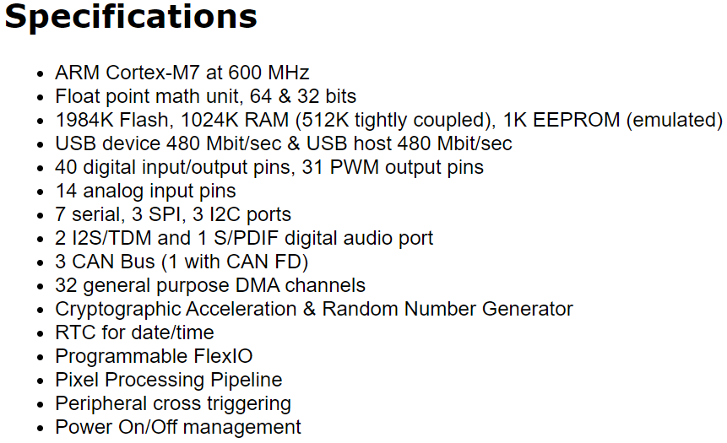[G] Teensy 4.0 Technical Specifications

Image Source: www.pjrc.com

[H] Arduino Uno Technical Specifications



[I] Arduino Mega Technical Specifications



[J] Parting Words

Thank-you for reading.